SMW3D OX Build Instructions
Small Format OX
Rev. 4
8/20/2015
Options:
Wire Sheathing Kit (step 8)
Plates Blasted (step 3)
Spindle upgrade (step 8)
Black Kit (step 1)
Wheel upgrade (step 1)
GT3 upgrade (step 6)
Additional X wheels upgrade (step 5)
Additional center brace (step 1)
Nema 23 Z upgrade (step 5)
TinyG upgrade (step 8)
Cable Chain upgrade (step 8)
E-stop Button (step 8)
Touch sensor endstop (step 8)

These build instructions are provided as a guide to assist you in building your OX in the most efficient and accurate way possible. They can also be used to supplement the OX build instructions that are available from Openbuilds on their build page. There is no grantee or warranty expressed within this document. Use caution and work safely, SMW3D is not responsible for any harm caused by the building of this kit to persons or other items. Proceed at your own risk.

How to use this manual
- We will have checked off each step’s material list. You are highly suggested to do the same. Each bag is labeled with the step number and a bill of materials associated with that bag will be provided here. Please check this completely prior to beginning your build. If anything is in error, stop here and email contact@smw3d.com and we will work with you to rectify the issue quickly.
- Once you have completed checking the BOM (Bill of Material) begin at step one and use the text and images to complete each step.
- If you chose particular options they may be bagged separately, but will be labelled as such.
- Each step will have the tools required. We do not repeat the tools required for each step but simply add to the tool list of the last step, if additional tools are required.
- Take your time. Enjoy, building is half the fun!
Step one:
Required pieces small format: SMW3D Customer
- 2 x 20 x 80 x 750mm
- 2 x 20 x 40 x 496mm
- 1 x 20 x 40 x 730mm
- Option: center brace
1 x 20x40x730mm
8 x T-nuts
8 x M5 x 8mm bolts
4 x cast 90s
- 4 x 5 hole 90s
- 4 x cast 90s
- 25 x M5 x 10mm bolts
- 8 x M5 x 8mm bolts
- 20 x T-nuts
Tools required:
Metric allen wrench set
Speed Square
M5 x .8 pitch tap
Mini level

Quick Tip:
You are going to have a spoiler board cut, have an additional one cut at 1000mm x 750 (large format and small format) and use it as a work platform! You will need a flat surface to build on.

Steps:
Note, the build images are of a large format OX. The difference is the additional support down the center, the remainder is the same.
Lay out the base.
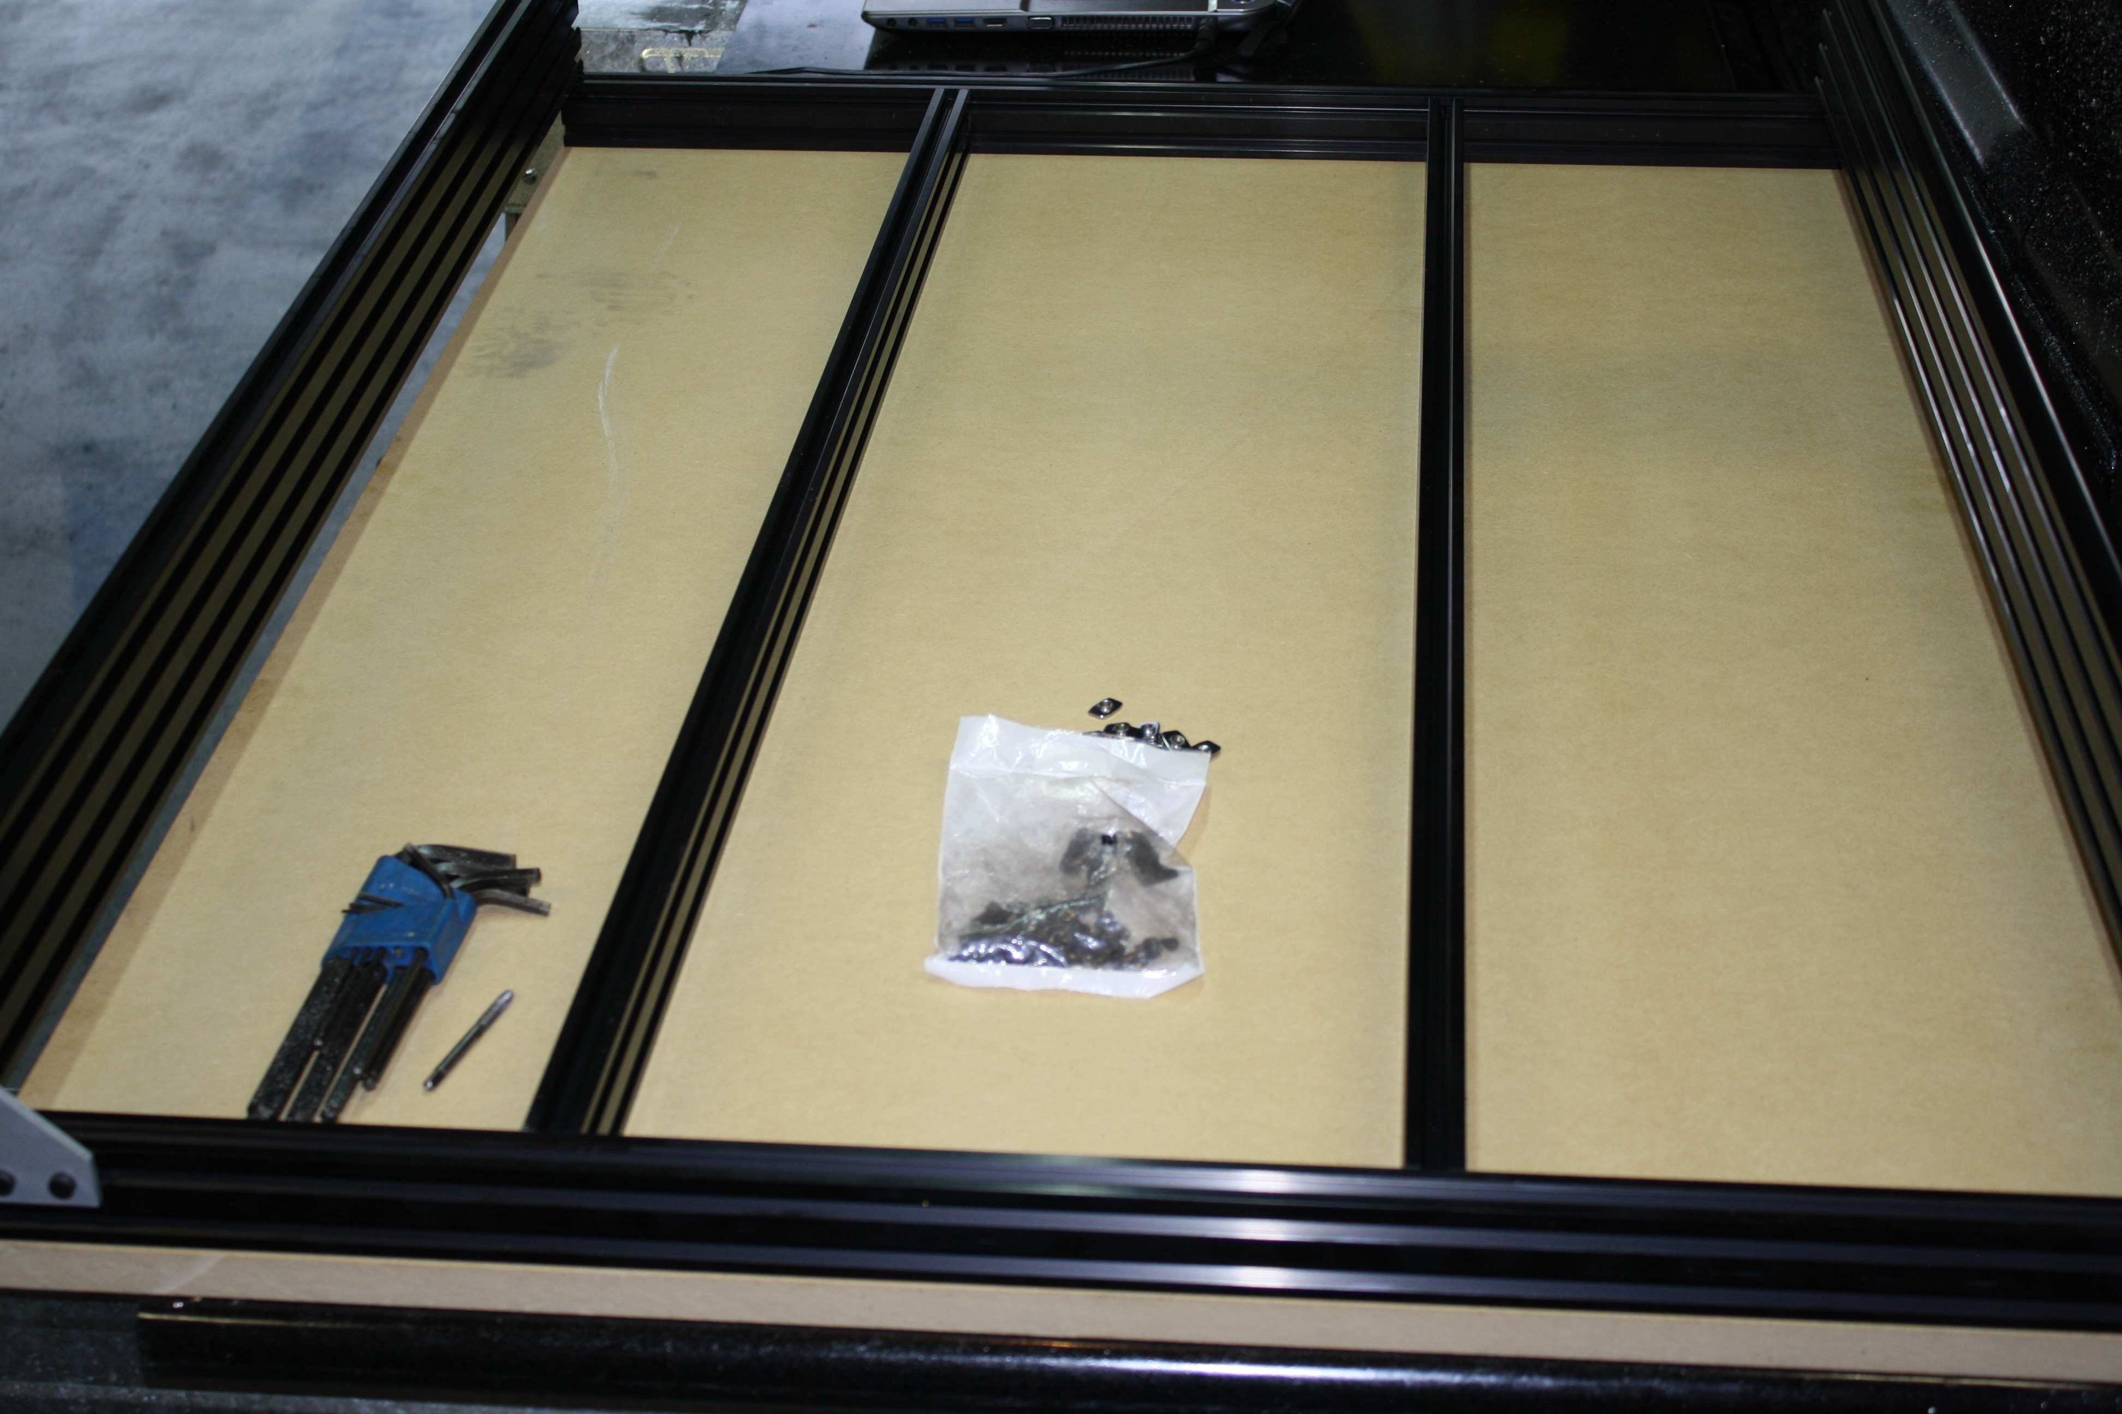
The 20 x 80 rails sit on top of the 20 x 40 rails and form a square. The support rail will be in the center of the box. Note: large format shown above with two cross members, small format only has one.
Tap M5 threads into the bottom two holes of each of the 20 x 80 aluminum extrusions on both ends. Which is the bottom? Does not really matter, you choose. On the end of the extruded aluminum you will see an X pattern with a hole in the center. This hole is the one that will require M5 x .8 pitch threads. Suggest tapping the holes about 15mm deep.
Insert three T-nuts in the top slot of the 20 x 40 near the edge. Note: if you have machined 5 hole 90s you will need to flip the direction of the T-nuts so that the thread faces the plate not the slot, opposite shown in the images below.
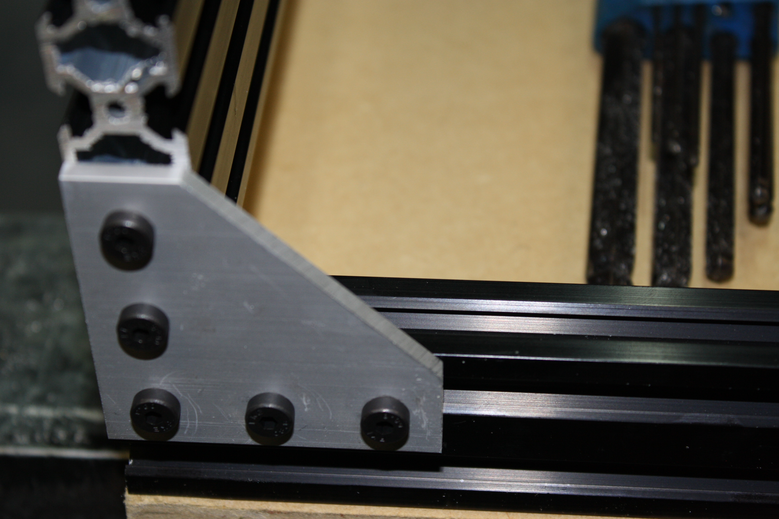
Install a 5 hole 90 on each corner with the M5 x 10mm bolts, squaring the rail before tightening. 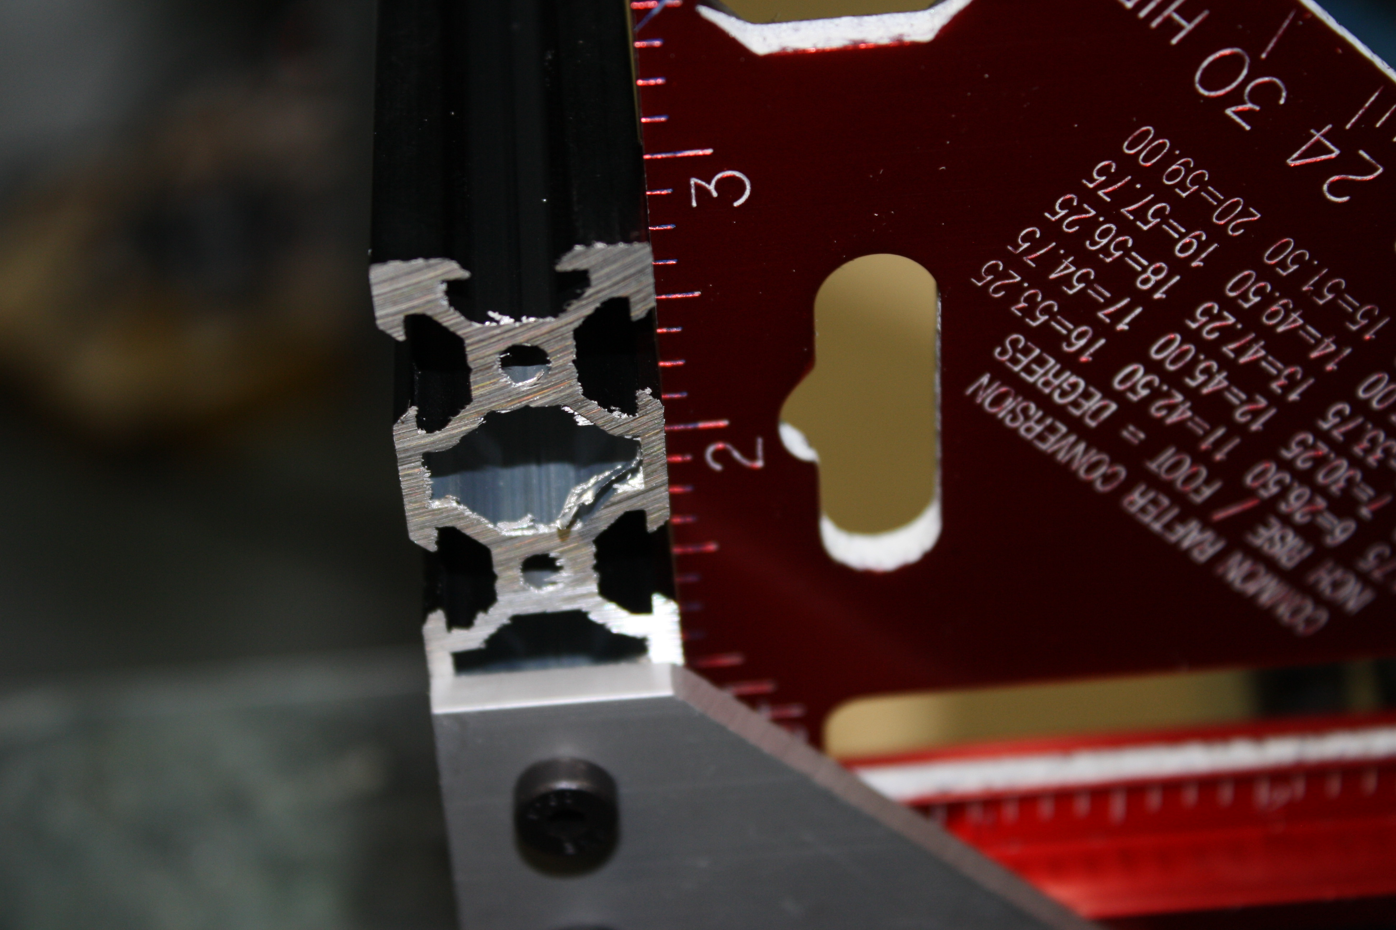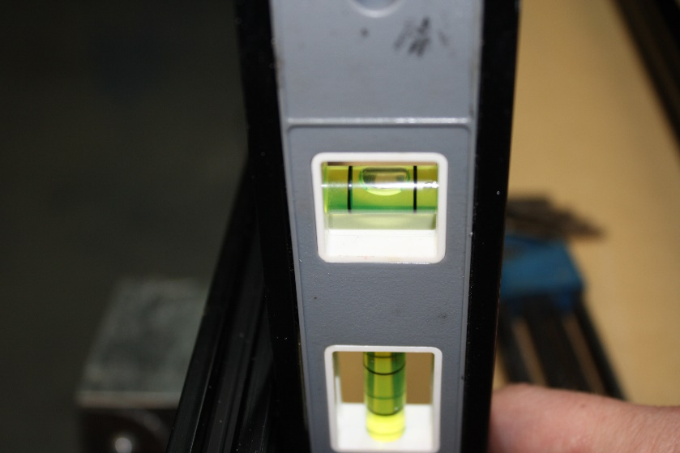
Do this for all four corners of the square frame.
On the inside top slot of the 20 x 40 front and rear frame sections install T-nuts, 2 for each supporting, or cross member, 20 x 40 rail.
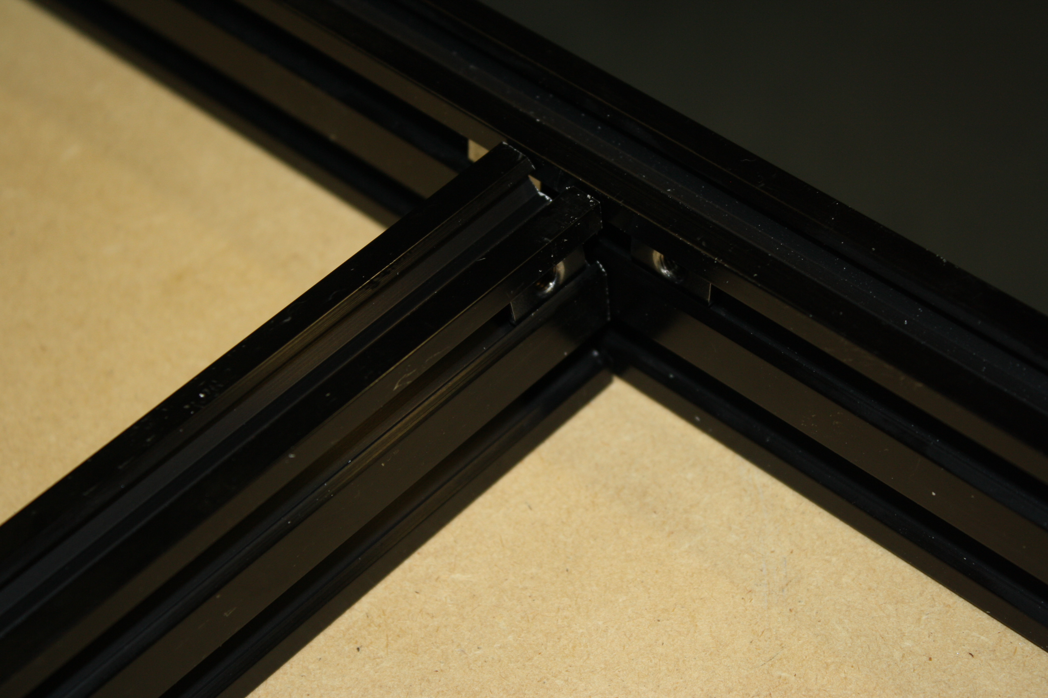
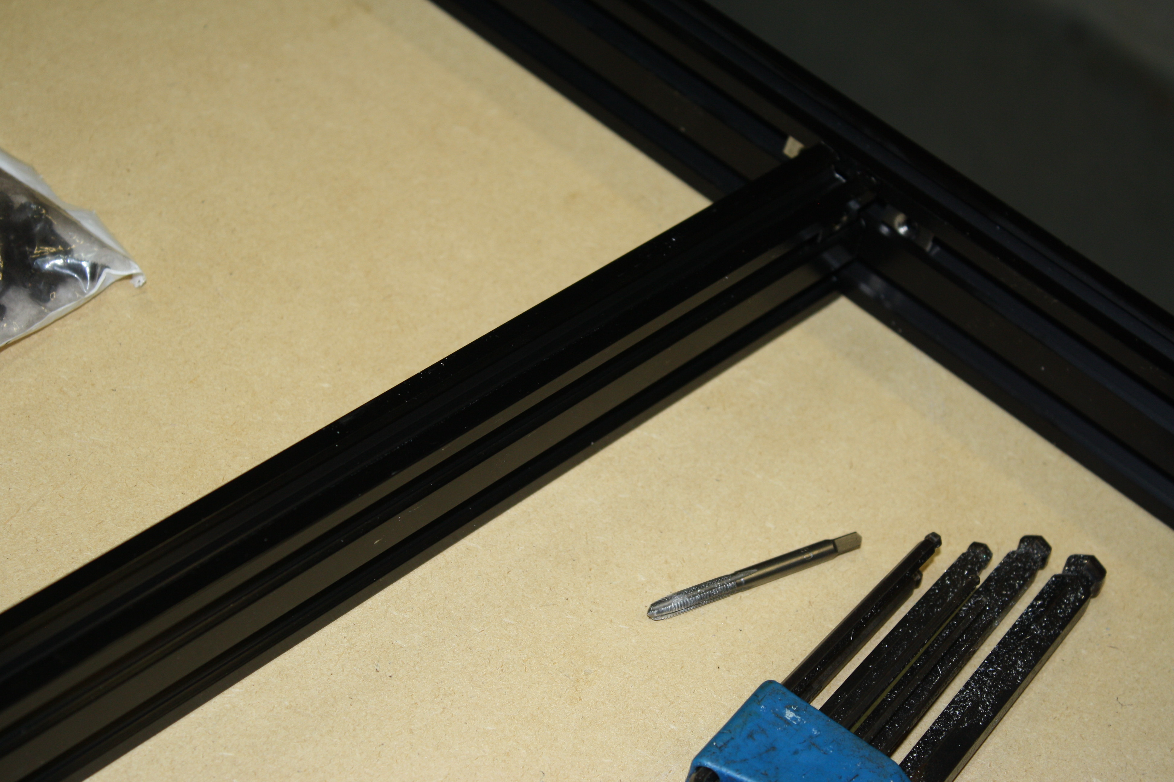
On the 20 x 40 rails, install two T-nuts on each end. 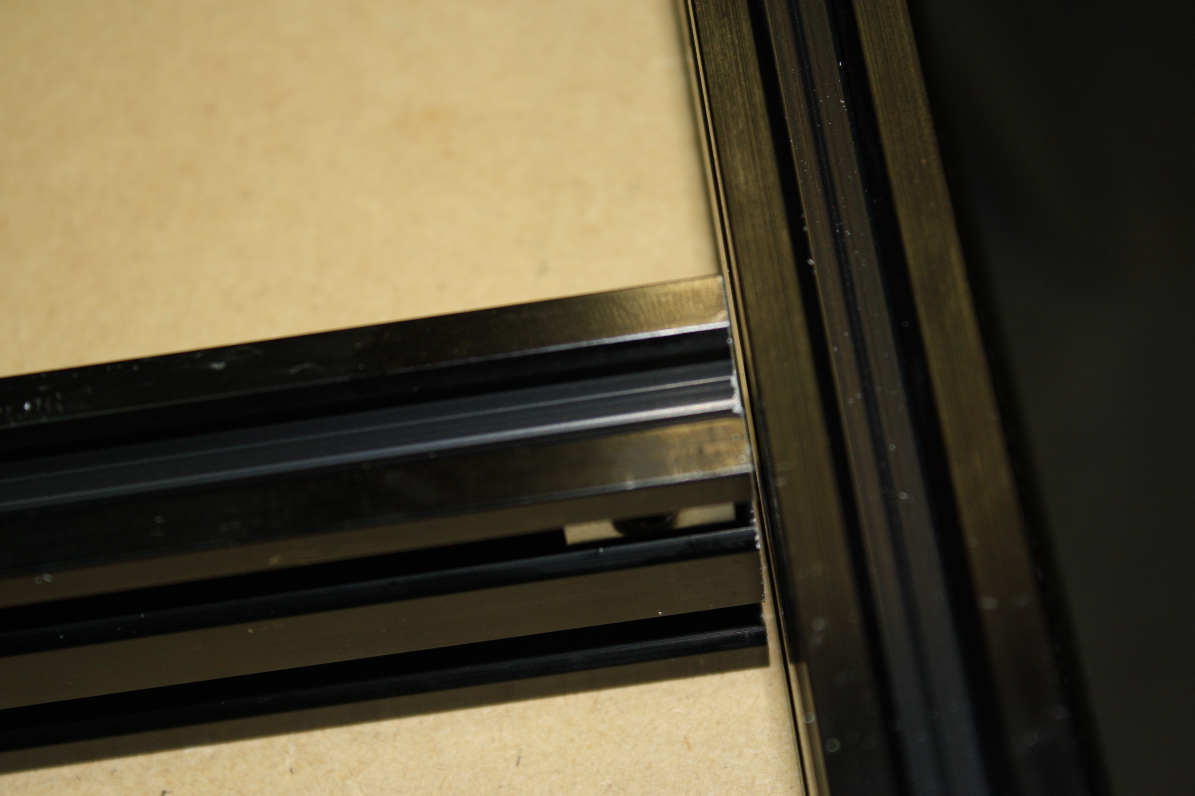
Note: it is very possible there is a slight gap between the support bars and the 20 x 40 end pieces. This should be this way.
Install one cast 90 in each of these joints using the M5 x 8mm bolts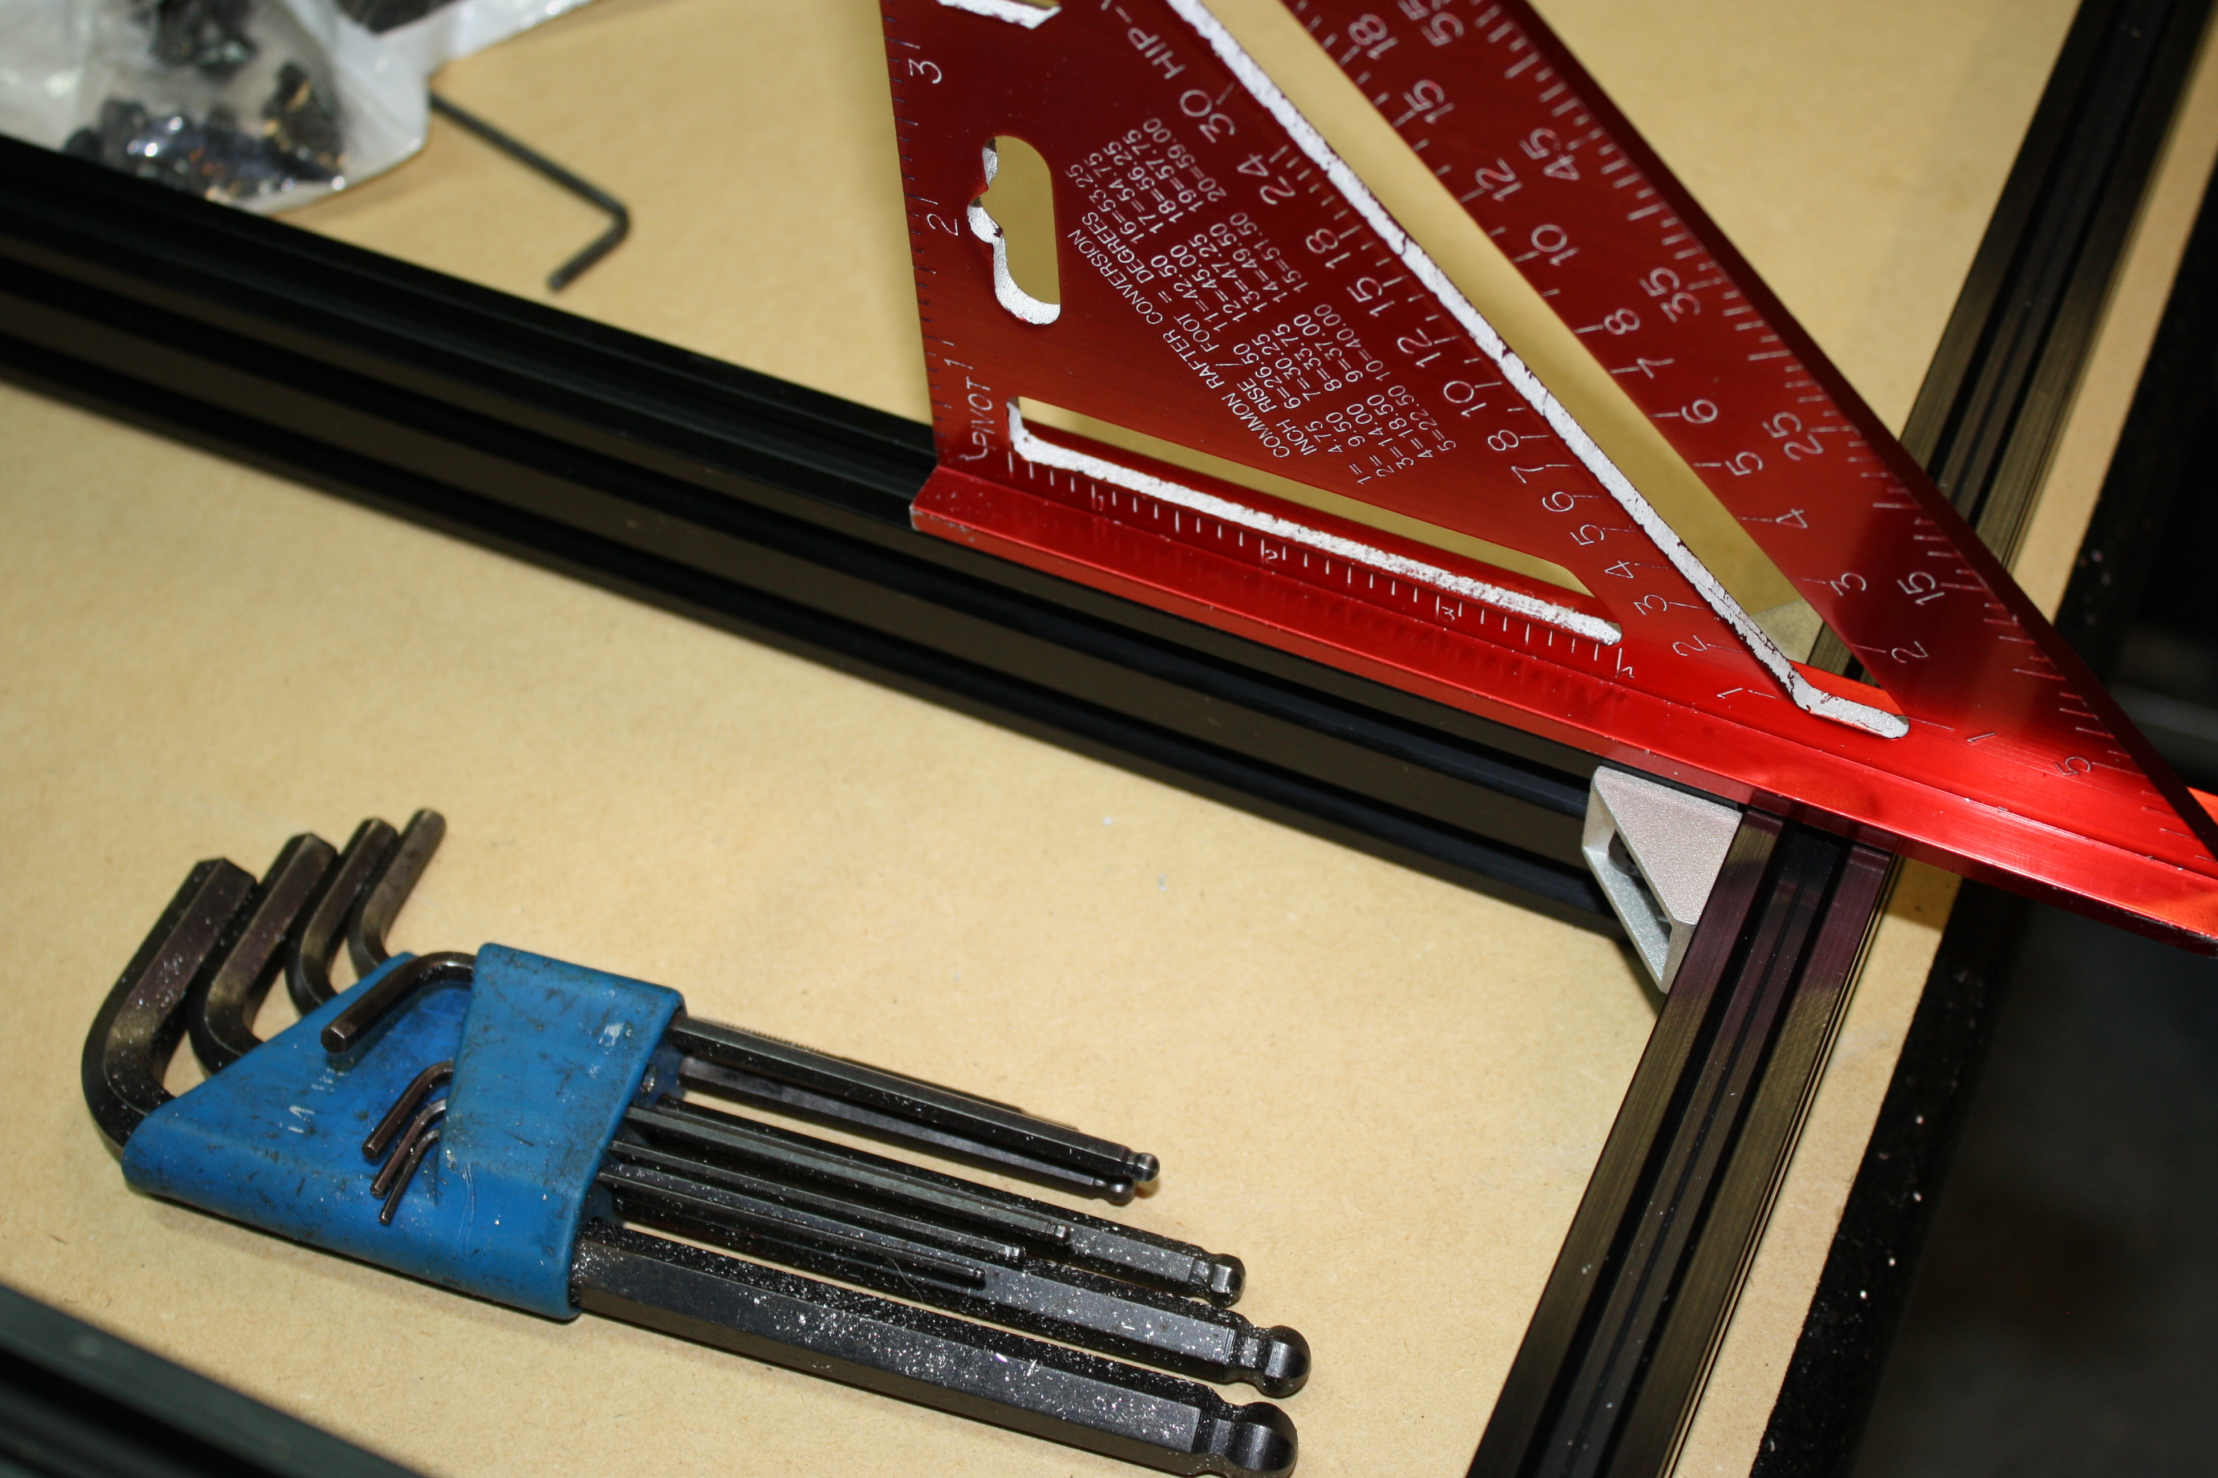.
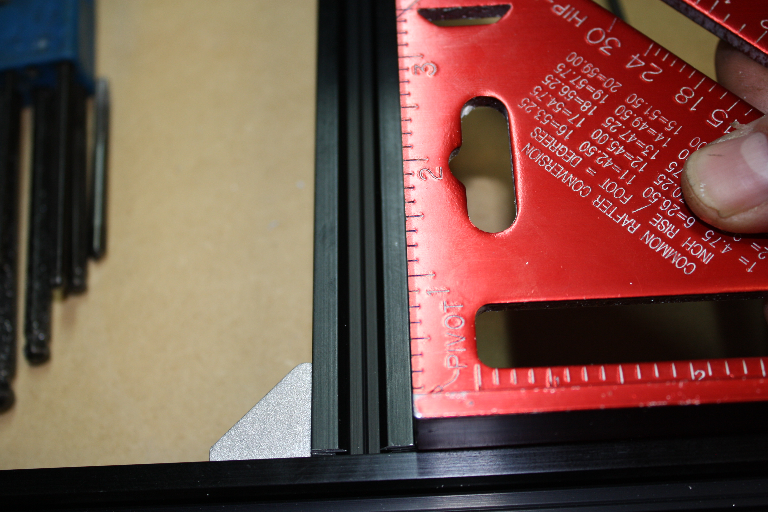
Make sure the corners are square and the top surfaces of the 20 x 40s are flat.
You can install these supports anywhere you like, equally spaced from the edges. We suggest 175mm from the inside edge of the 20 x 80mm Y gantry sticks on the large format, centered on the small format.
Step two:
Square everything. Use a level, use a tape measure, use a set of calipers, a micrometer. Whatever you have available, square the frame now. Every cut you will make with your CNC and the rest of the build relies on the trueness of the frame you are looking at.
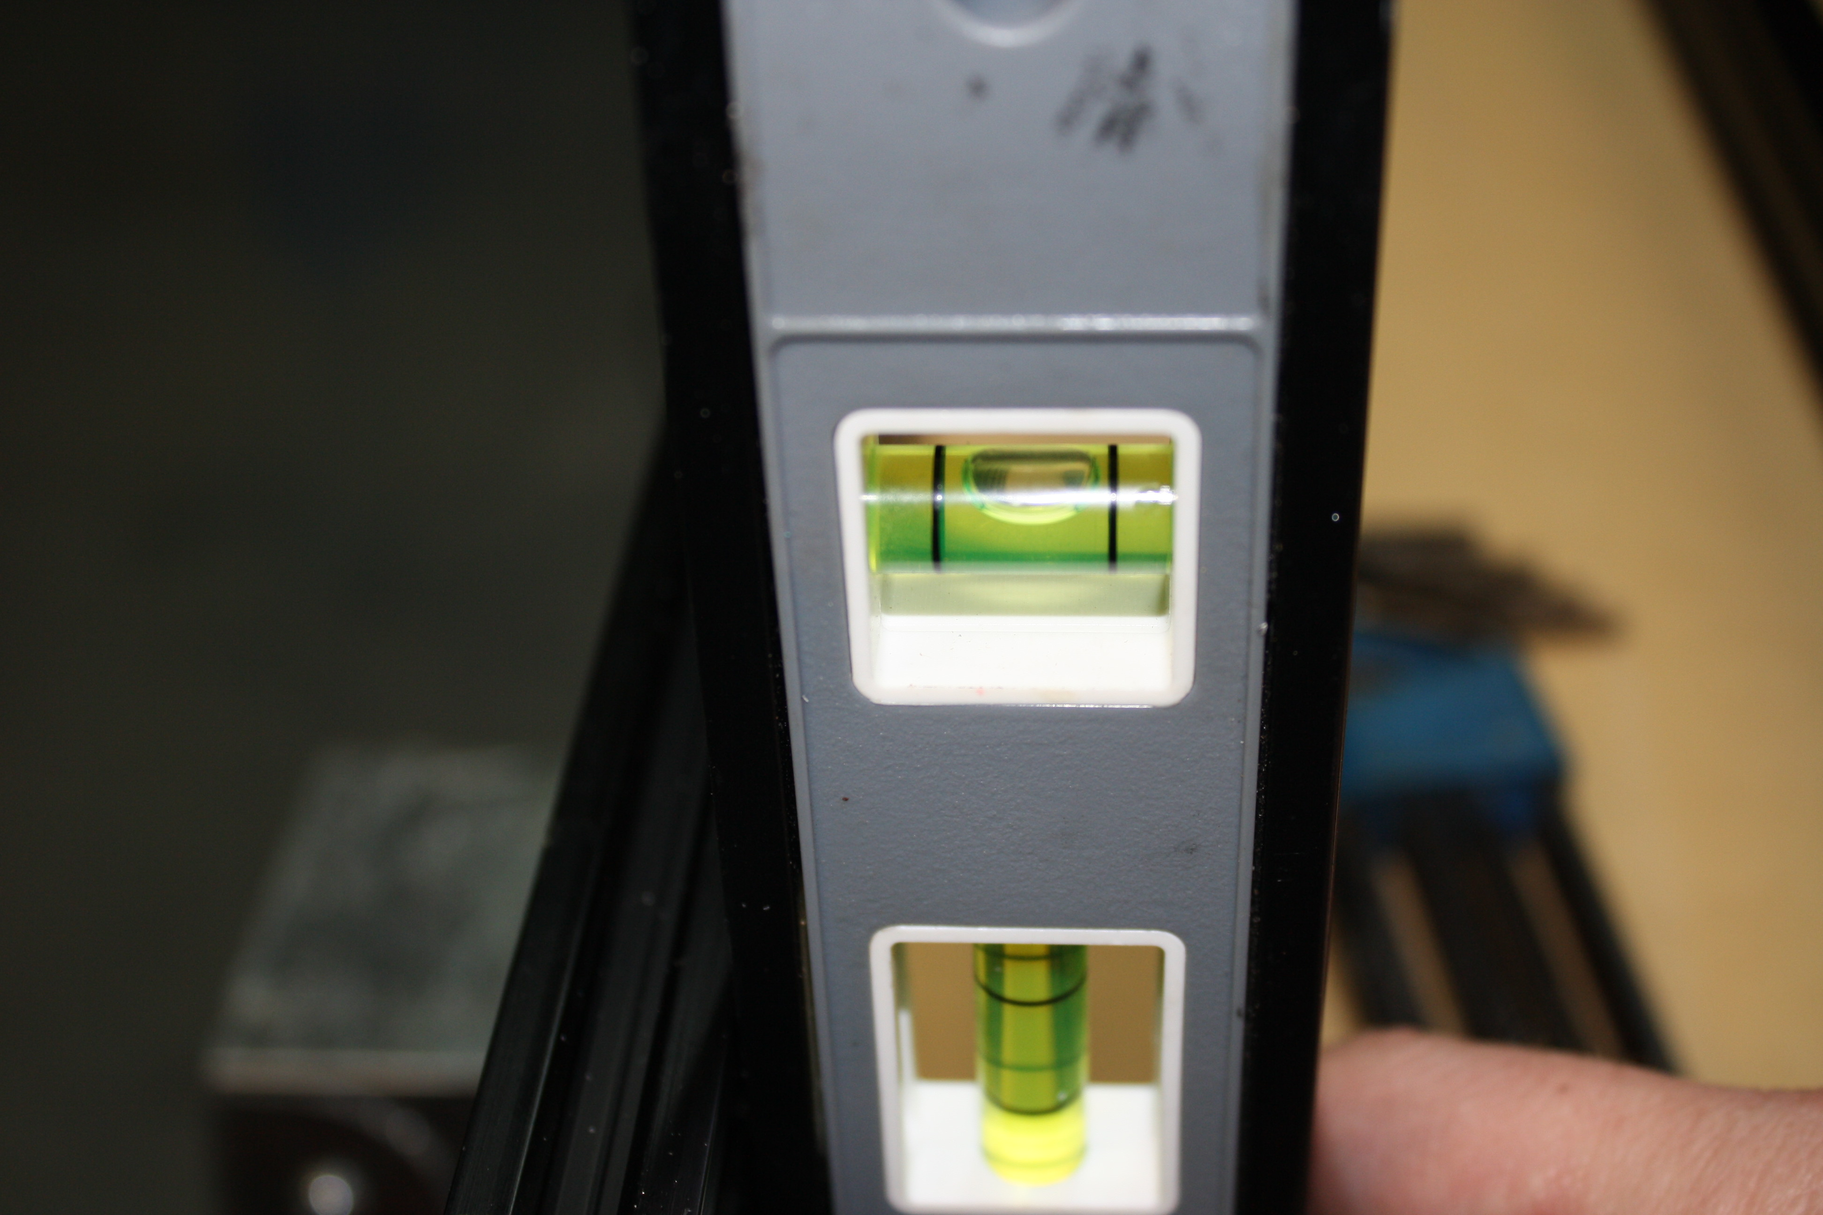
Step three:
Required pieces: SMW3D Customer
- 14 x wheel kits
- 14 x M5 x 30 bolts
- 2 x Nema 23 motors
- 2 x Y gantry plates (the larger plates)
- Optional blasted plates
- 6 x eccentric spacers
- 8 x M5 nuts
- 8 x ¼” spacers
- 8 x M5 x 25mm bolts

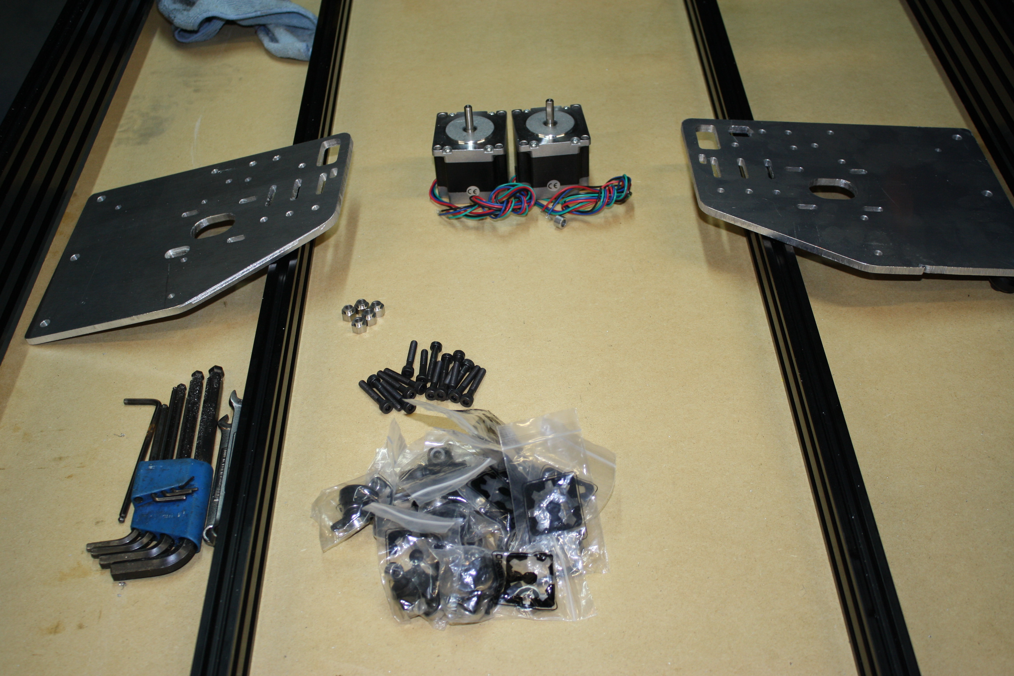
Tools required:
5/16” combination wrench
10mm combination wrench
Metric allen wrench set
Steps:
Begin by installing three wheel kits per plate on the bottom row. This is done by building a wheel kit (if you have never built a wheel kit, please search online), installing an eccentric spacer and replacing the M5 x 25mm bolt in the wheel kit with an M5 x 30mm bolt. Do not forget to put the spacer in between the bearings on the wheel kit. Loosely tighten the nuts on the three wheel kits per side.
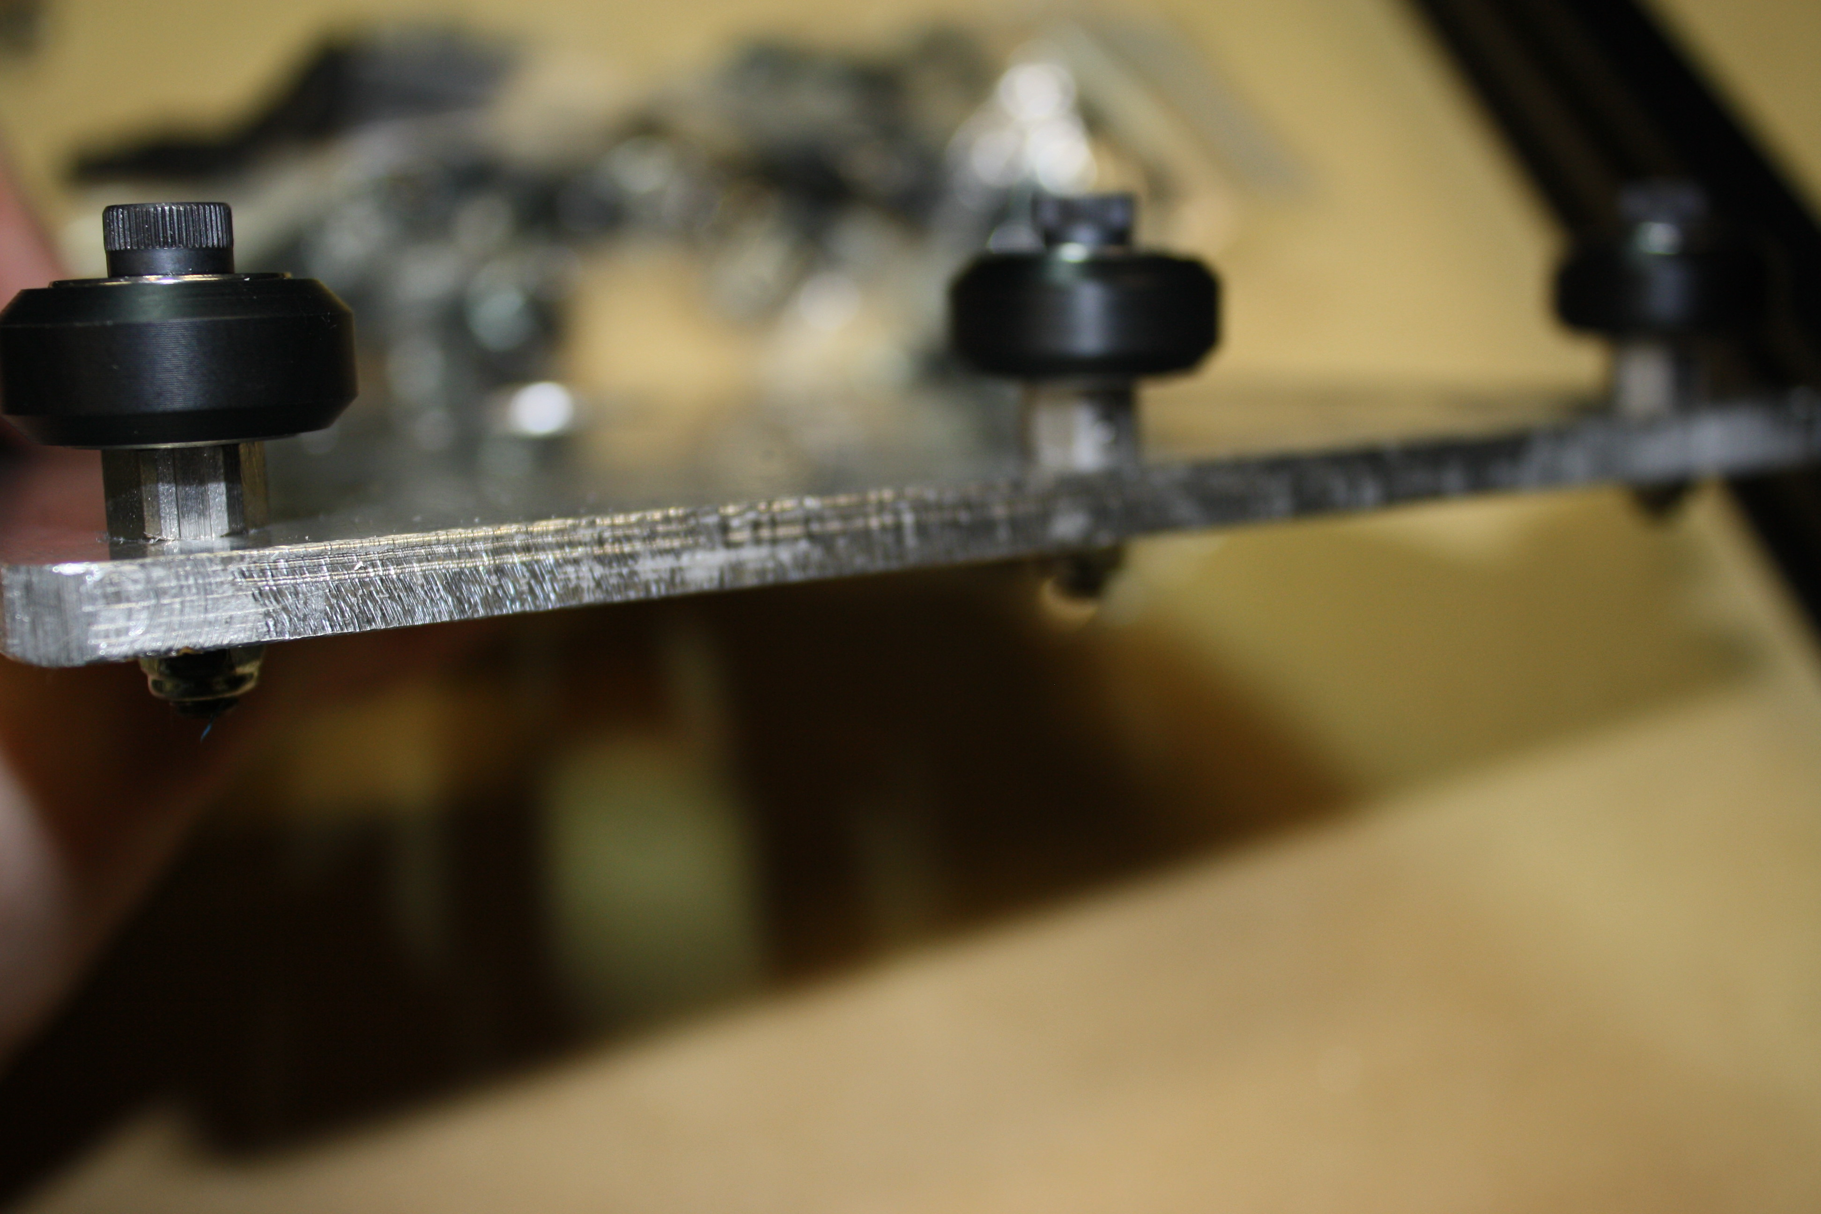
Turn the eccentric spacers till the slot on the eccentric spacer faces down towards the bottom edge of the plate.
Now let’s install the stepper motors. Depending on the controller you want the motors may be different amperage but they will be the same frame, Nema 23.
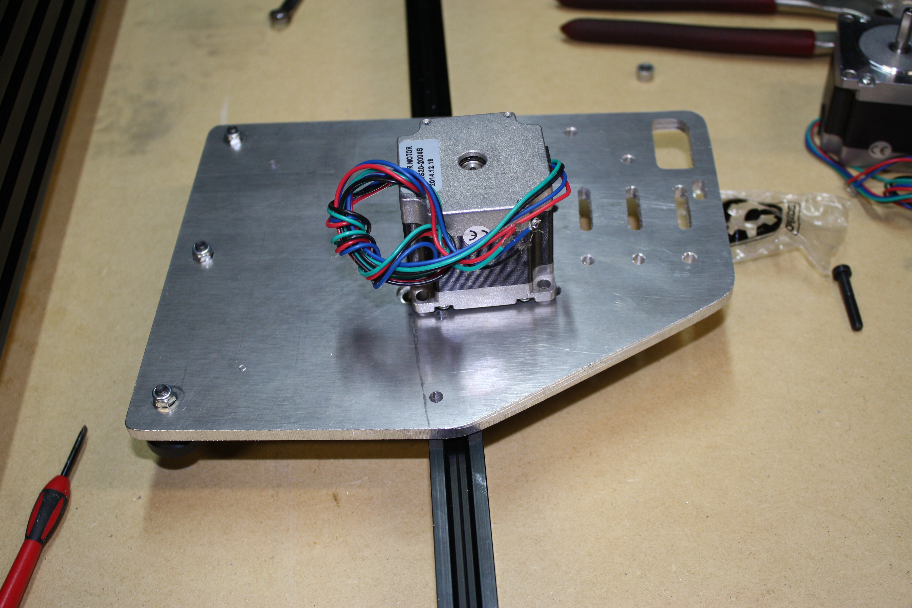
Place the motors on the outside of the plate and install a M5 x 25mm bolt from the wheel kit into the slot on the plate with the head facing towards the OX bed (same side as the wheels).
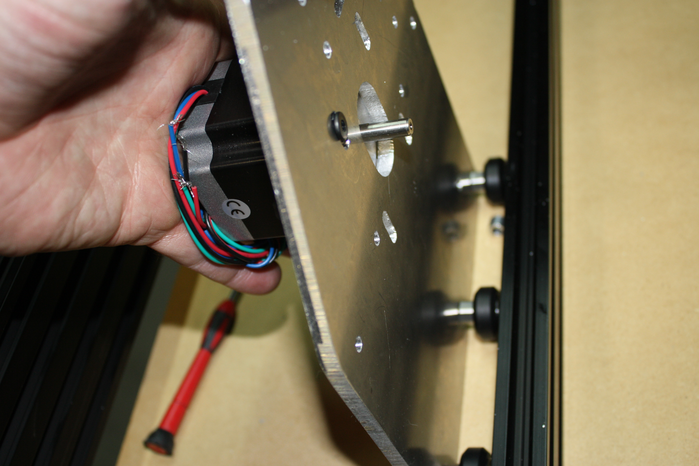
Tighten these bolts.
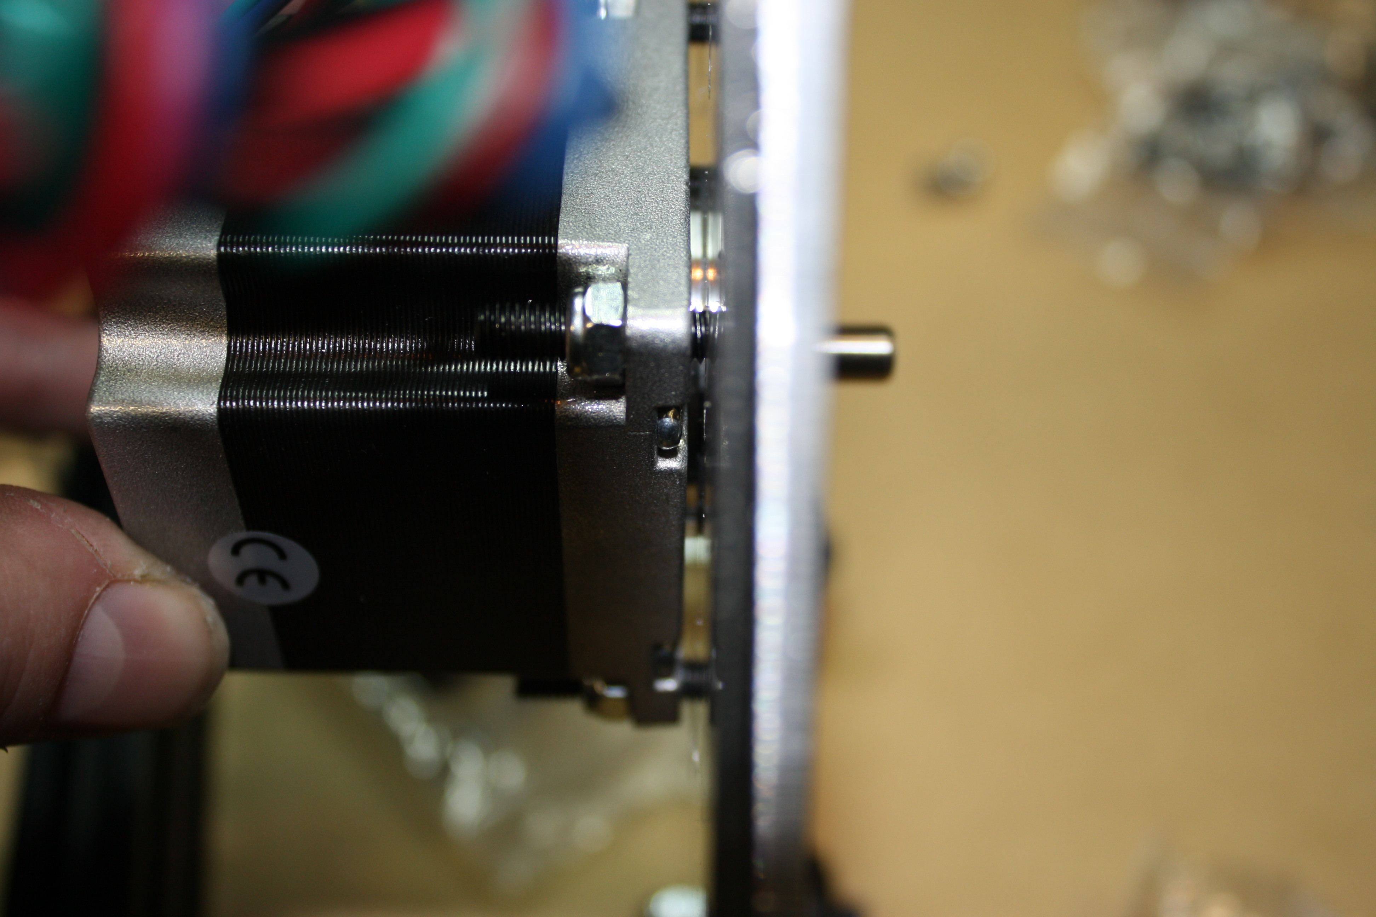

Now install the plates on the OX. Install four wheel kits on the top row of the Y gantry plates. Replace the M5x25mm bolt in the wheel kit with a M5 x 30mm. Install and tighten wheel kits. Make sure the wheels still turn after install.
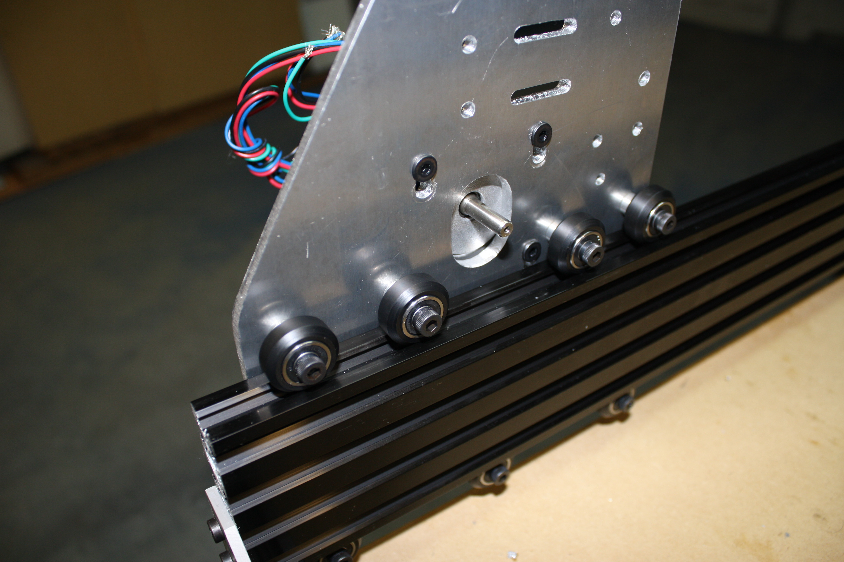
Now turn the eccentric spacers, slowly and evenly, till all four top wheels touch and have a slight resistance. It is possible you will not be able to get all four to drag the same. There are small imperfections in the wheels, bearings, bolts, metal dust from cutting the plates, etc. this will wear down and you will be able to truly true the wheels after a couple of runs.
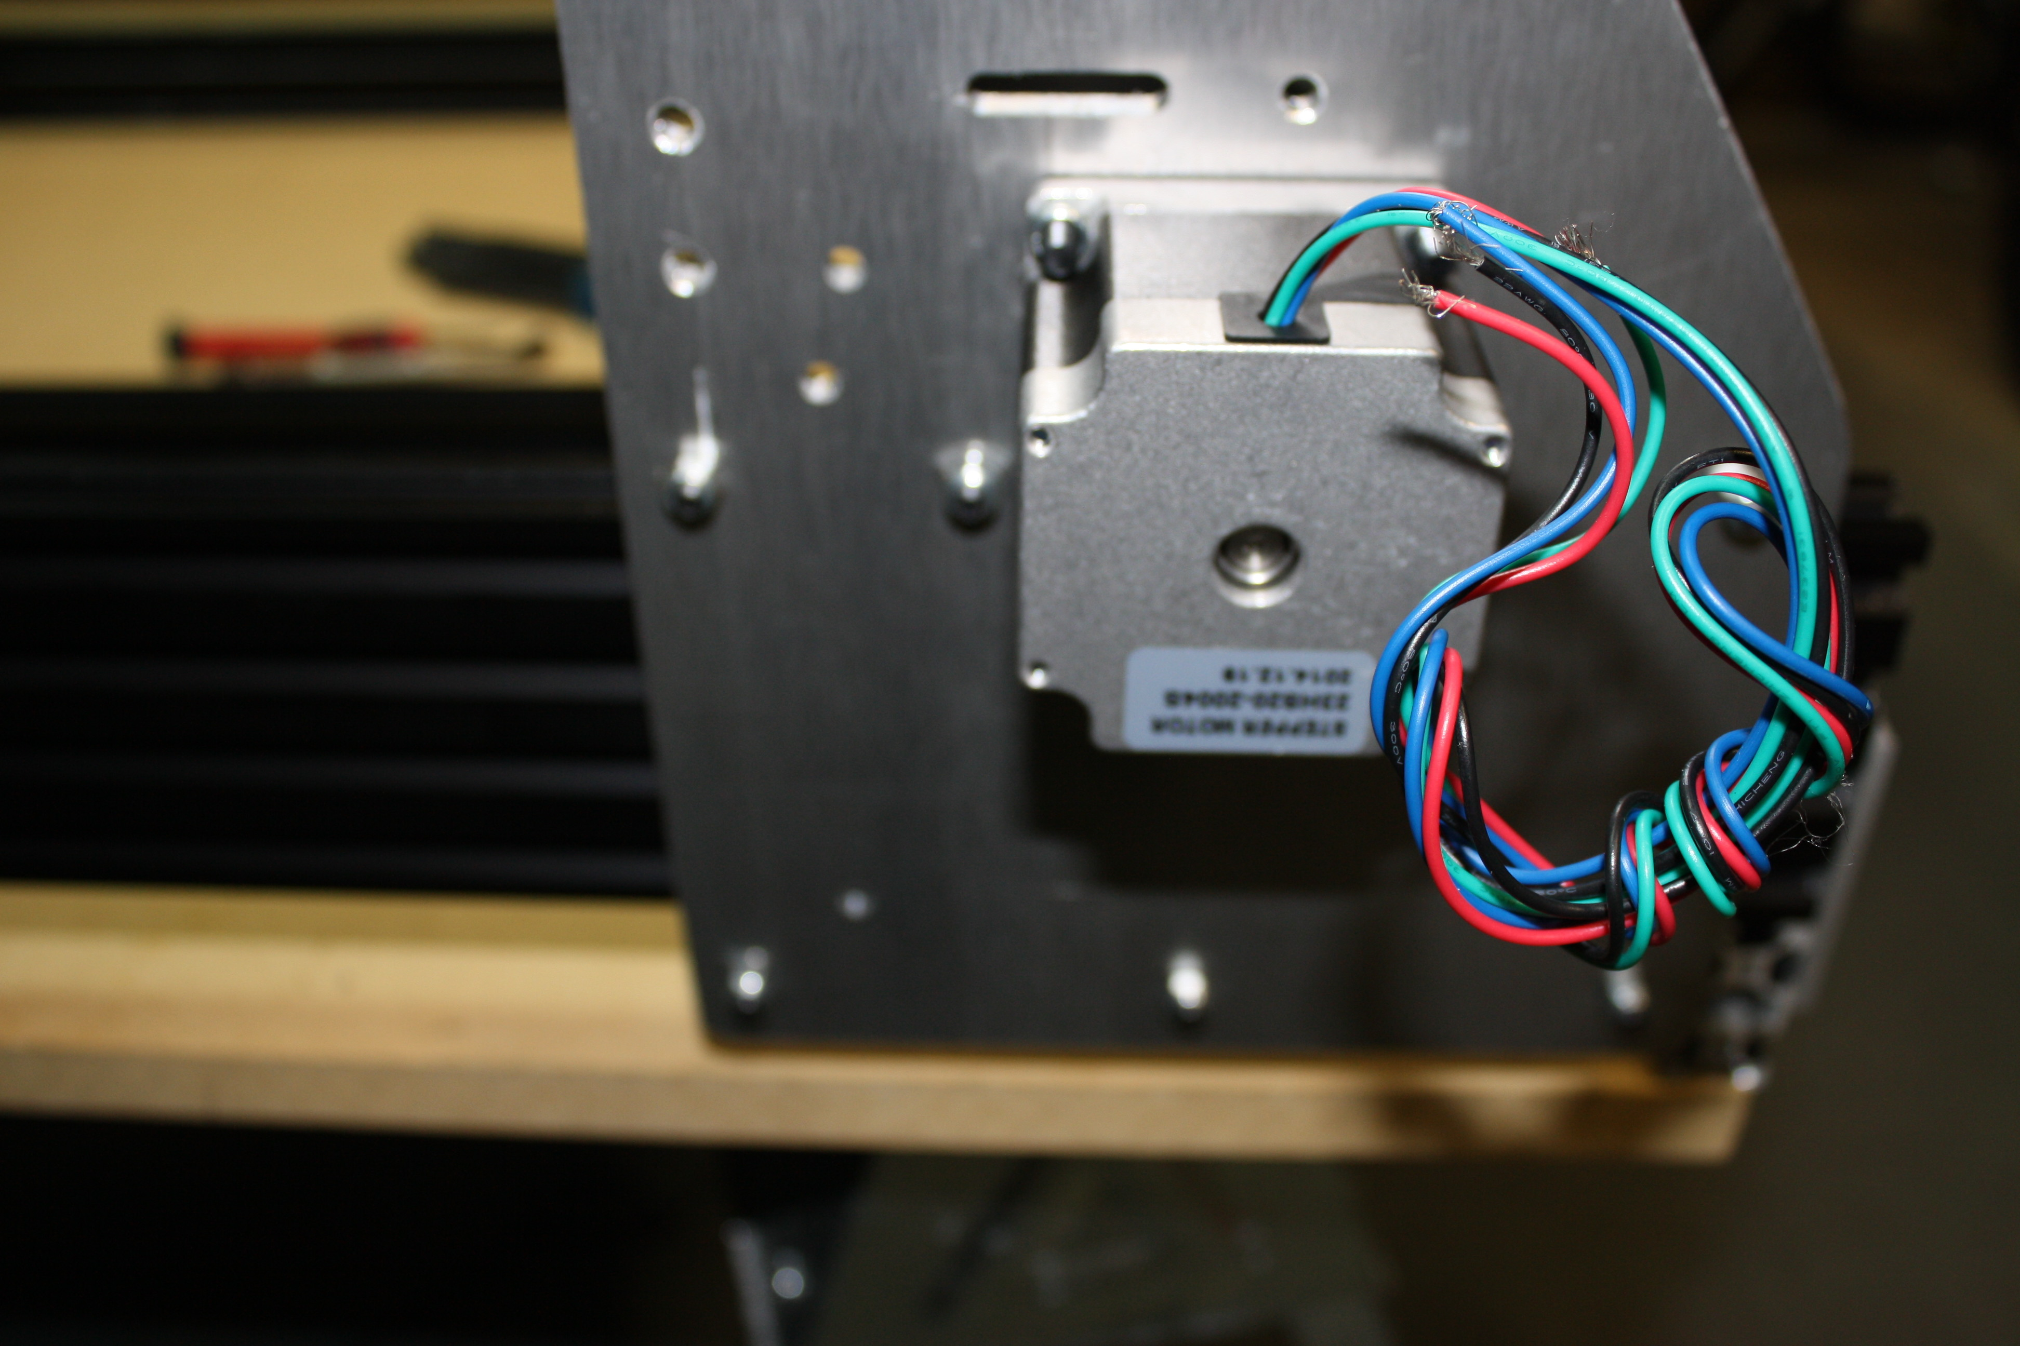
After tightening the eccentric spacers, make sure the nut and bolt are tight on each wheel.
You should be able to move the Y gantry plate down the 20 x 80 and all four top wheels and all three bottom wheels have movement, none should sit idle. It should not require excessive force to push the plate down the extruded aluminum, you should be able to do it with ease. If it requires excessive force the eccentric spacers are too tight and will wear out the wheels prematurely.
You should be left with 6 qty ¼” spacers and 6 qty M5 x25mm bolts.
Step four:
Required pieces small format: SMW3D Customer
- 2 x 20 x 60 x 500
- 20 x 40 x 500
- 18 x M5 x 15mm bolts
- 2 x T-nuts
- 2 cast 90s
- 2 x M5 nuts
- 2 x M5 x 8mm bolts
Tools needed:
Metric allen wrench set
Metric Tap set
Hand file
Steps:
Tap threads in the ends of the 20 x 40, 4 holes.
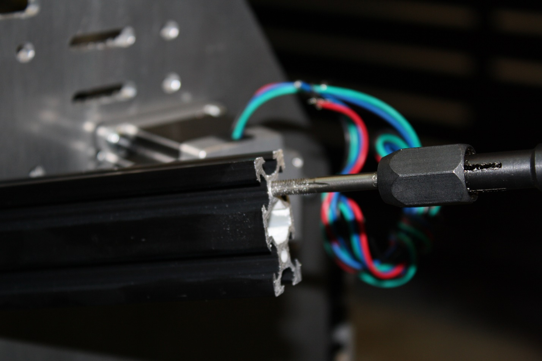
Tap the 20 x 60, all 12 holes.
Slide two, one per end, T-nuts into the top slot of the front 20 x 60. 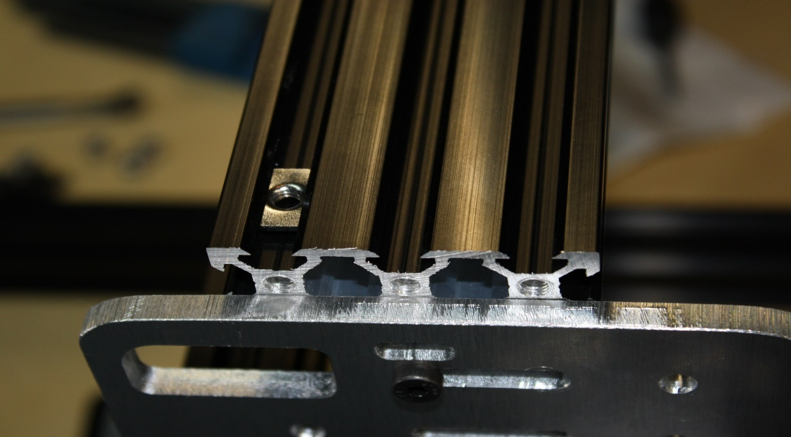
Slide the 20x60s into the gantry plates, if it is too tight you can loosen your 5 hole 90s on the frame and this will allow the 20x80s to move in or out a little. You should not have to loosen the corners but it is one way to provide a little freedom to get the X gantry (the two 20 x 60) extrusions in place. You can also loosen the wheel kit bolts to make it a little easier too.
Bolt the 2x20x60s in with the M5 x 15mm bolts and do the same to the 20x40.
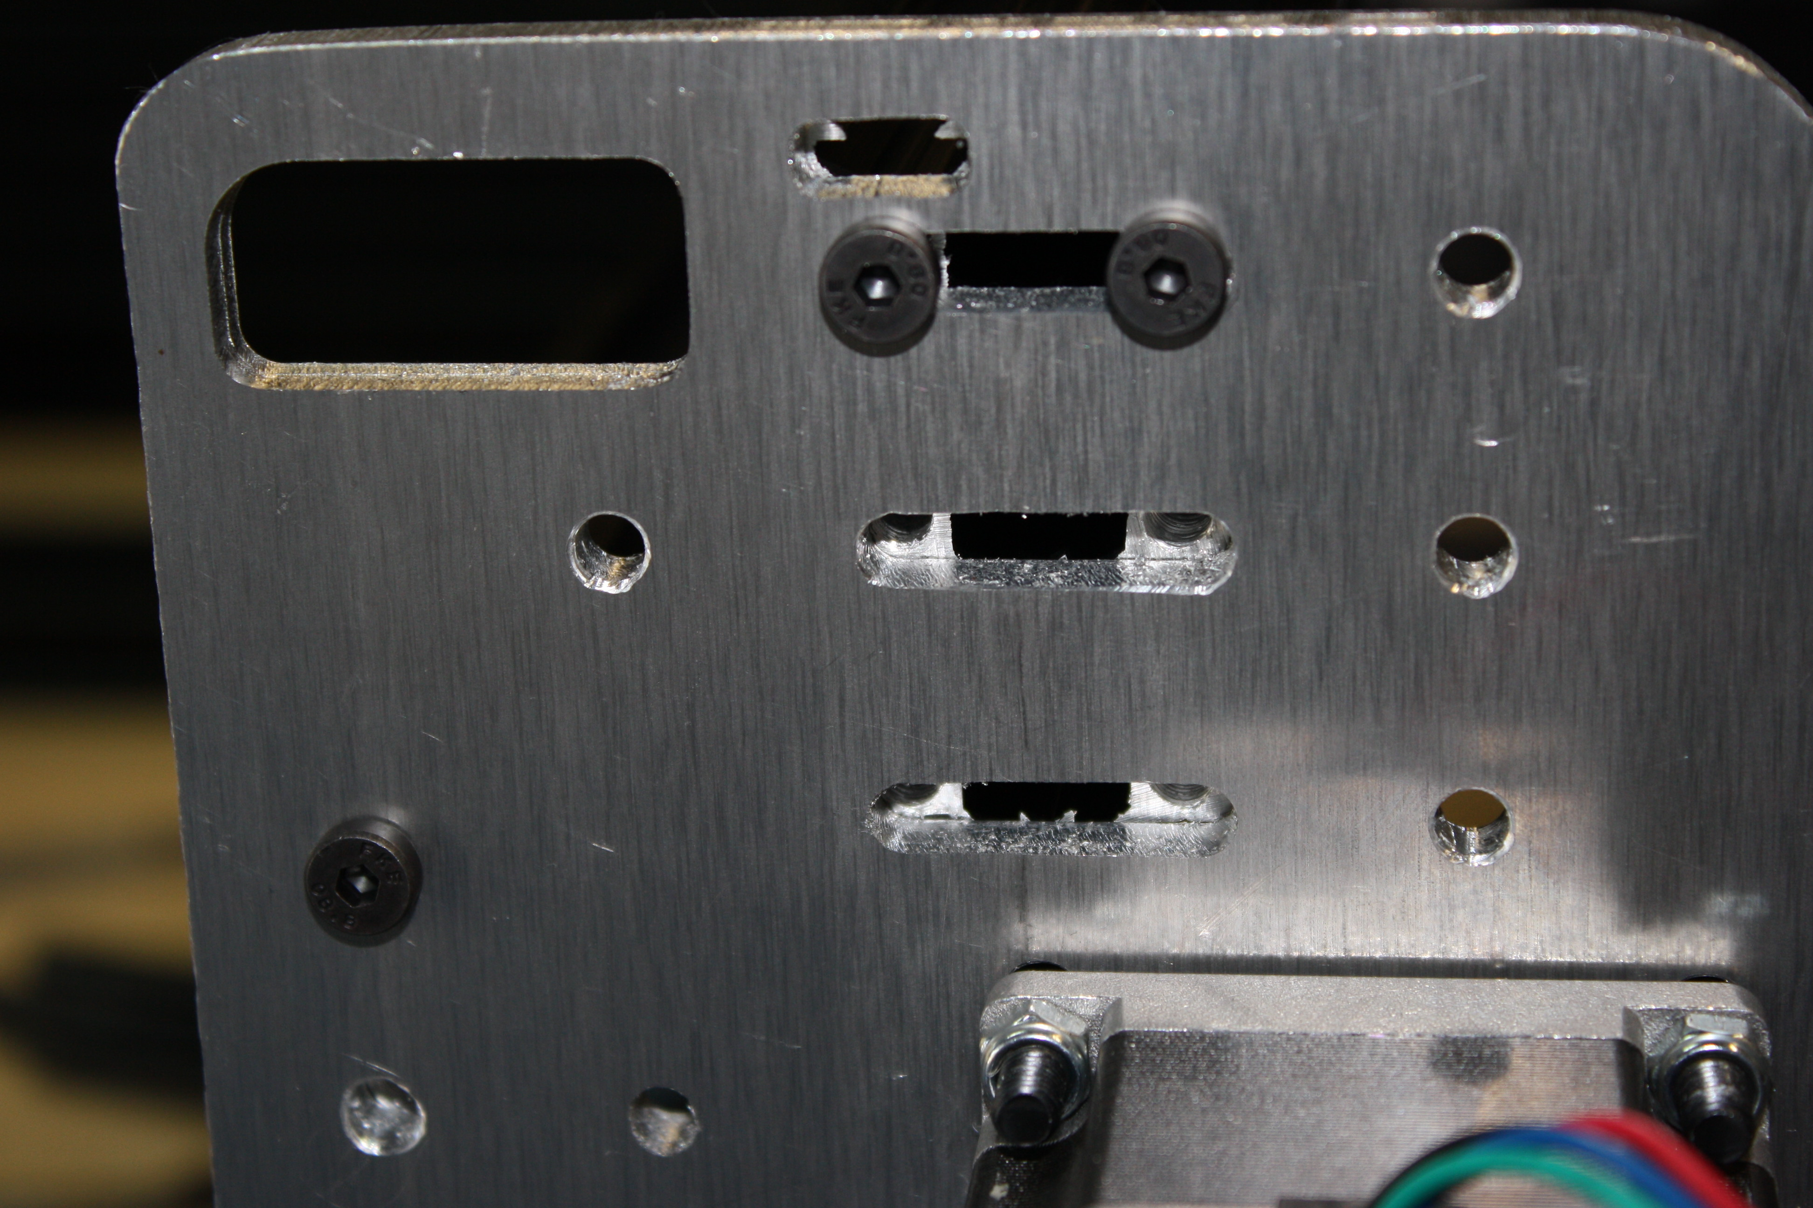
DO NOT over tighten these bolts. It is very easy to strip aluminum threads.
Check the trueness of your frame and make adjustments if necessary. 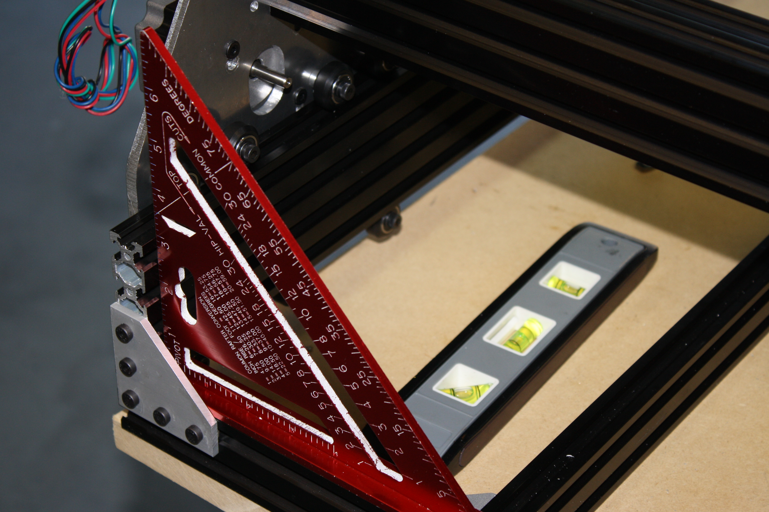
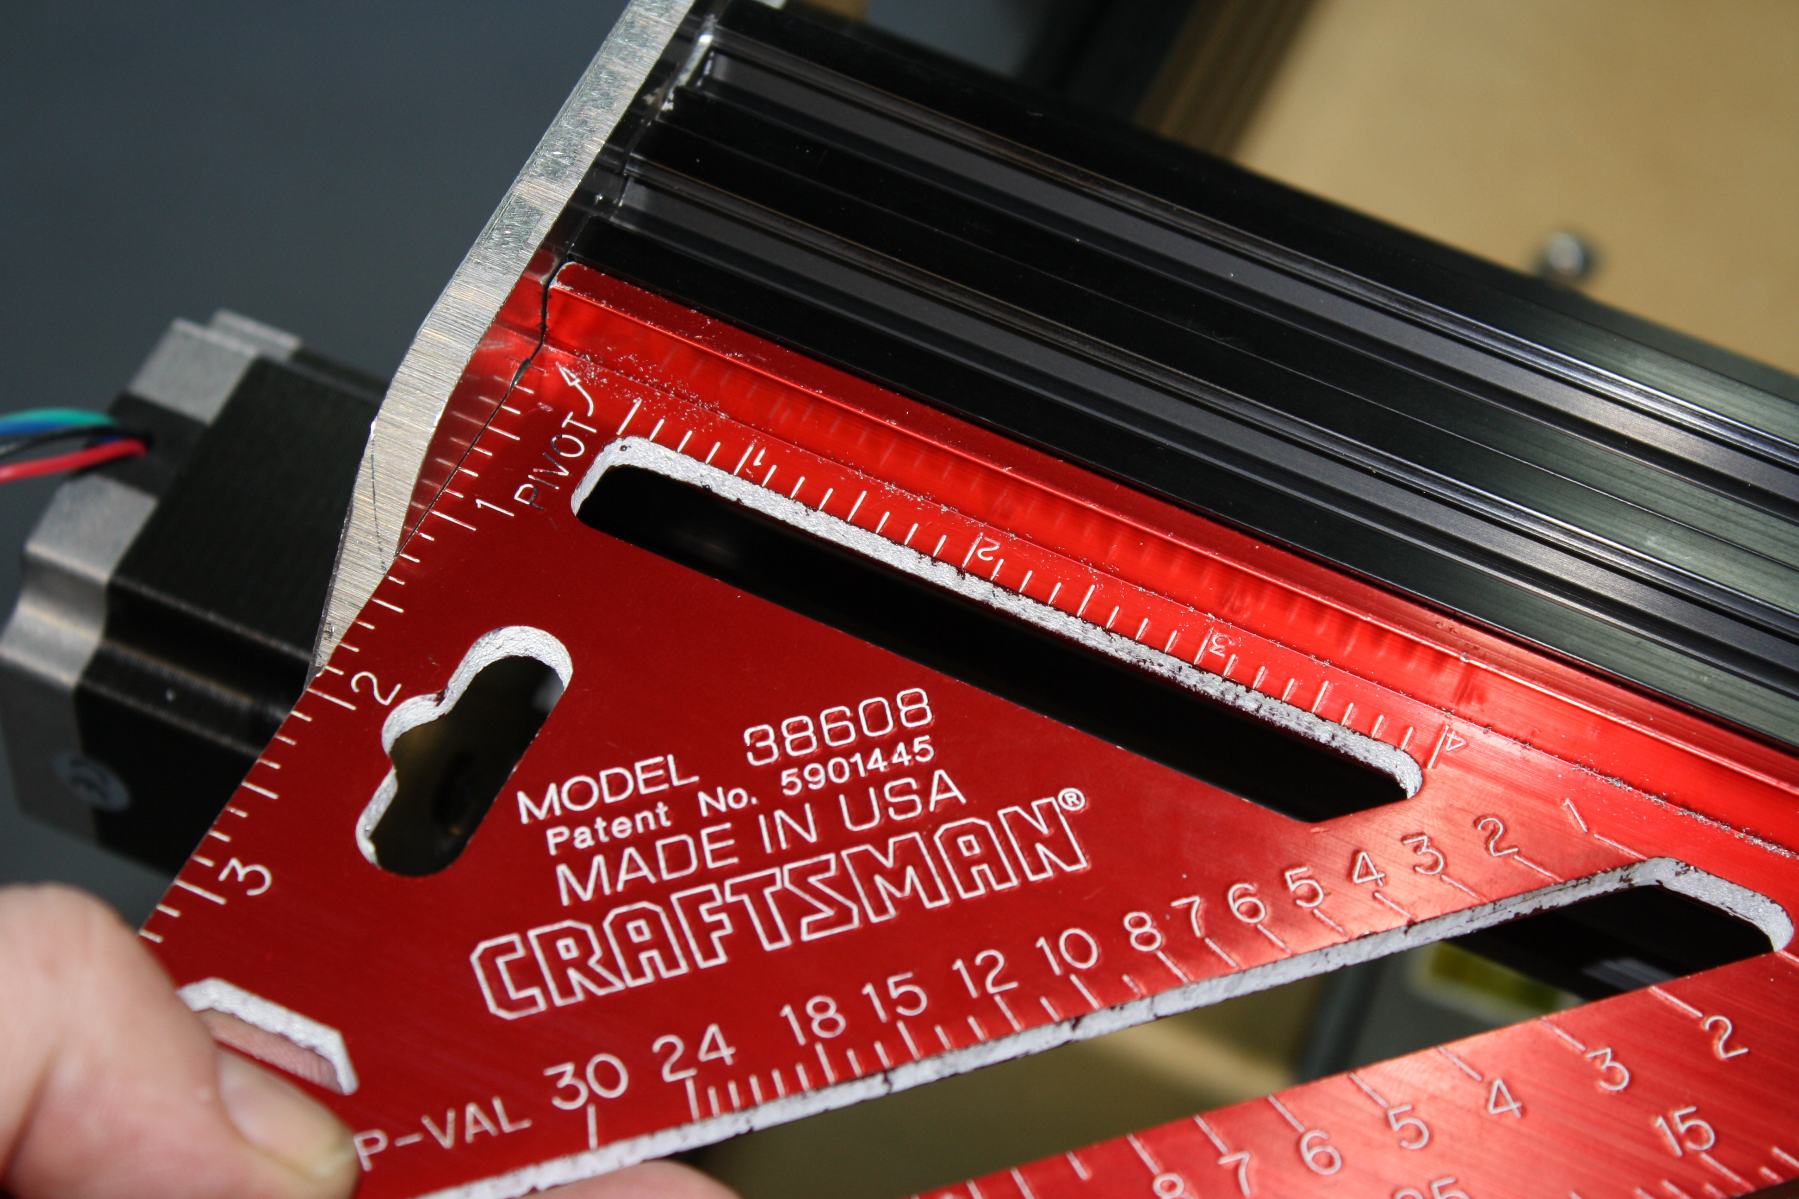
There should be no gap between the 20 x 60 extruded aluminum.
Quick Tip: If you strip a screw remove the piece of extruded aluminum and tap the hole deeper, use one of the M5 x 25mm from the wheel kits.

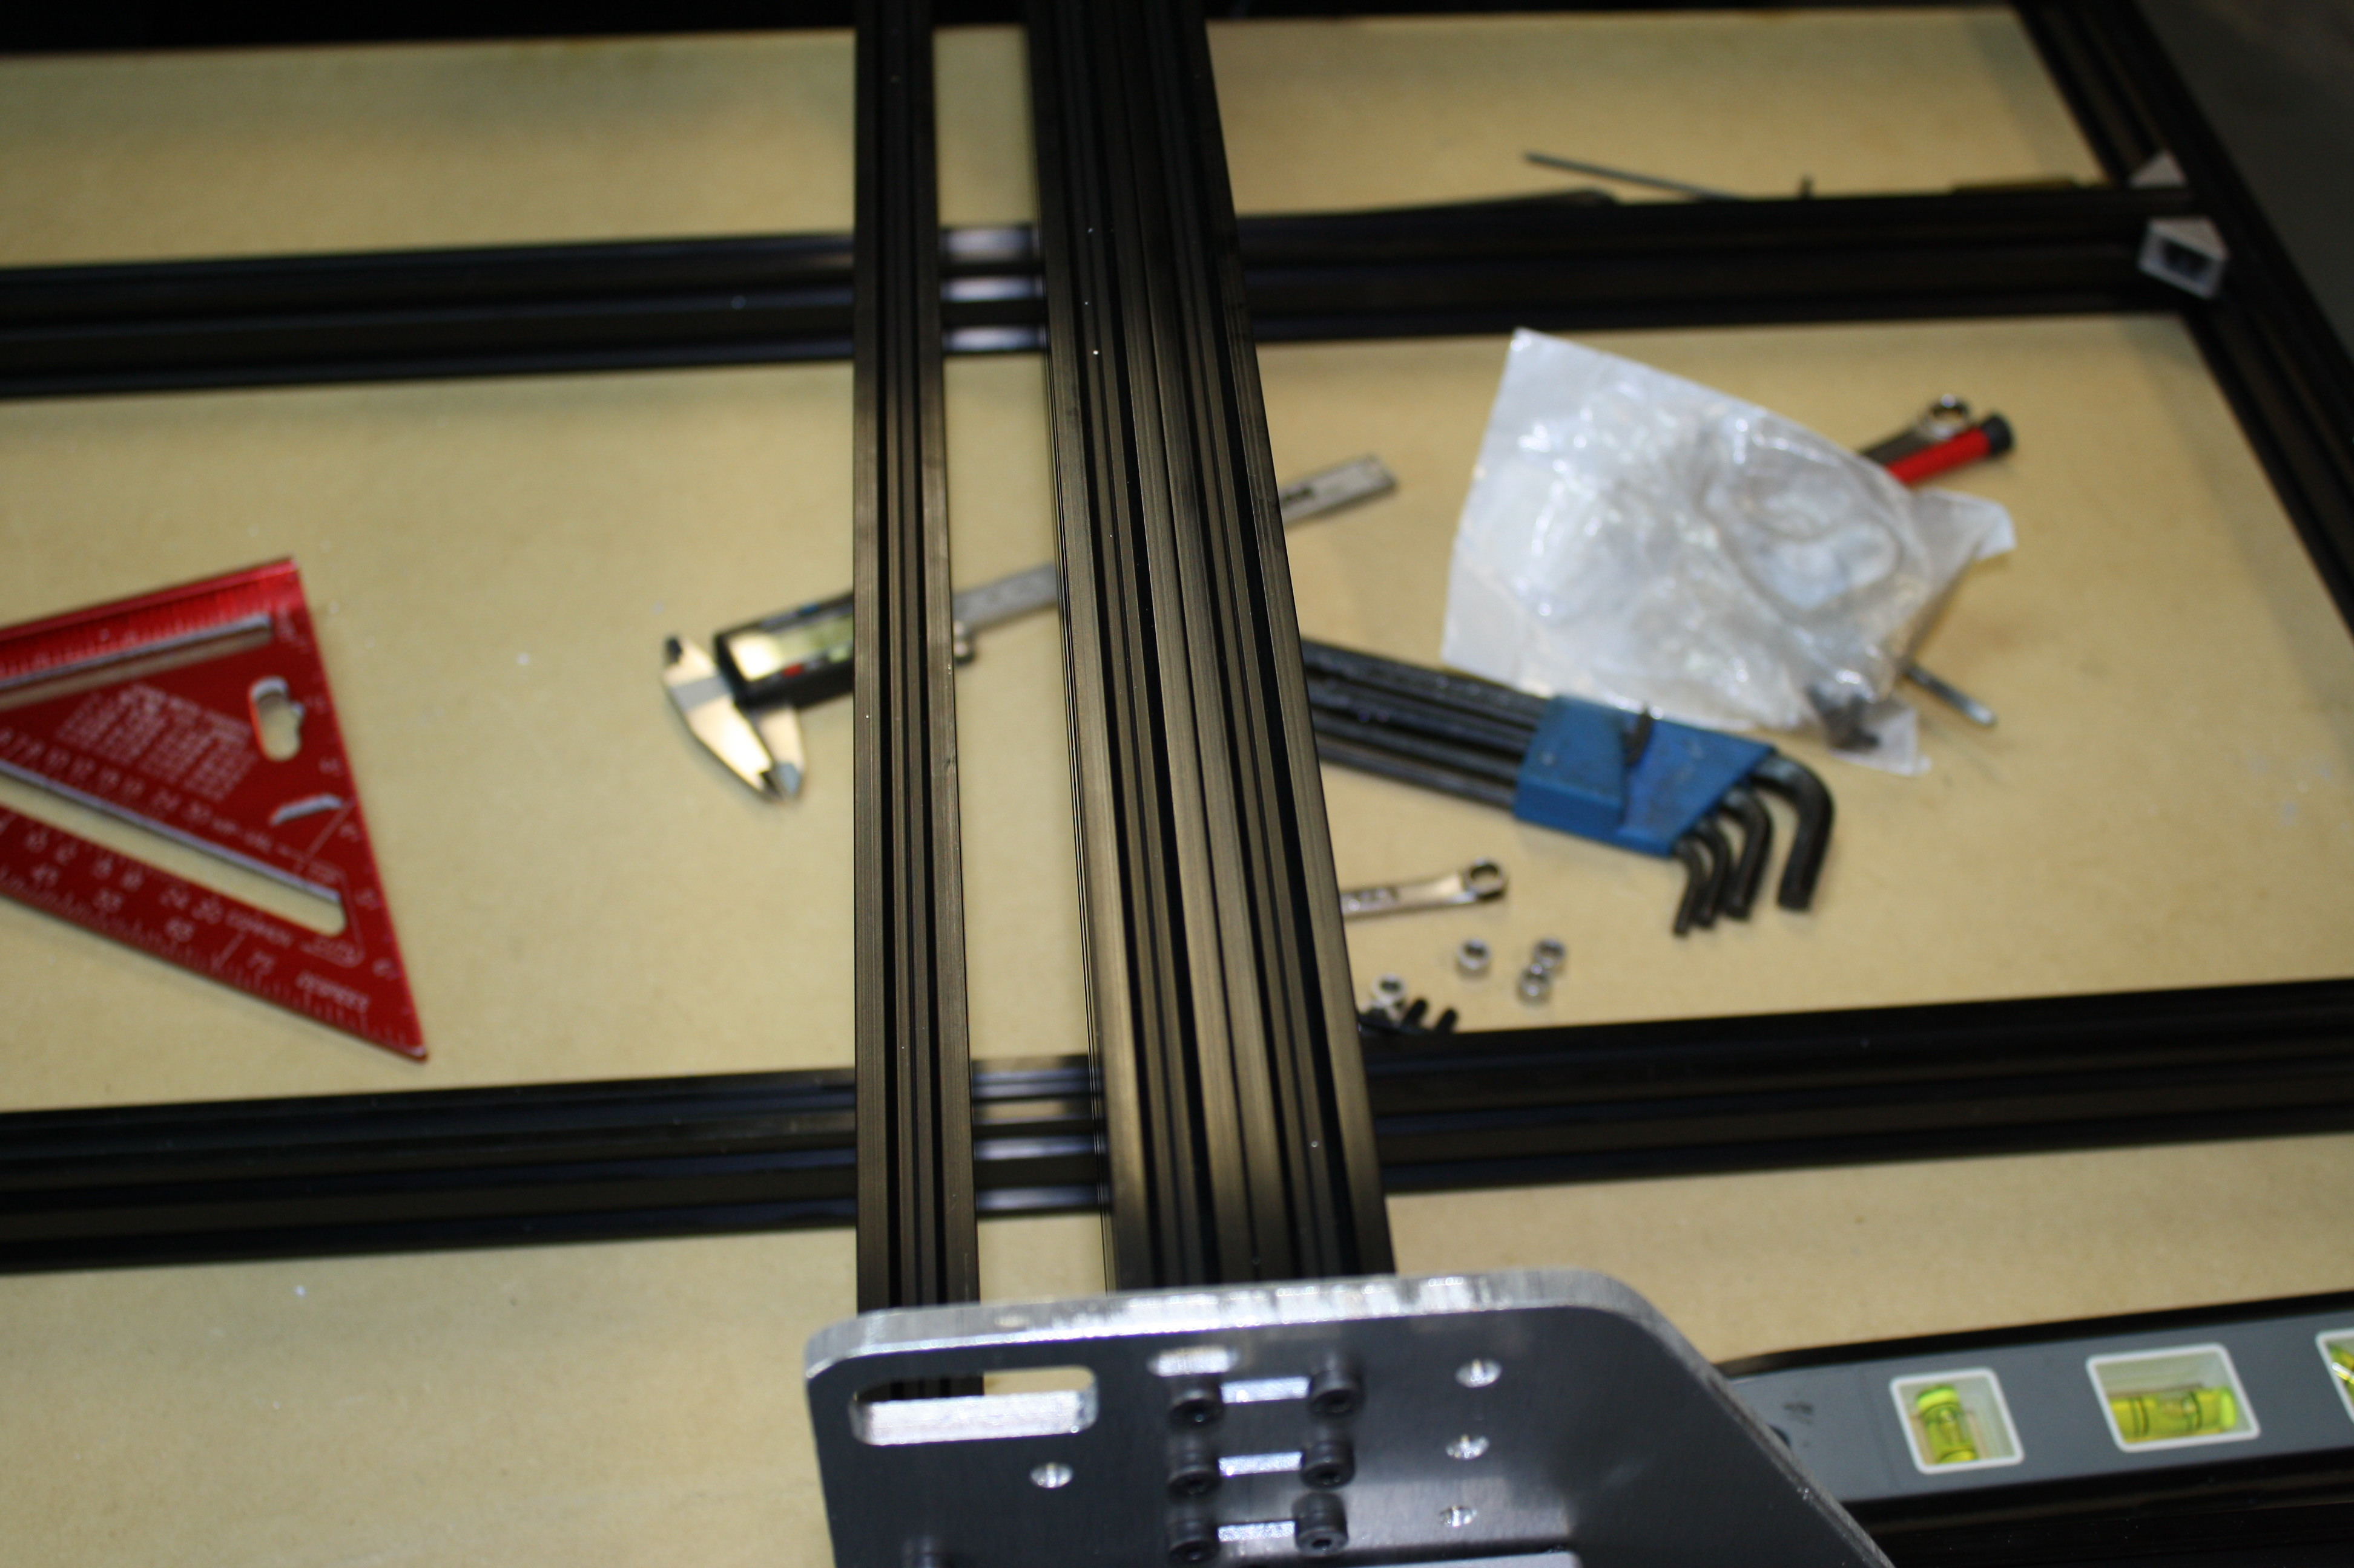
File the two tips off of one side of each cast 90.
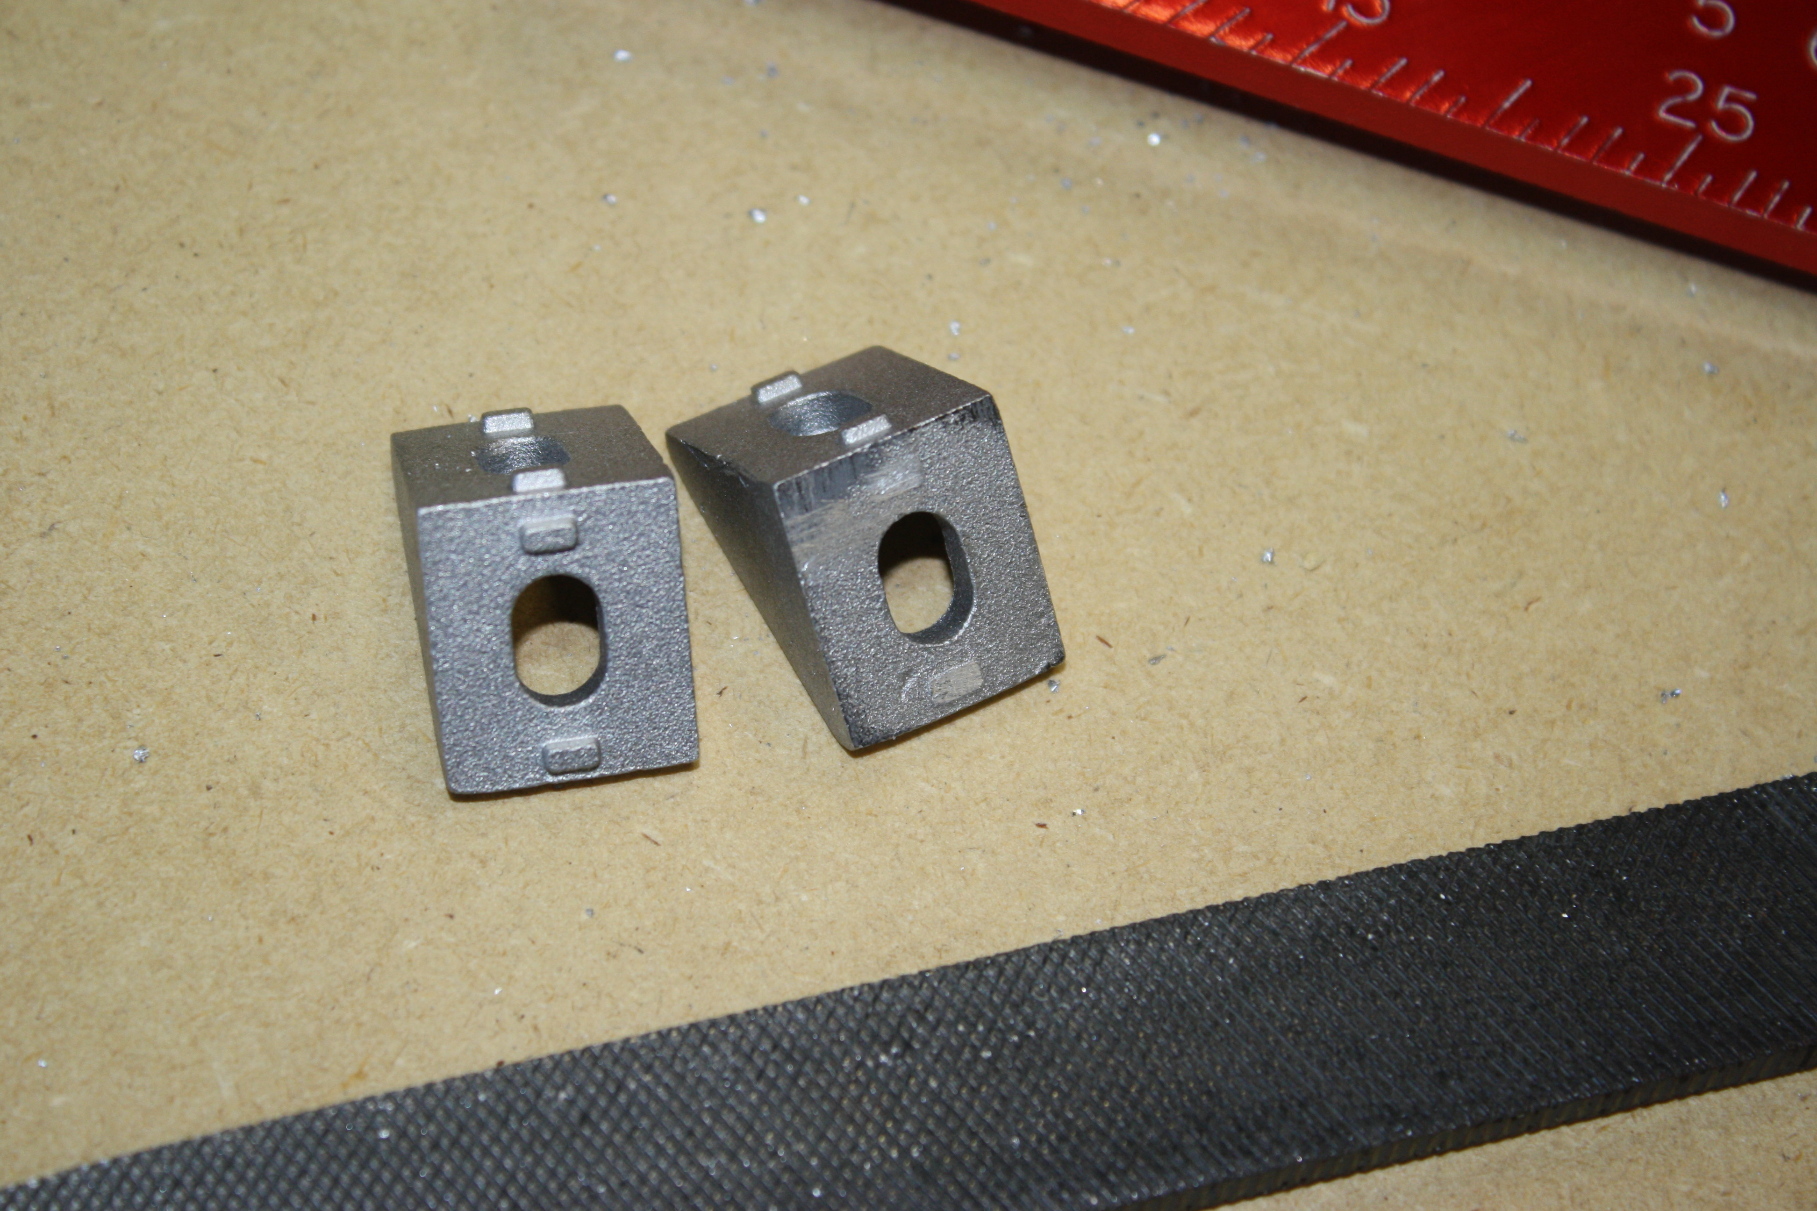
Lay the flat side of the cast 90 (you just filed off the tabs) against the gantry plate and attach it with a M5 nut and M5 x 15mm bolt, do the same for the other side of the gantry.
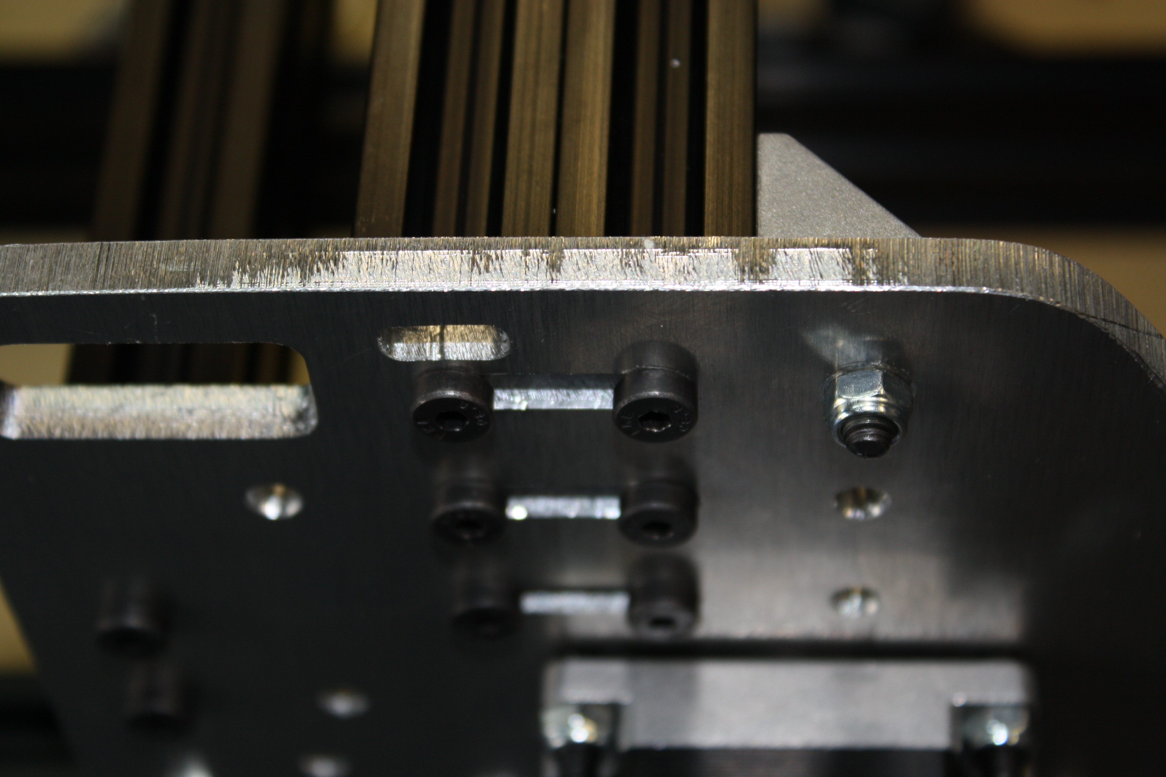
Place the M5 x 8mm bolt in the open hole on the cast 90 and thread and tighten into the T-nut.
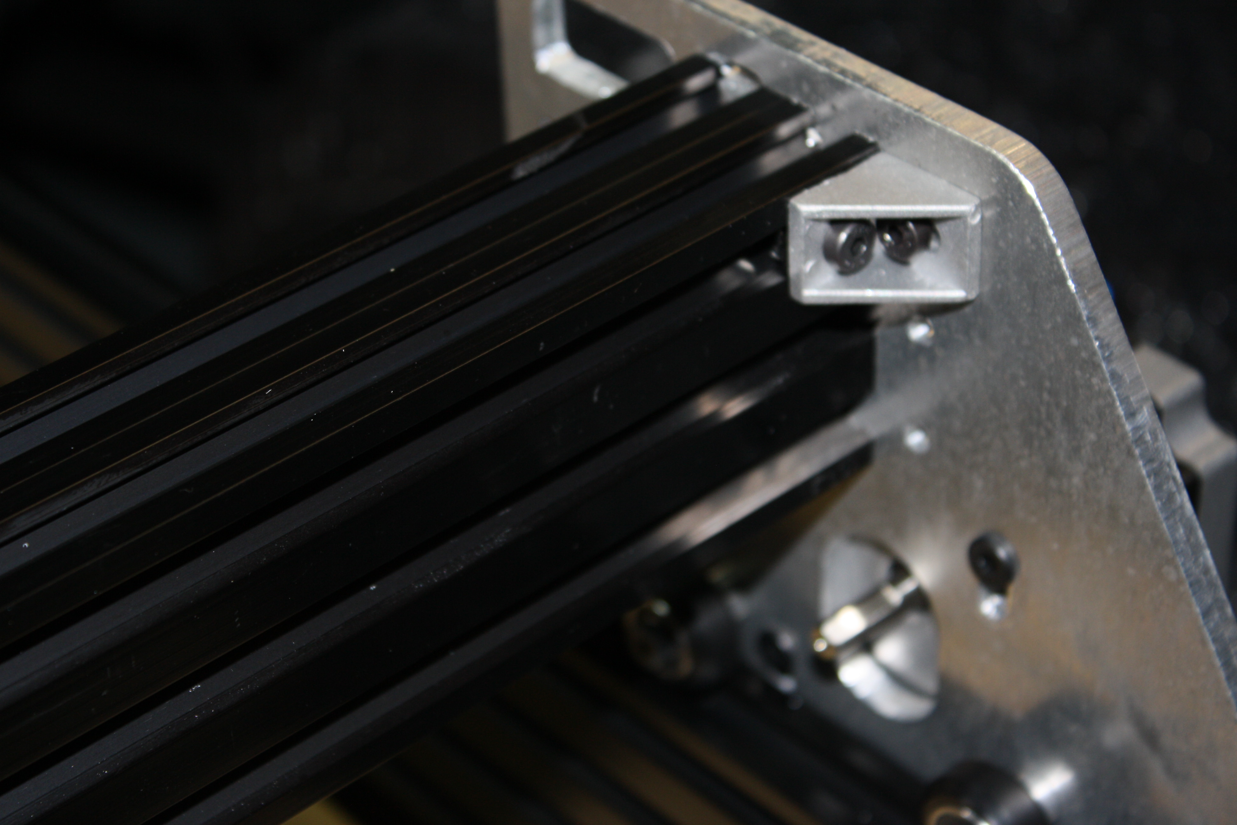
Step Five:
Items required: SMW3D Customer
- 2 X gantry plates
- 14 x wheel kits
- 4 3mm spacers (or 18 x10x5x1mm shims)
- 4 M5 x 65mm bolts
- Optional wheel upgrade
  - + 2 M5 x 65
  - + 2 3mm spacers
  - +4 wheel kits
  - +6 ¼” spacers
- 16 M5 nuts
- 7 eccentric spacers
- 6 LP M5 x 40mm bolts
- 6 LP M5 x 20mm bolts
- 1 ACME nut block
- 2 Nema 17 threaded rod plates
- 2 688 zz bearings
- 2 lock collars
- 1 8” ACME SCREW
- 1 20 x 60 x 180mm
- 1 5mm x 8mm coupling
- 3 M3 x 45 bolts
- 3 1.5” spacers
- 1 Nema 17
- 2 spacer blocks
- 6 M5 x 15mm bolts
- 1 Nema 23

- 11 ¼” spacers
- 4 M5 x 25 bolts
- Optional Nema 23 upgrade:
  - -3 x 1.5” spacer
  - -3 x M3 x 45 bolts
  - -1 x NEMA 17
  - -1 x 5mm 8mm coupler
  - -1 Nema 17 threaded rod plate
  - +1 x 6.35 x 8mm coupler
  - +1 x Nema 23
  - +1 x Nema 23 threaded rod plate
  - +3 x 20mm spacer
  - +3 x 9mm spacers
  - +3 x M x 45 bolts
  - +3 x M5 nuts
Begin by installing the Acme nut on the front gantry plate. Install two M5 nuts in the plastic block and install two LP M5 x 20mm bolts to secure it. Make sure the block is correctly positioned and not off angle with bottom of the plate. The blocks lower surface should be square with the lower surface of the plate. 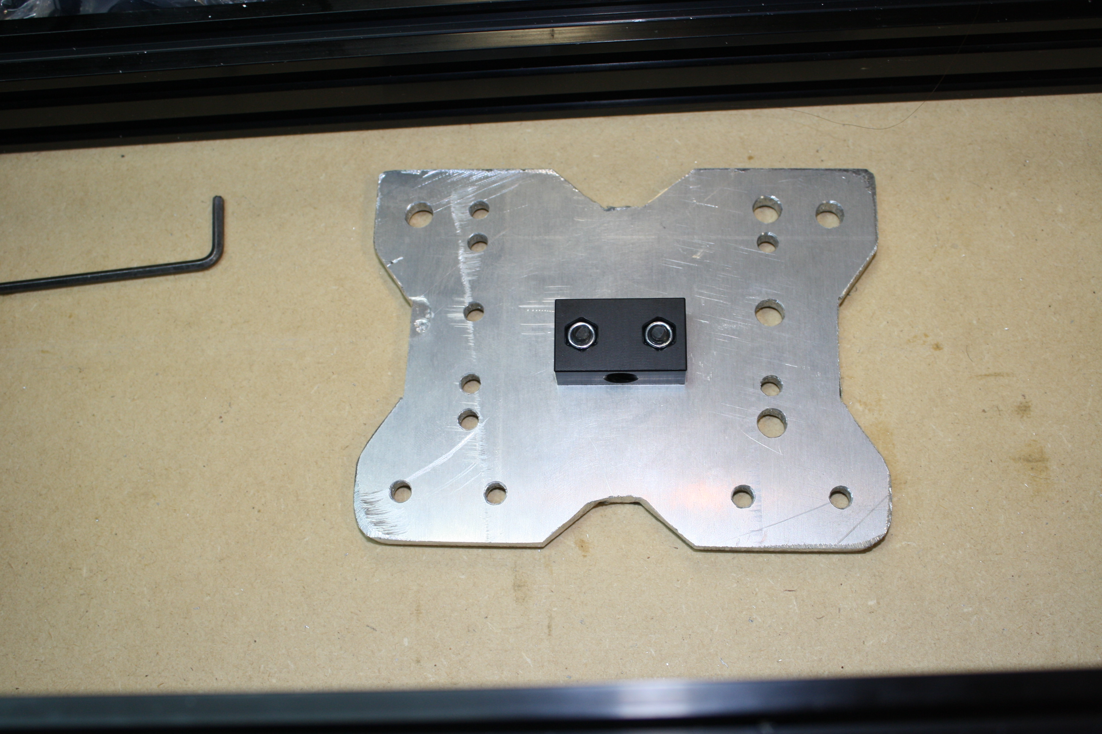
Next install the two spacer blocks with 4 qty LP M5 x 20 bolts. 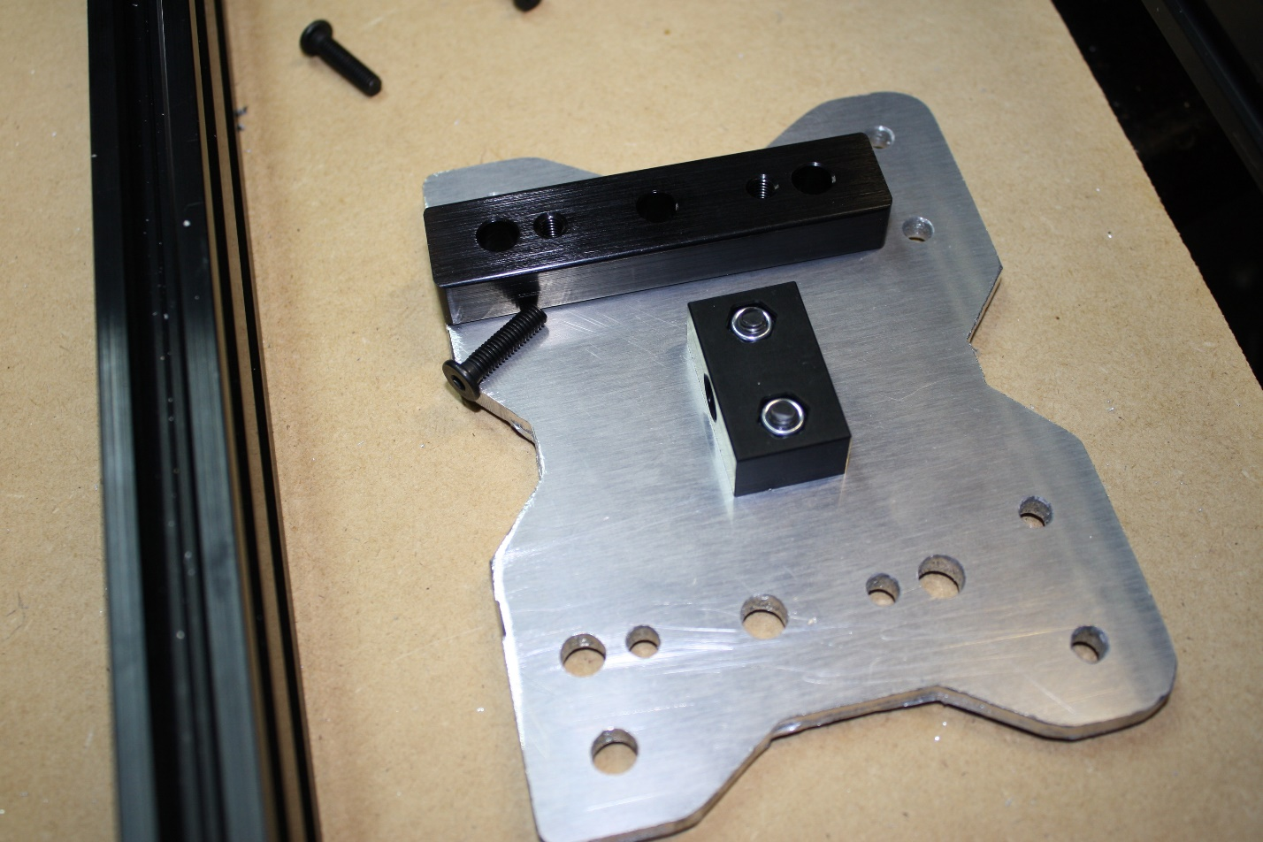
After, we want to install 6 wheel kits into the spacer blocks with M5 x 40mm bolts. Basically install as normal but with 40mm bolts. We want to install the left three wheels with eccentric spacers. The slot in the eccentric spacer should face outwards.
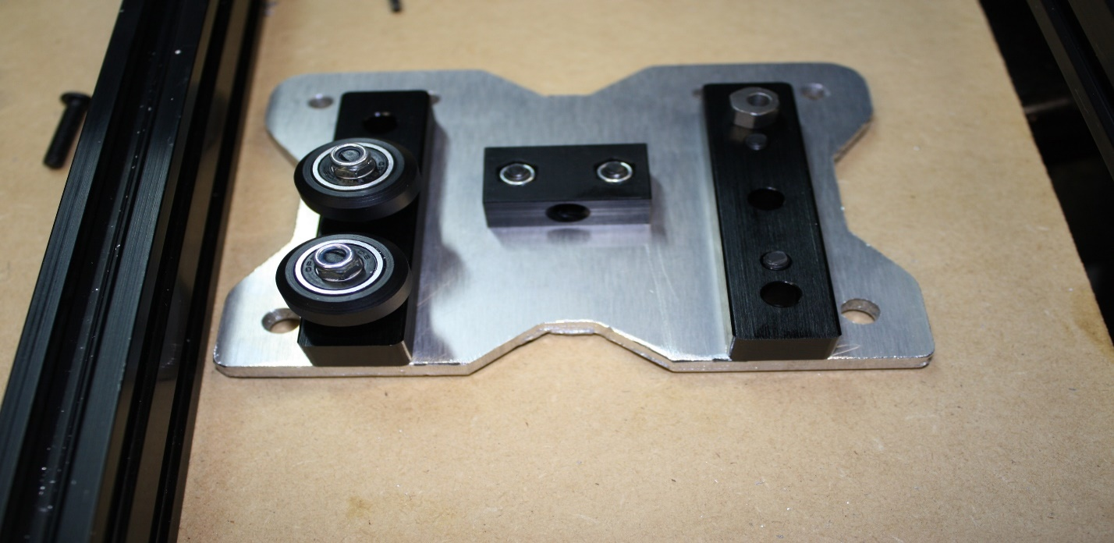
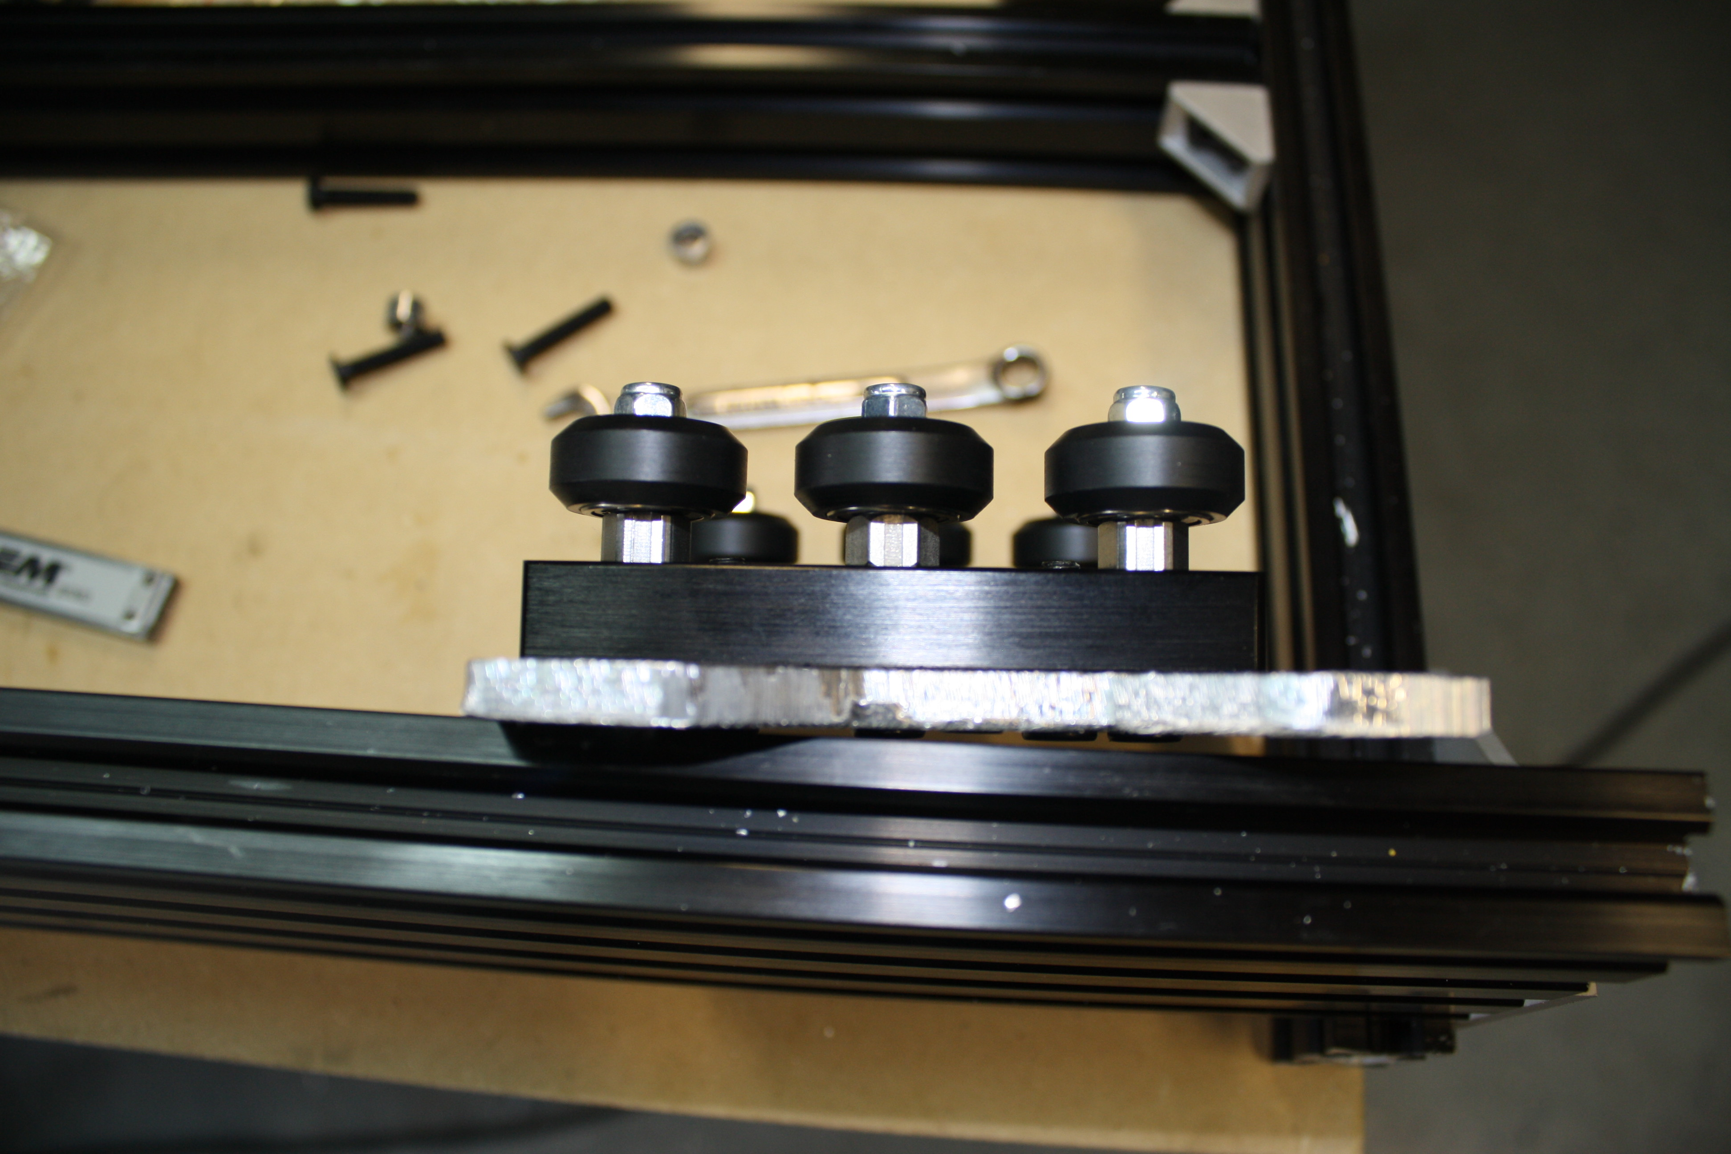
Now install a M5 x 65mm bolt into the front gantry plate. Build a wheel kit. Install the ¼” spacer, the wheel, ¼” spacer, a 3mm spacer, another wheel kit and the ¼” spacer, then the back plate and a nut. Do this for all four top axles on the X gantry. Leave the four M5 nuts loose for now.
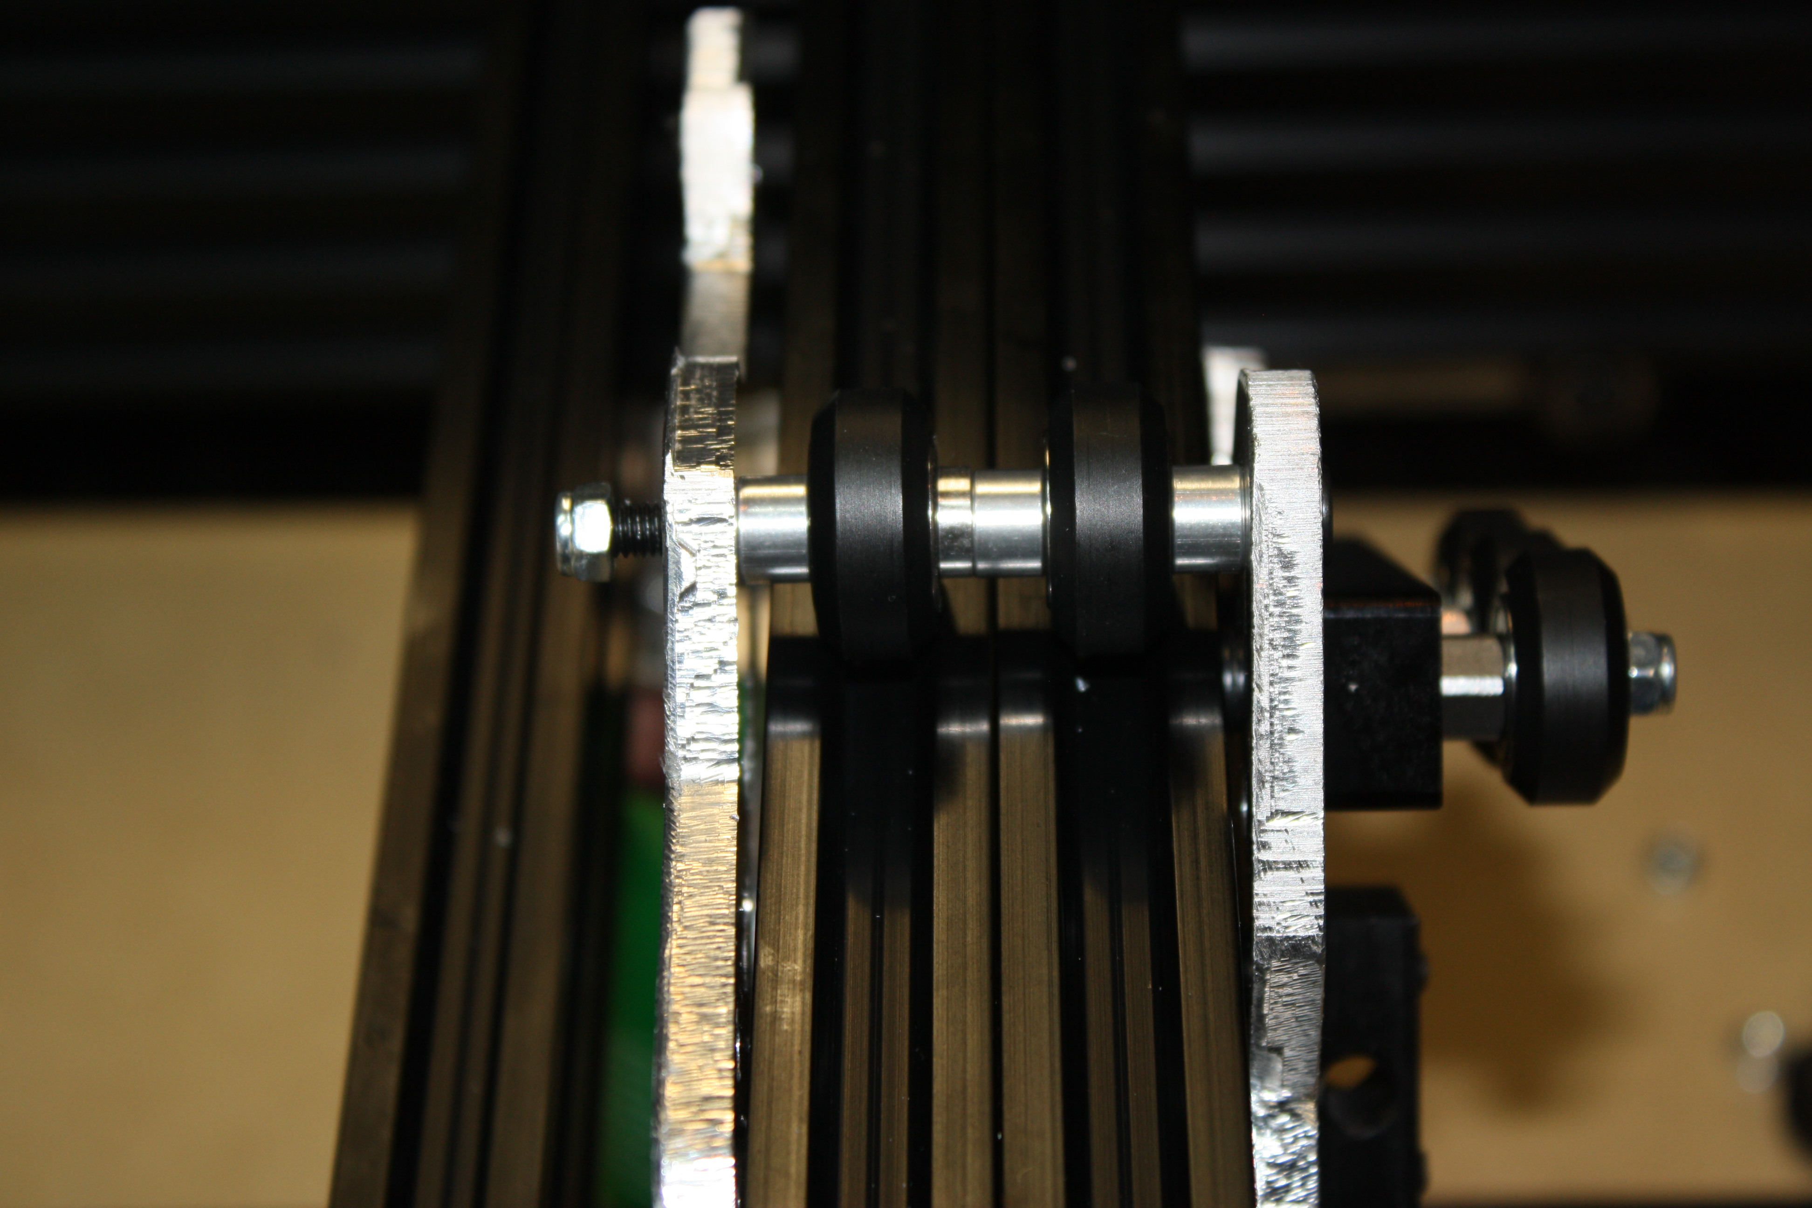
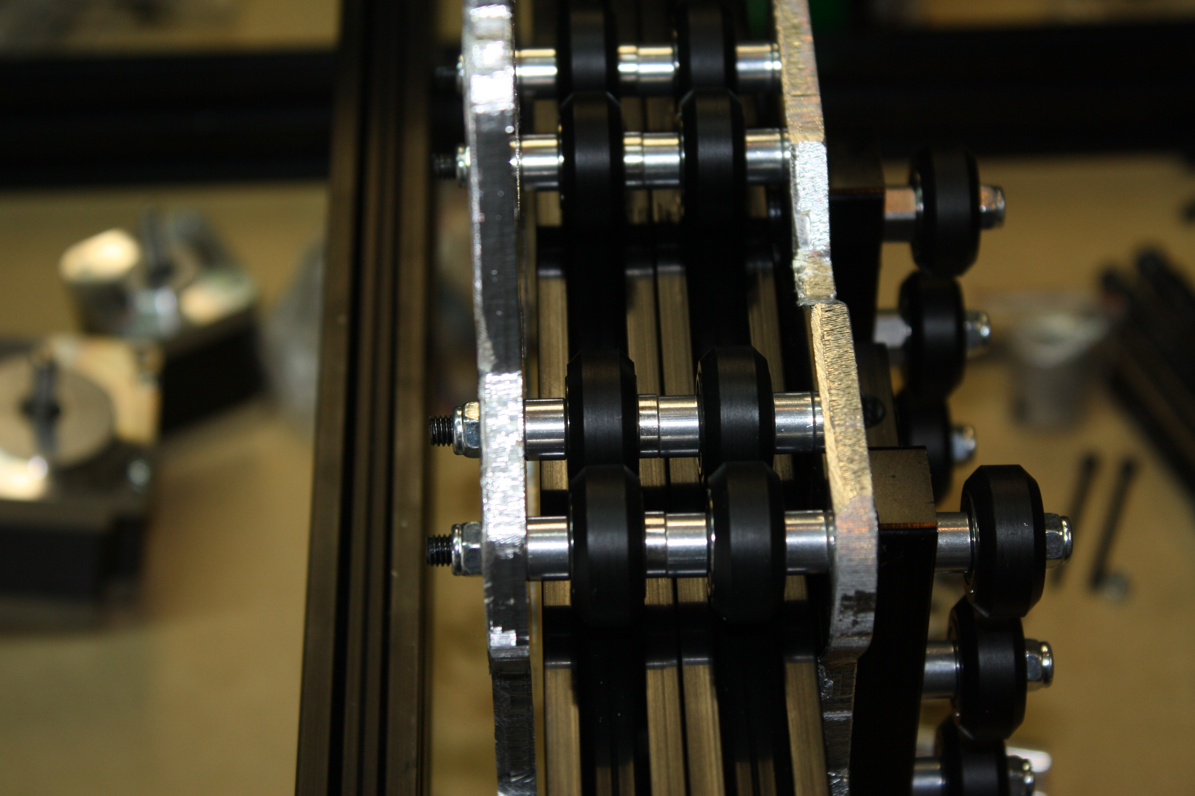
Now install the lower two axles, this time use an eccentric spacer in place of the outside ¼” spacers.
(image shown upside down for viewing ease)
NOTE: The above shown is with the additional gantry axles upgrade. If this option was not chosen, simply install two axles on top and two on bottom.
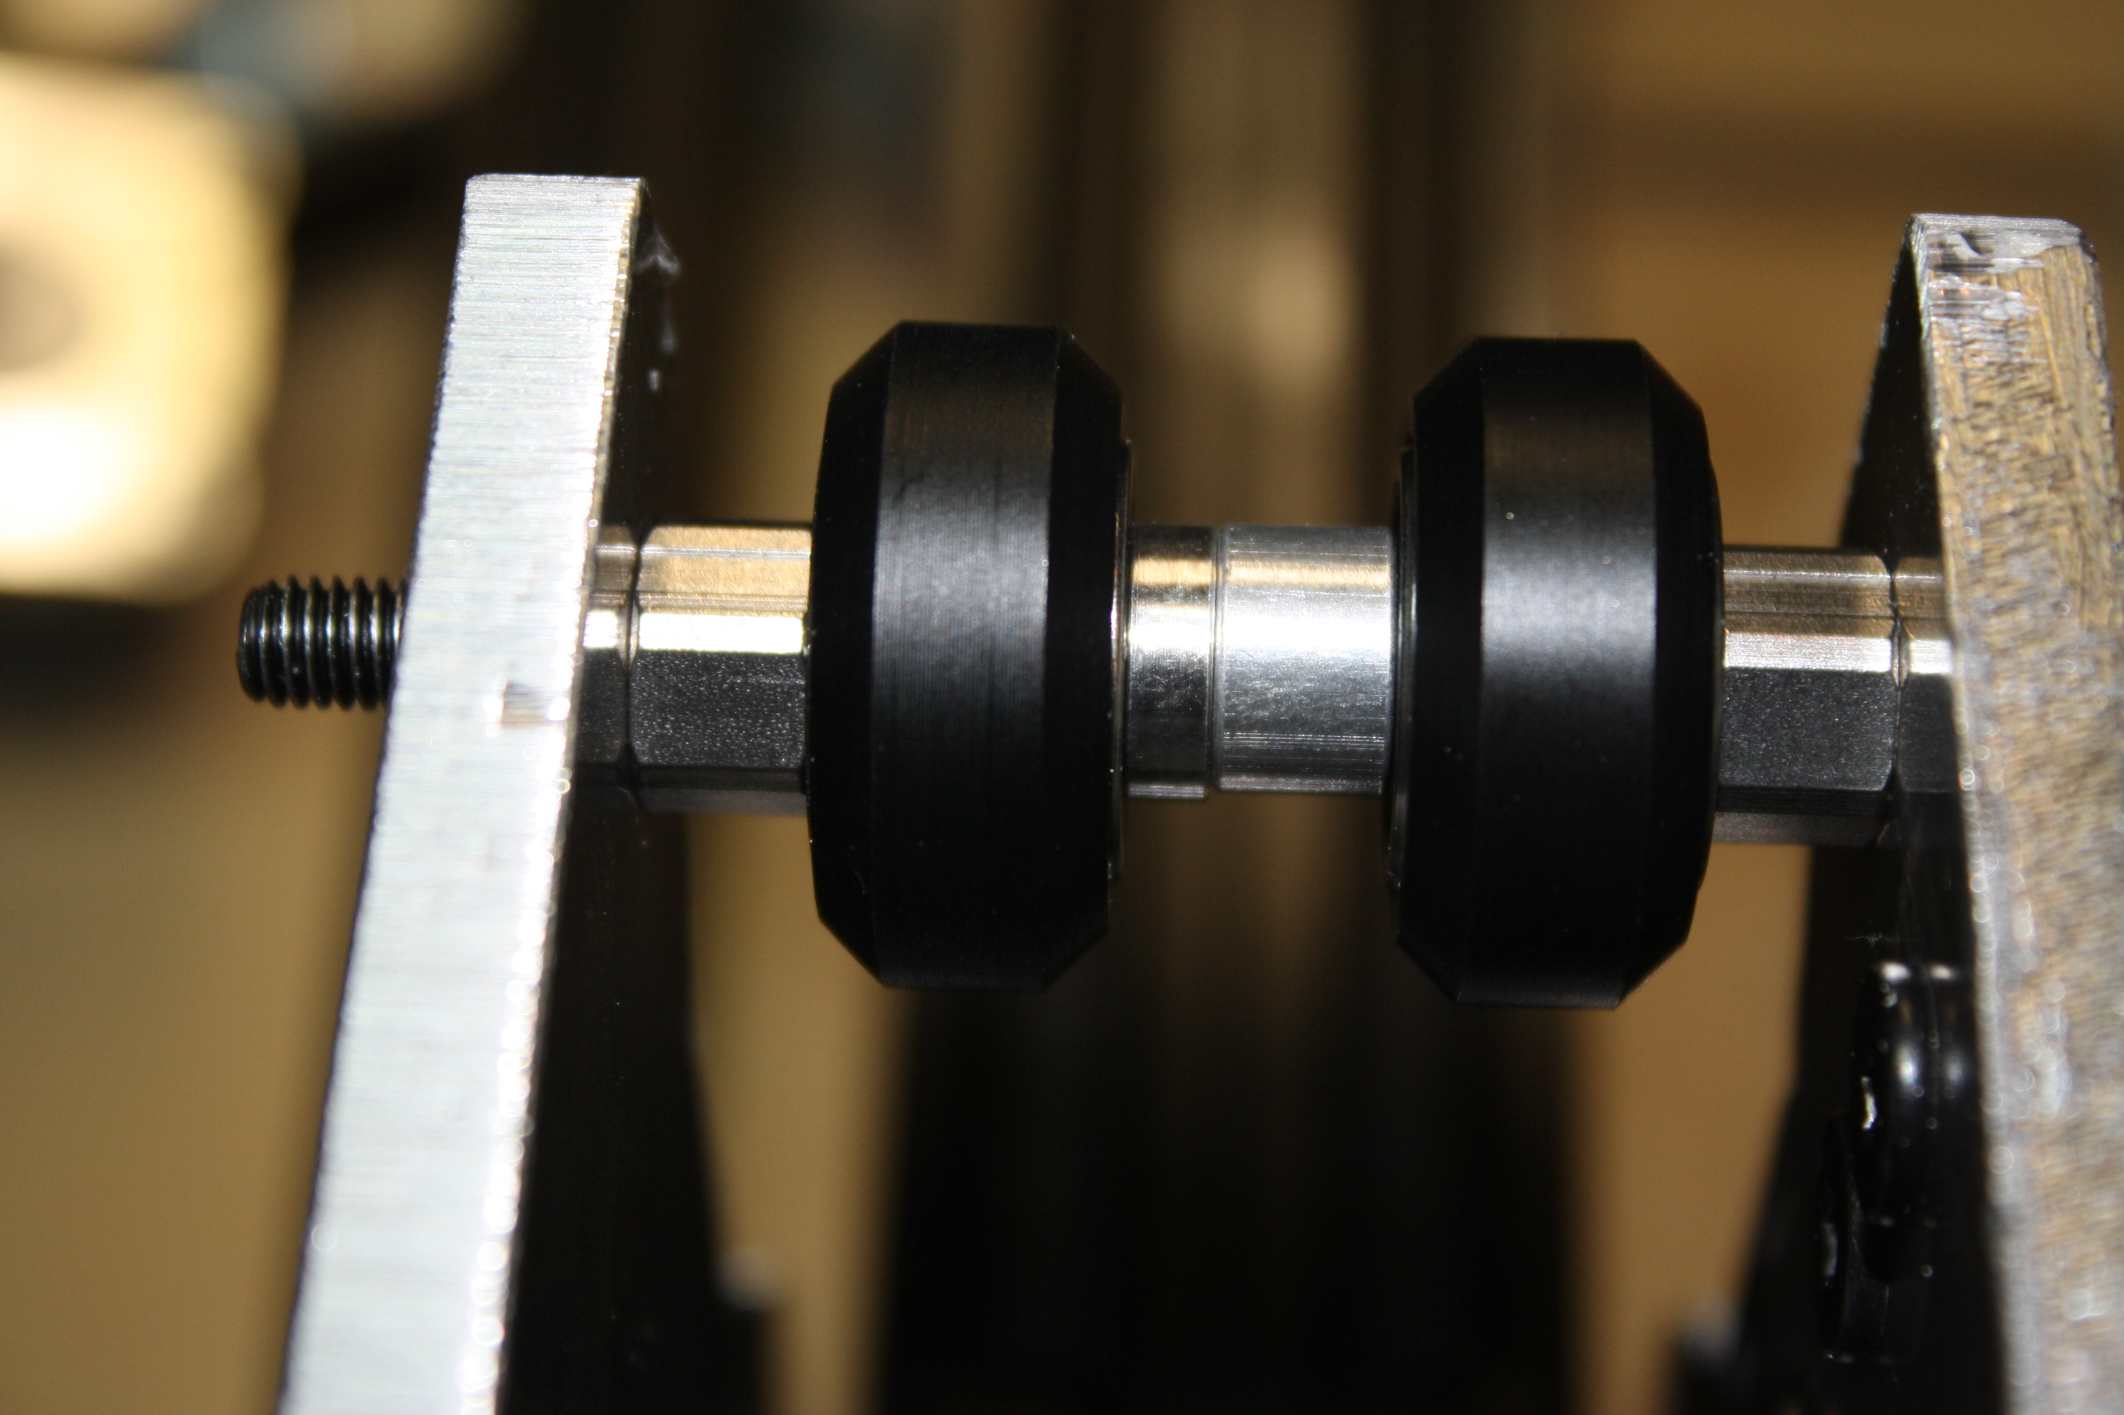
Tighten the eccentric spacers till all four wheels across the top can be turned by hand but have light drag.
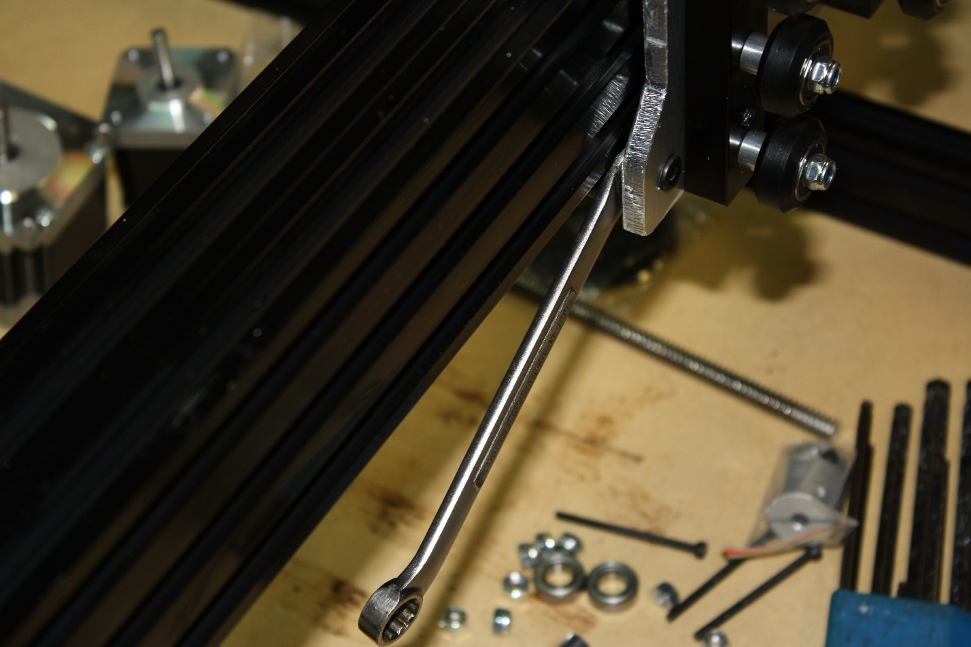
Tighten all M5 nuts.
Next install the Nema 23 motor for the X gantry. Use four M5 x 25 bolts and four M5 nuts. Again, tighten against the motor against the gantry plate. If you use a combination wrench this will be an easy task, otherwise the nuts are slightly hard to grab.
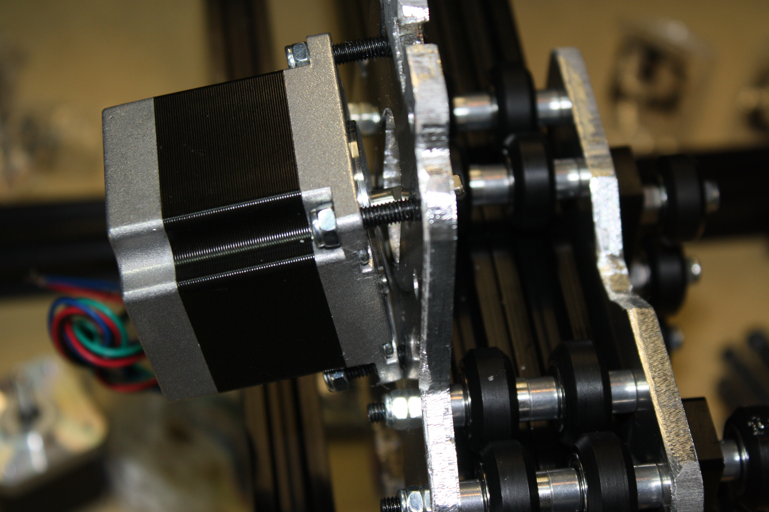
Now tap all 6 holes on the 1 x 20 x 60 x 180mm extrusion. 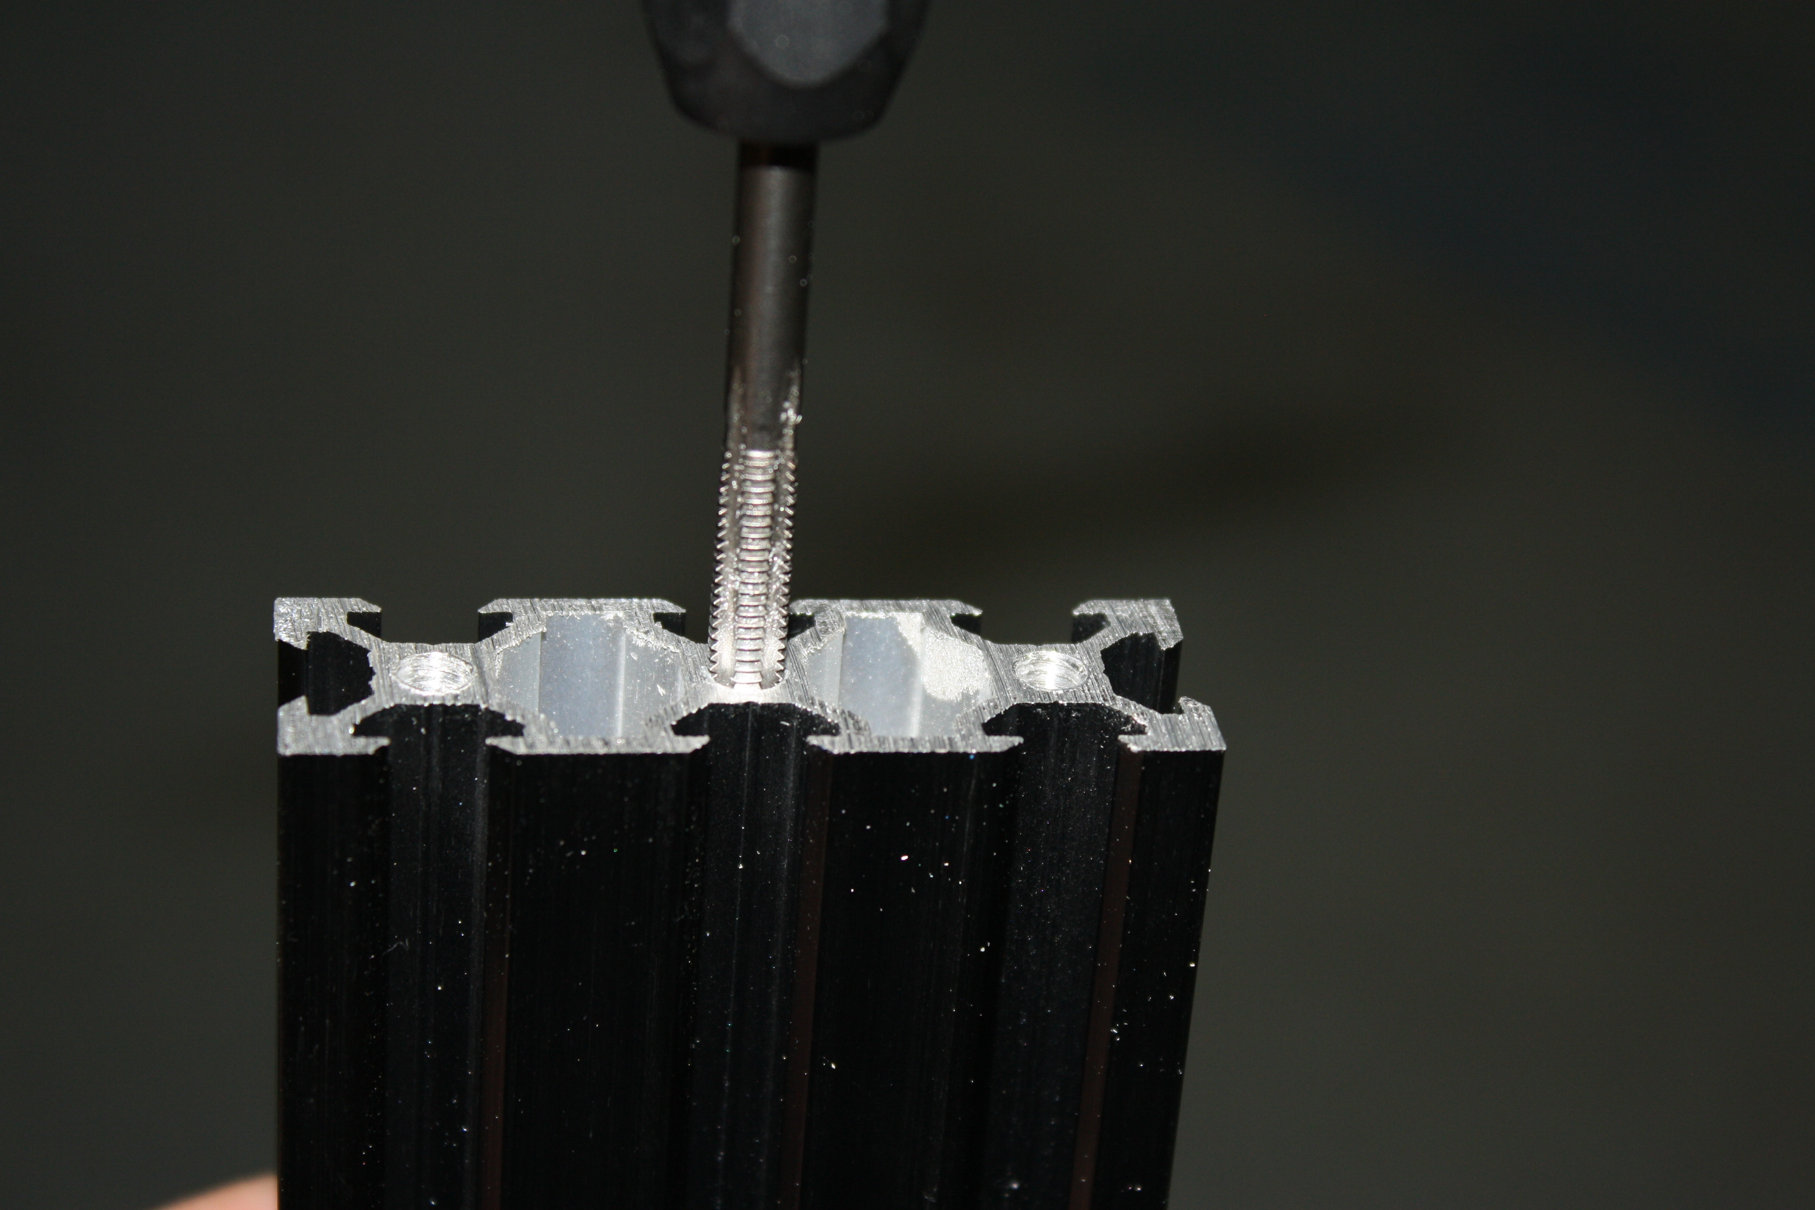
Install a threaded rod plate on one end of the 20 x 60 with three M5 x 10mm bolts. Leave this loose.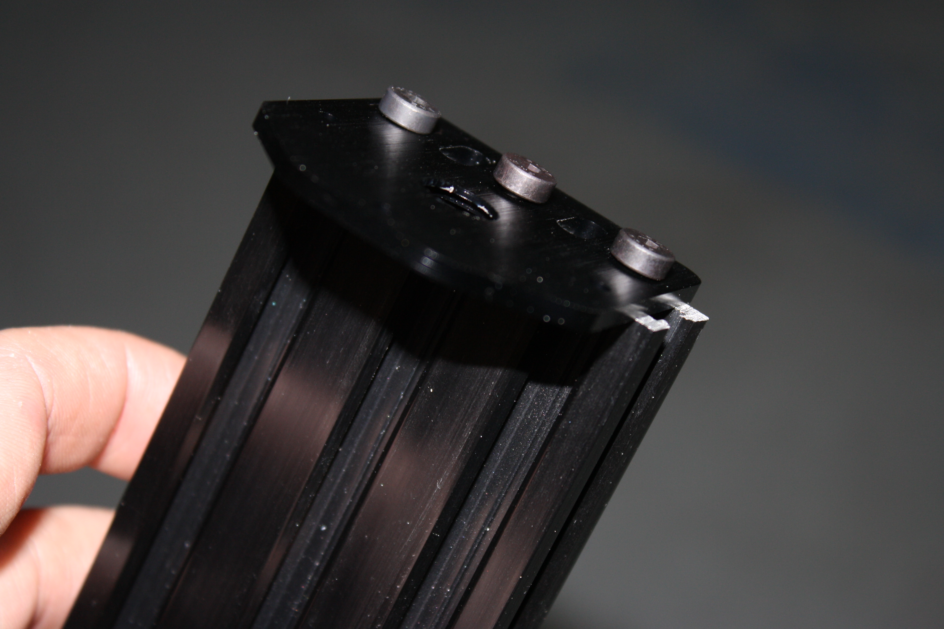
Note there is a recess in the threaded rod plate, this should be where the bearing resides, they should face each other.
Install the coupling on the Nema 17.
Install the Nema 17 on the plate with three 1.5” spacers and M3 x 45 bolts. 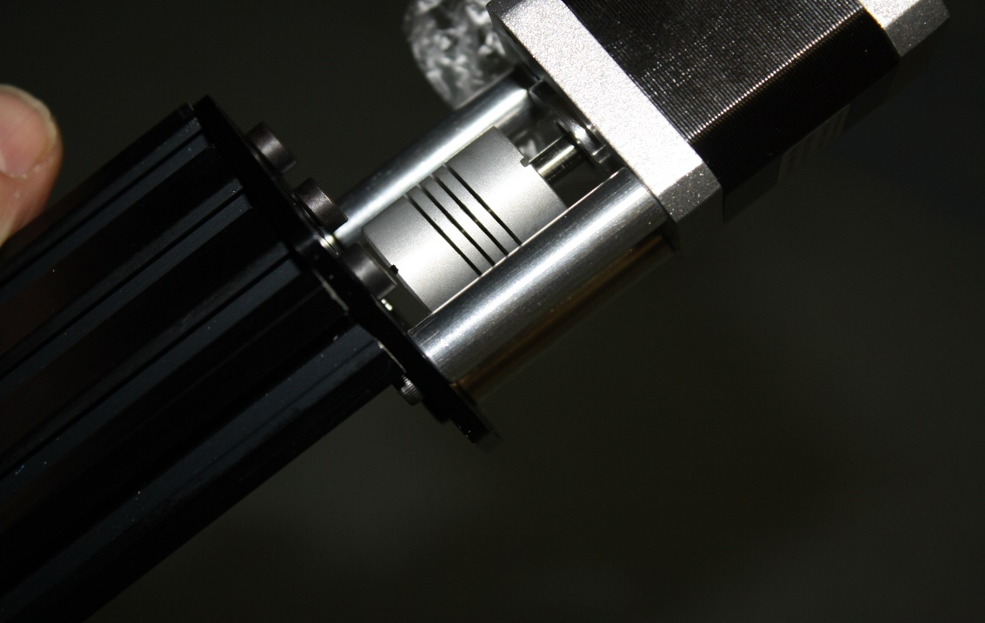
Install a lock collar on the ACME.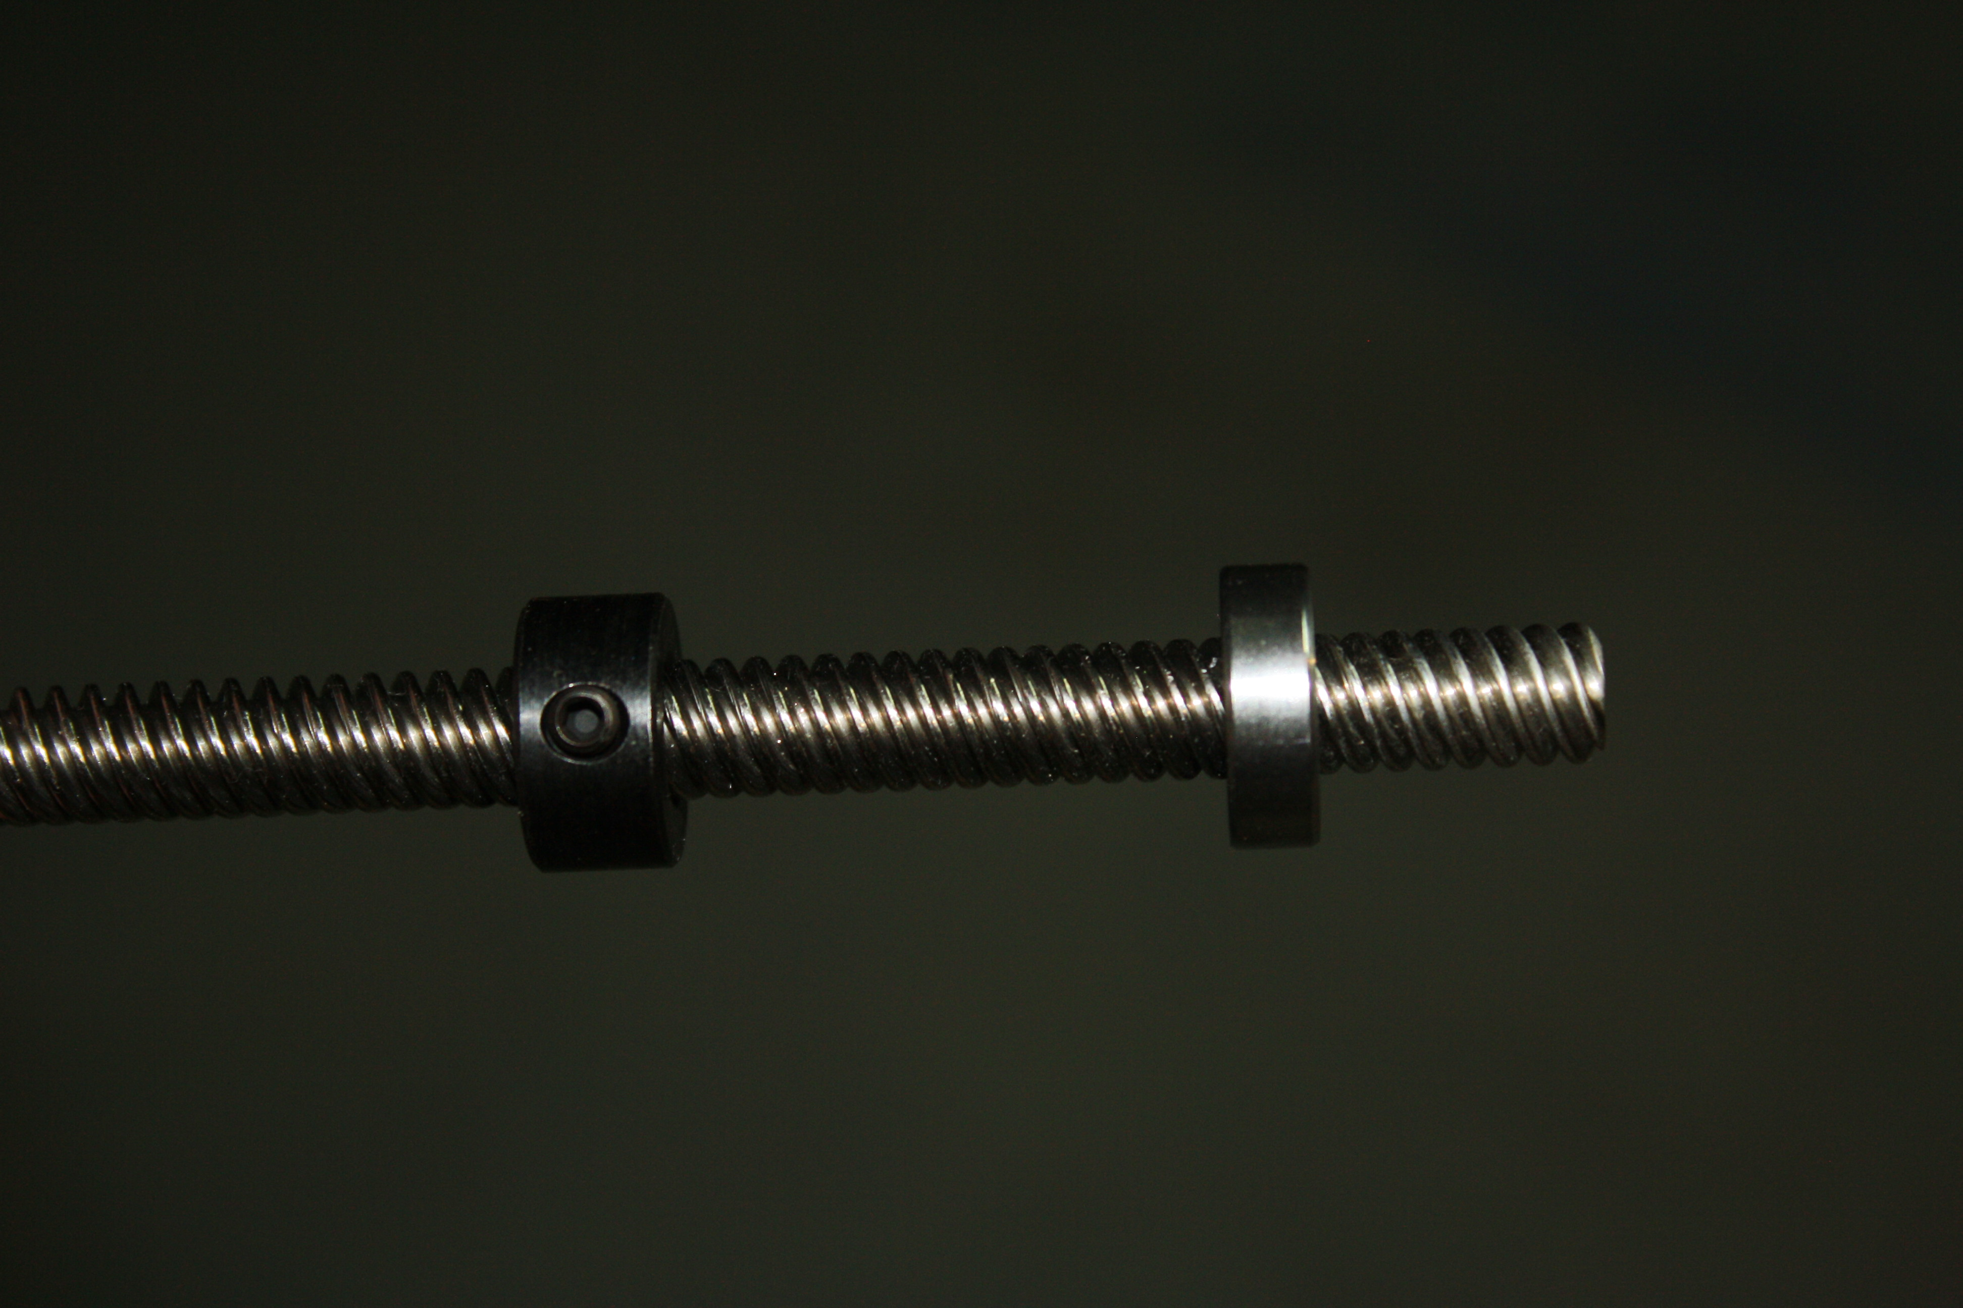
Install a bearing on the ACME.
Install the ACME screw in the coupling. 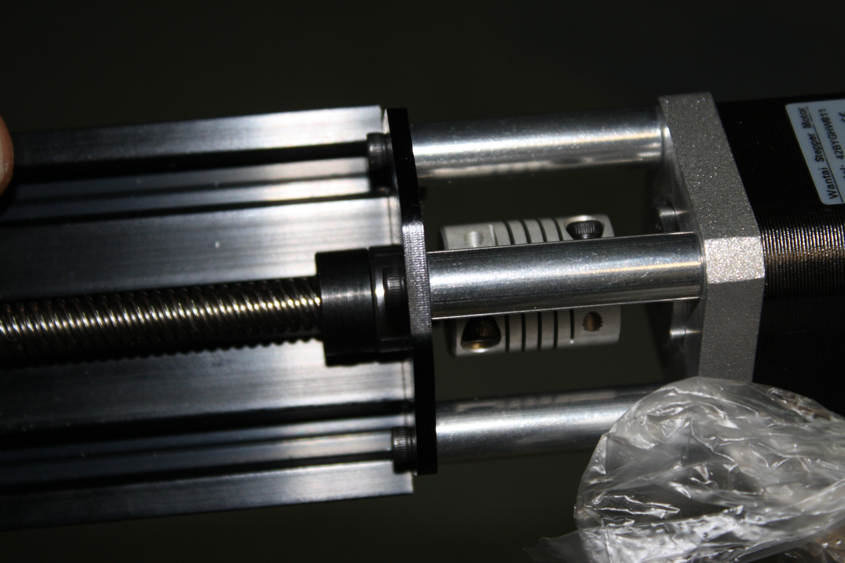Tighten the lock collar.
Now thread the ACME screw and assembly into the ACME nut block and thread it through using the coupling to turn it.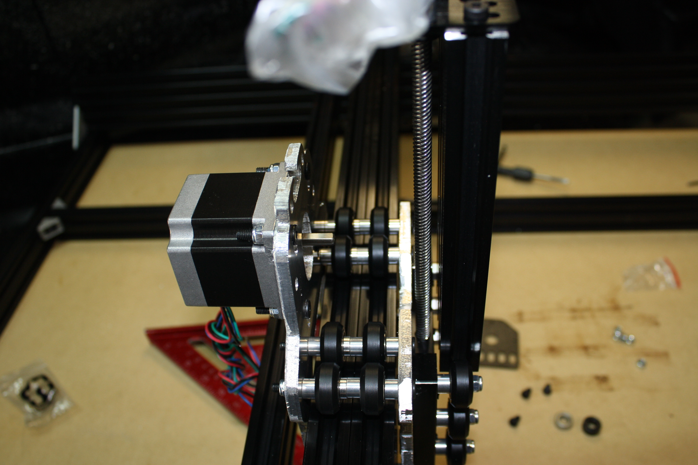
Once the lower ACME thread protrudes through the ACME block install a lock collar, bearing, and the lower plate. Push the bearing and lock collar all the way down into the lower recess in the threaded rod plate. Make sure there is now no play in the Z axis up or down.

Now tighten the 6 screws holding the threaded rod plate onto the 20 x60x 180.
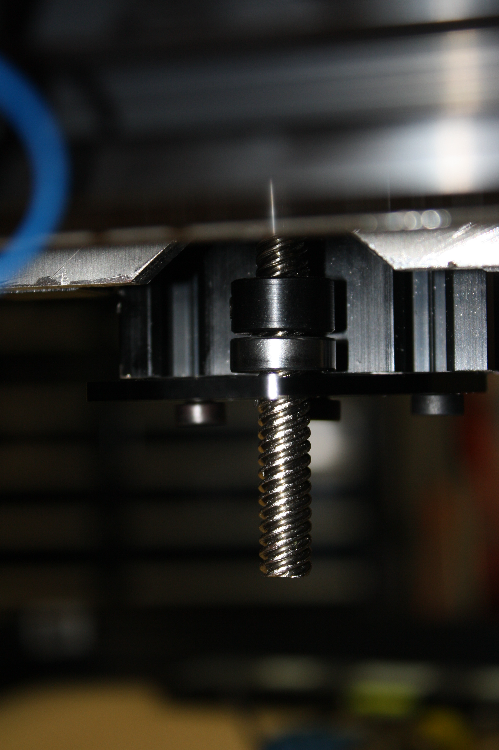
Make sure the lock collar and the bearing are pushed all the way against the threaded rod plates and tighten the lock collar to hold everything in place.
Next, tighten the three eccentric spacers on the Z gantry. Be cautious not to over tighten these. There should be no play on 20 x60x180mm Z axis, but it should be able to move freely up and down by turning the ACME screw. A good rule of thumb is you should be able to turn the wheel by hand with a small amount of resistance. 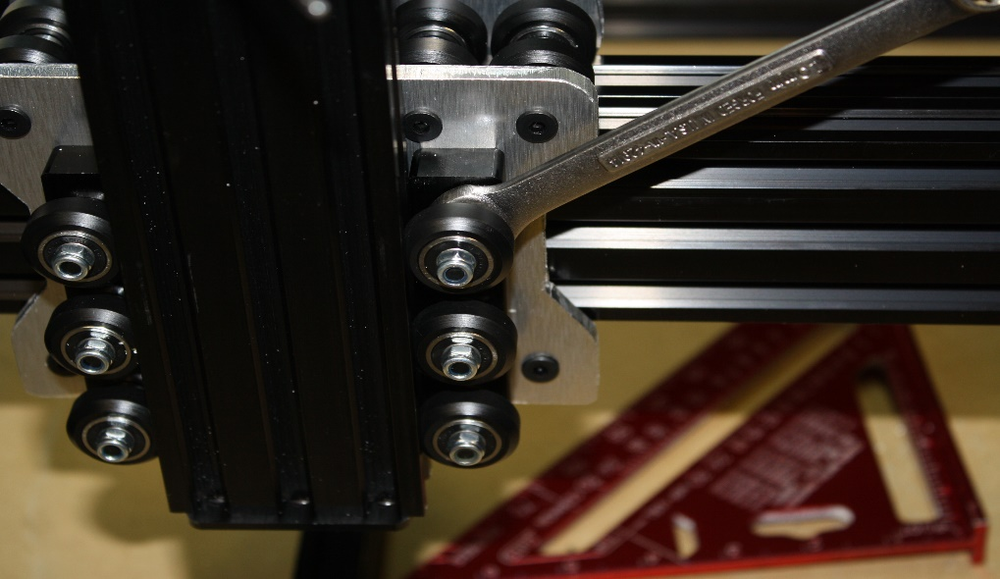

Note:
If you chose the NEMA 23 upgrade, install the NEMA 23 threaded rod plate on the top of the 20 x 60 Z axis. Install the 6.35mm x 8mm coupler. Install the 20mm and place on top of it the 9mm spacer then the NEMA 23. Run the M5 x45 bolt through the motor both spacers and the plate. Tighten all this down with a M5 nut. Repeat three times as shown above with the M3 x 45 bolts.
Step six:
Items required small format: SMW3D Customer
- 4 T-nuts
- 2 drop-in T-nuts
- 6 M5 x 8mm bolts
- 2 x 780mm GT belt
- 1 x 650mm GT belt
- 3 x GT pulleys with 6.35mm bore
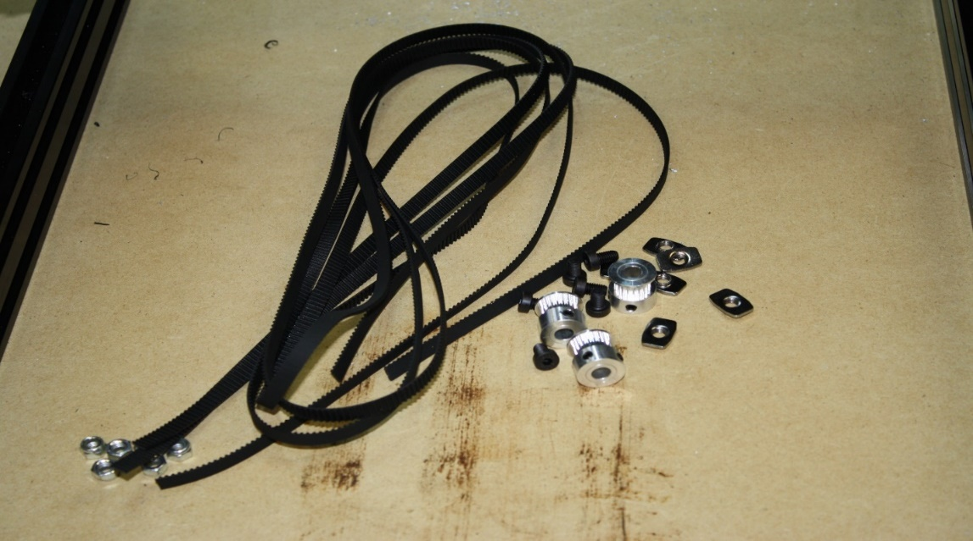
Begin by installing all three pulleys on the Nema 23 motors, aligning them perfectly with the slot in the V-slot.
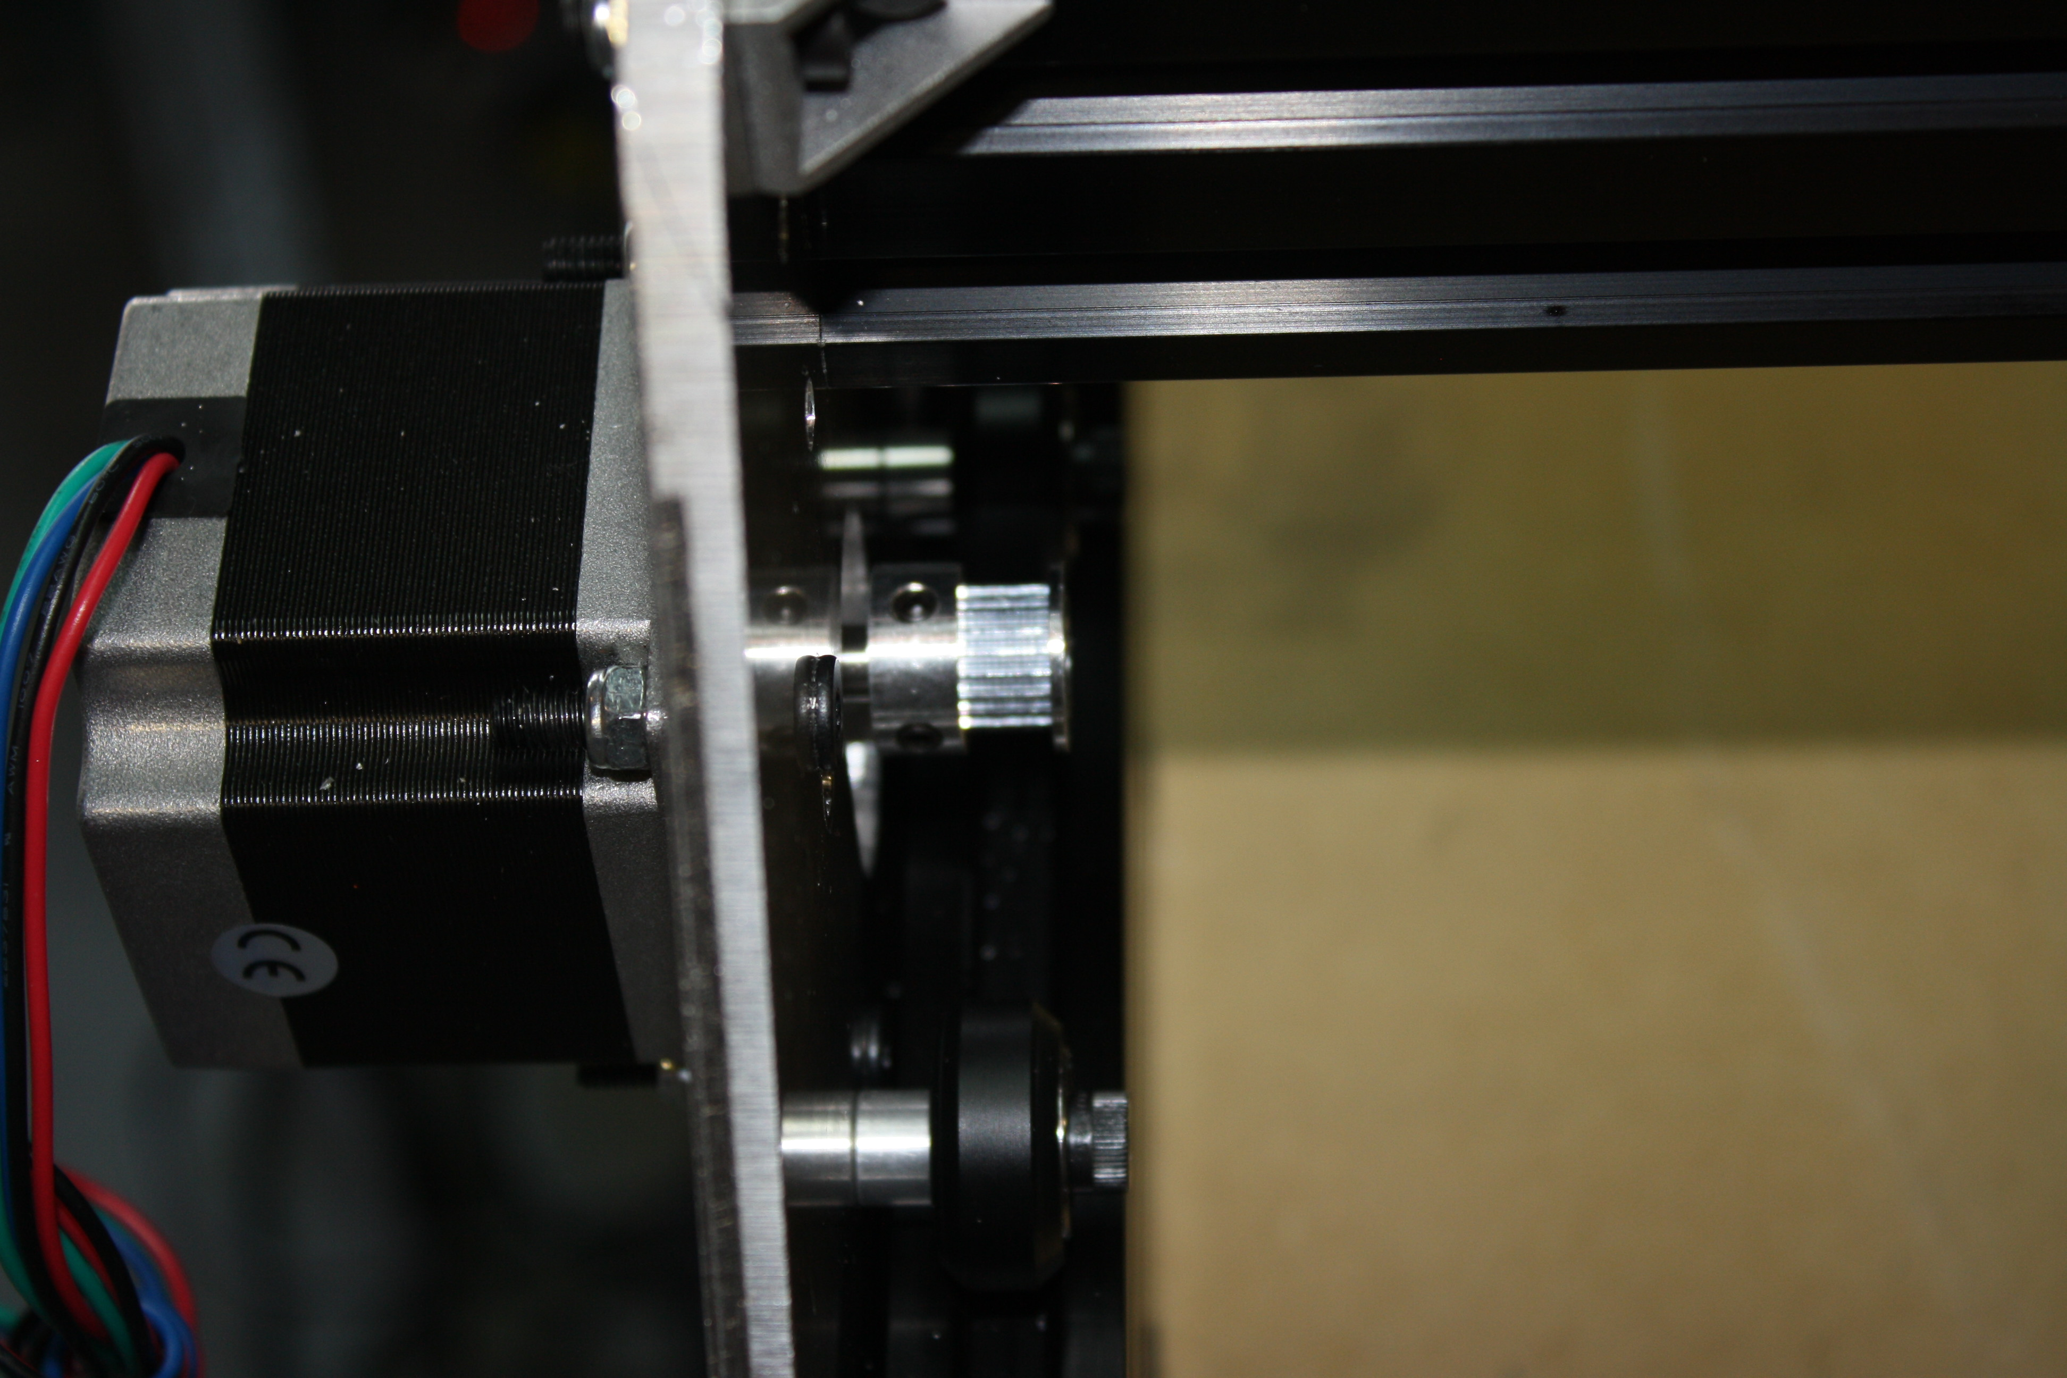
On all three pulleys, route the GT belt over the pulley and under the wheels.
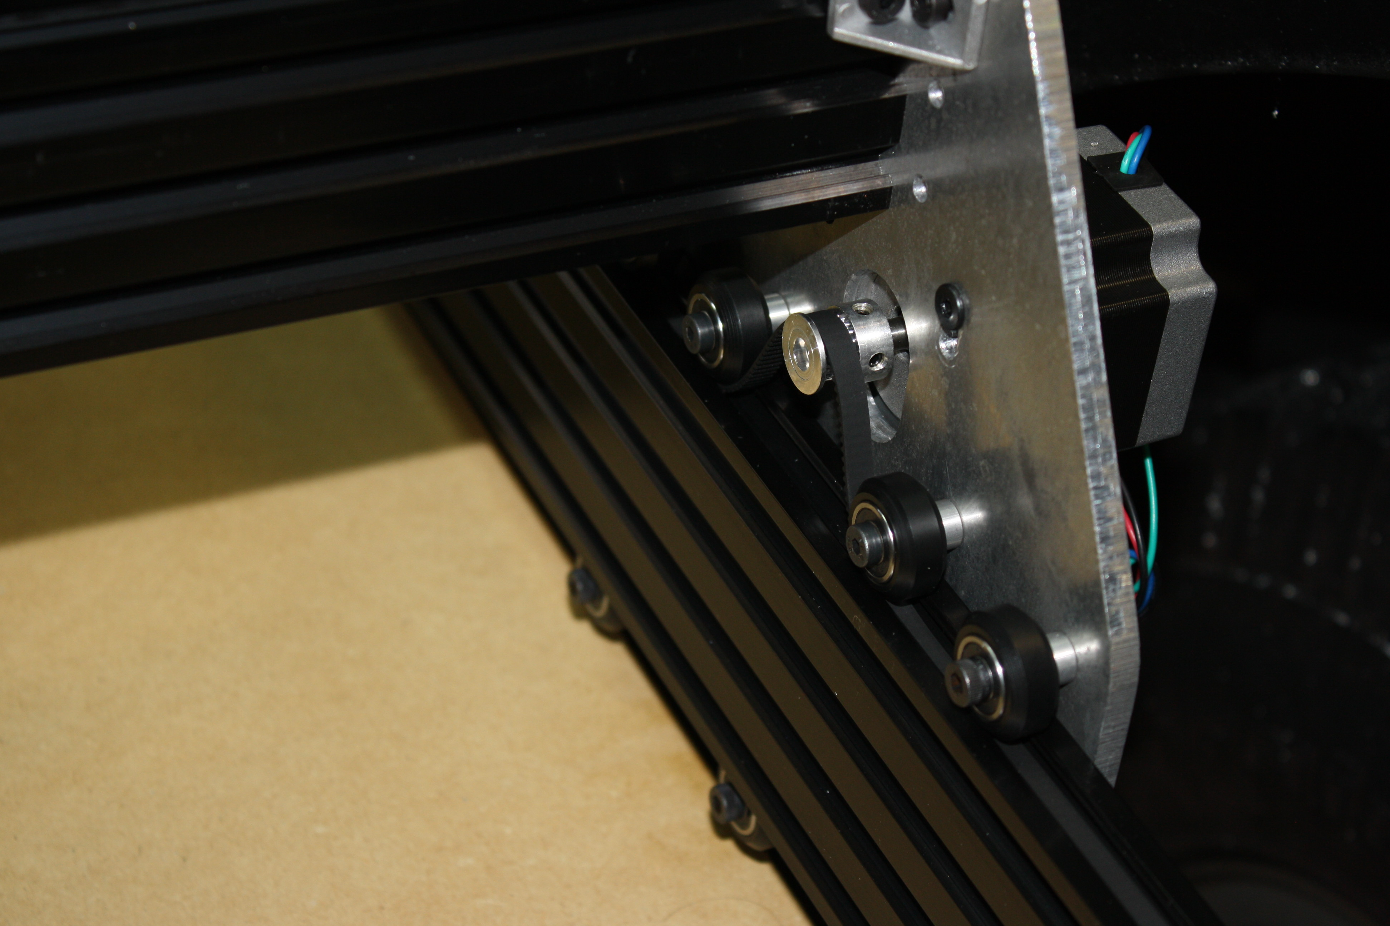
Slide a T-nut in the end of each axis, over the belt and tighten the M5 x 8mm on one end.
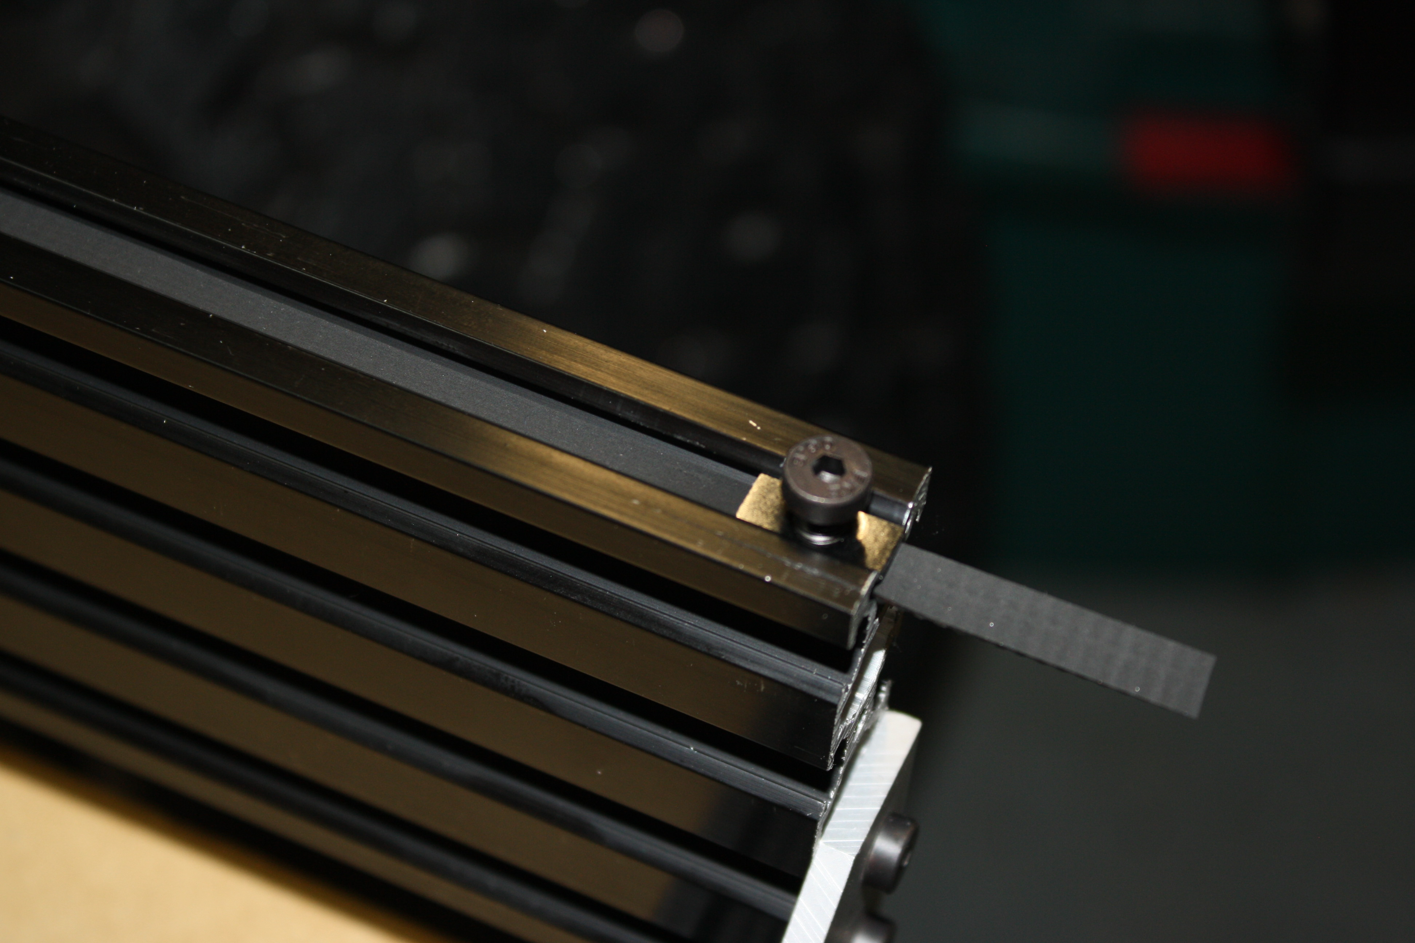
On the opposite end, pull the belt extremely tight and tighten the M5 x 8mm bolt.
Preform the same task on all three belt drives. The X axis will use the two drop in T-nuts.
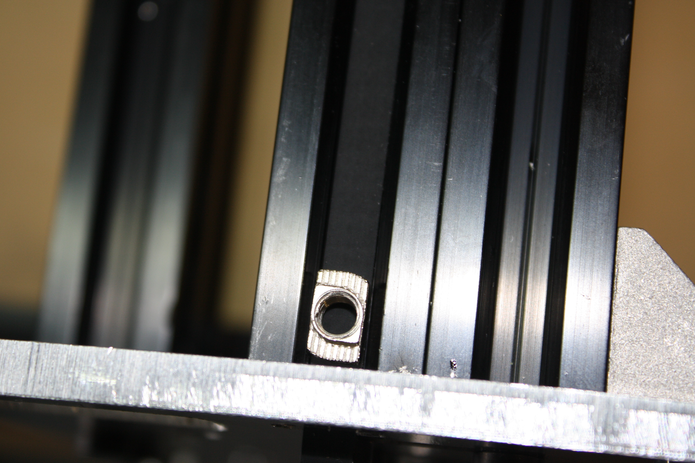
NOTE: If you are using the GT3 belt upgrade you may have to use file to thin the drop in T-nuts to allow room for the belt to slide under them.
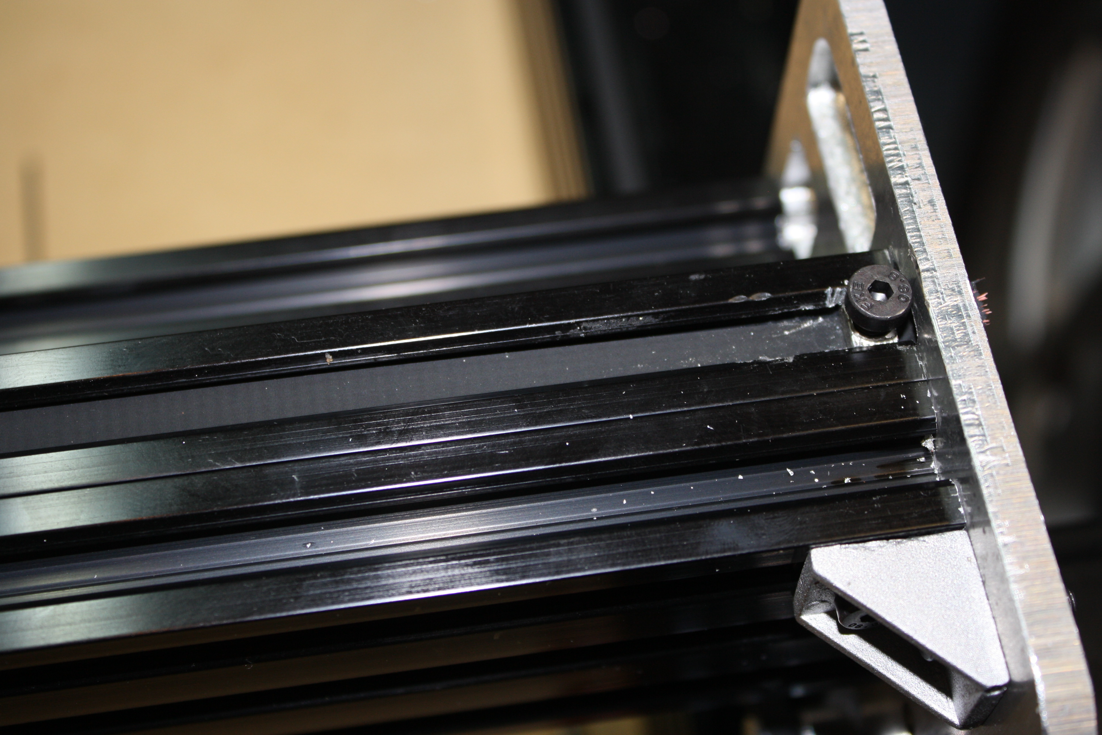
This can be a difficult step but take time to ensure the belts are tight but not so tight the axis can’t move freely. Make sure once installed the pulleys are aligned perfectly with the belts and the slots in the v-slot.
Step seven:
Install spoiler board.
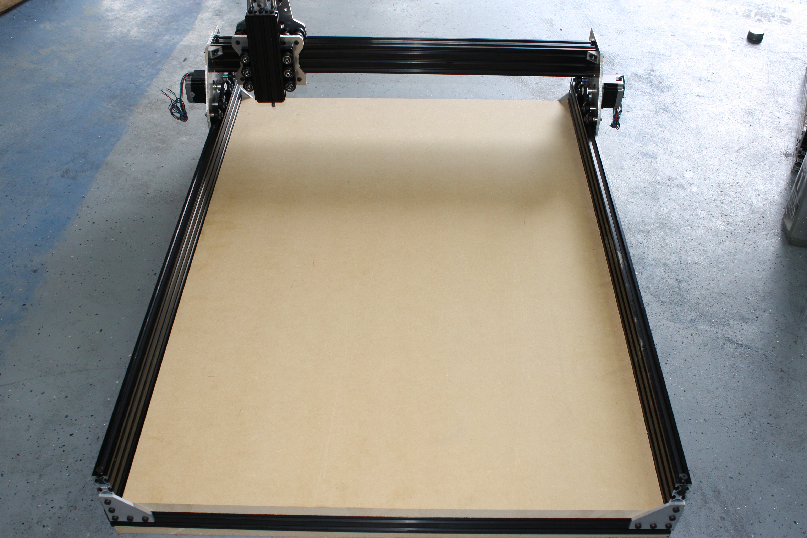
Measure the inside of the frame and have your local home improvement store cut this to length. Do not force it in. Do not force it in. If it is too large trim it. Forcing the spoiler board will knock the entire system out of square.
Step eight:
Items required: SMW3D Customer
- Spindle motor
- Wire for motors
- Heat shrink tubing
- Power supply
- Power supply cable
- Optional Spindle upgrade power supply
- Optional wire sheathing
- Speed control
- 2 Clamp
- 4 cast 90s
- 4 T-nuts
- 4 M5 x 10mm screws
- Fan for cooling control board
- Two lead wire for spindle
- Upgrade TinyG
- Upgrade X gantry cable chain
  - Cable chain
  - 20mm spacer
  - M5 x 35mm bolt
  - M5 nut
  - 2 x M4 x 20mm bolts
- Upgrade Z touch sensor
- Upgrade E-stop button
Tools required:
Soldering iron
Steps:
These steps will not include much detail as they will be dependent on which controller you use.
Extend the leads on all stepper motors to your controller. Use the provided heat shrink tubing and 4 lead wire to run the stepper motors to your controller.
Wire the power supply to your controller and spindle. If you chose the spindle upgrade. Take the power cable for the power supply and trim about 4” off of it. Strip both ends and chain the two power supplies input cable together. Shown here:
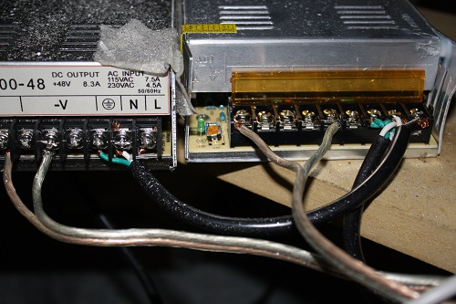

The 24V power supply goes to your controller… WATCH POLLARITY!
The 48V power supply goes to the spindle speed control and from the speed control to the spindle.
The spindle mount is what is referred to as the “quick and dirty” method. Visit the Openbuild’s build page and under the OX build there will be a quick set of instructions on how to perform this task. As shown here:
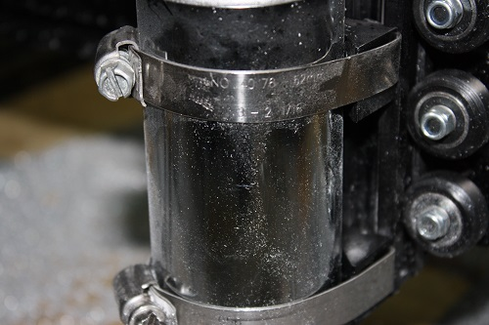
If you chose the TinyG please follow the directions on the outside of the package to take you very informative websites on how to set everything up. Your motors are 1.8 degree steppers, the pulleys are 20 tooth, and this should be all you need to get the correct steps/mm for the x and y.
The Z axis endstop can be seen on the SMW3D website where we give a good description of its use.
The E-stop button should be installed between the 24V power supply and the controller. When pressed this should stop all motion of the gantry motors. The spindle will remain turning but will stop moving therefor saving your work piece.
Simply take the ground or power wire and cut it. Run one end into one side of the kill switch and the other out of the same leg on the E-stop button. One side of the E-stop button is fully connected when pressed, the other is fully connected till pressed. Do not connect the power supply for the spindle and the controller together, this will send 48V to the controller and destroy it.
The X gantry cable chain is to be installed on top of the 20 x 40 rear brace. You will need to drill and tap a hole into the top slot of the 20 x 40 and install the M4 bolt through the hole on the end of the cable chain. This is done using and M4 x .7mm tap.
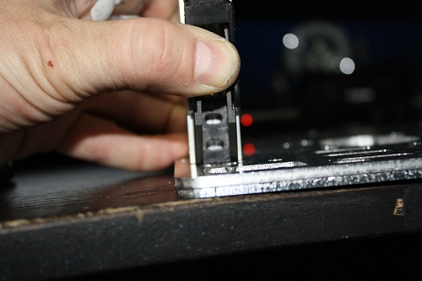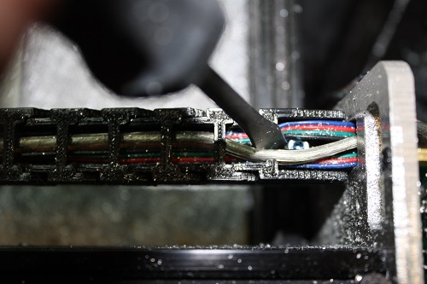
The other end of the cable chain goes to the hole above the Nema 23 on the X gantry rear plate. You will need to drill a hole in the side of the end of the cable chain:
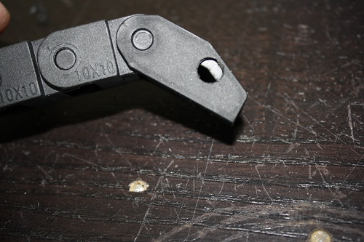
The install the spacer, bolt and nut. Then run all cables through your chain.
Congratulations! Your OX is now complete and you are ready to configure your controller and start cutting! SMW3D appreciates your business and looks forward to helping you achieve all your build goals!

