Thank you for purchasing the Hobby-Fab OX kit. The below instructions will assist you in building the kit. Each step begins with a BOM, then goes down through that step. If something looks confusing, or a term doesn’t make sense scroll a few photos up or down where you are stuck, you will most likely quickly understand.
Step one will be the Z axis.
Z-axis:
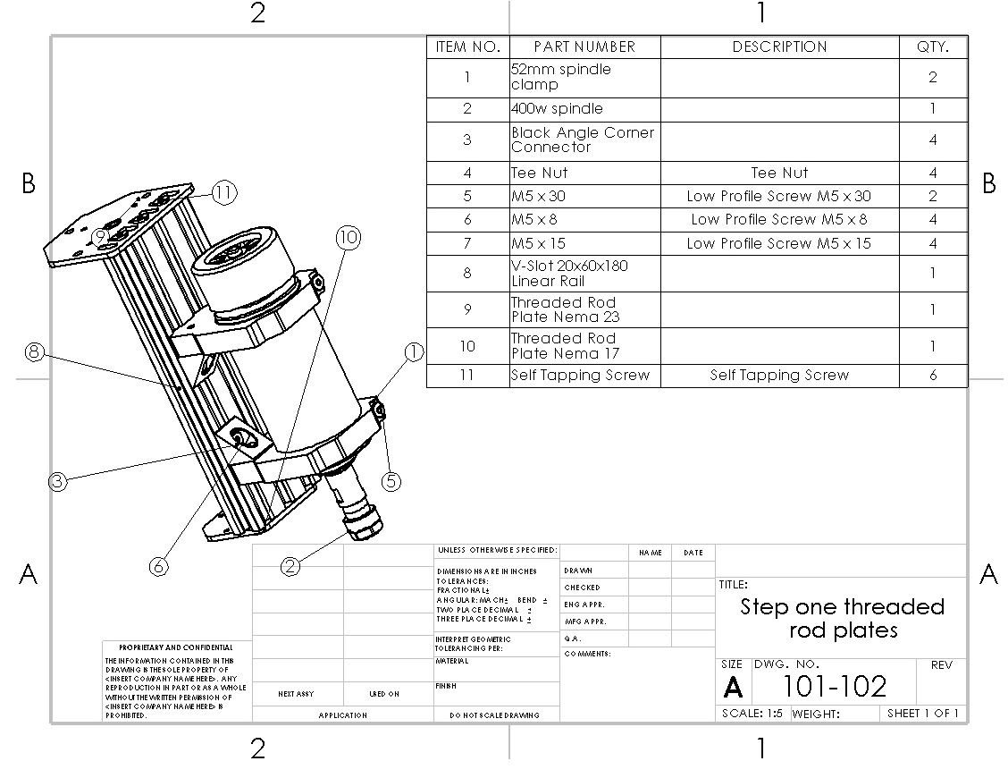

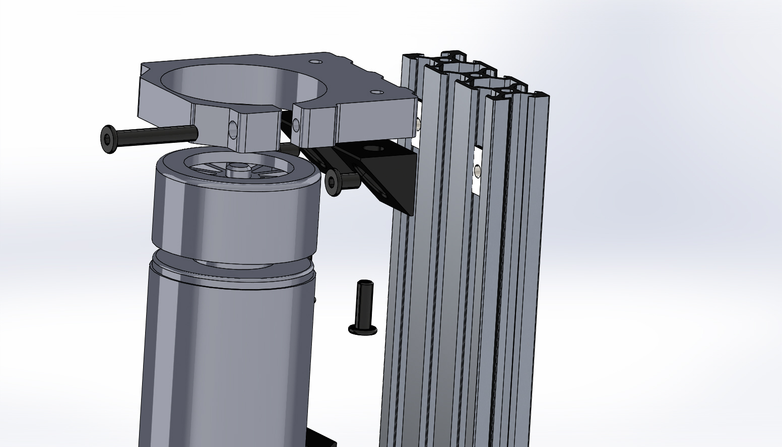
Exploded View. M5 x 8 bolts go into Tee-nuts, M5 x 15 go into V-Slot.
- Slide the clamps over the spindle motor (these are a tight fit, you can open them with slight hand pressure to install over spindle).
- The clamps should ride at the top and bottom of the spindle, the bottom clamp should be approximately 26mm from the bottom of V-Slot.
- Loosely install the M5 x 30 bolt in the spindle clamps and tighten at the last step. Perform on a flat surface so both clamps are oriented the same direction.
- Slide Tee-nuts in V-Slot
- Install M5 x 8mm bolts through black 90 brackets into tee-nuts in V-Slot loosely.
- Install spindle clamps to black 90 brackets with M5 x 15mm bolts.
- Once all is aligned, tighten M5 x 8mm, M5 x 15mm, and M5 x 30mm bolts.
Now we install the threaded rod plates.
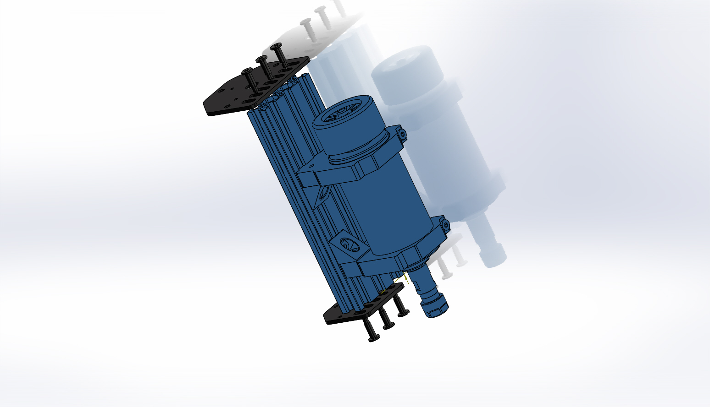
- The smaller plate goes on the bottom, the bearing recesses face each other. Install with 3 qty (per side) self-tapping screws and leave loose.
- Now that the self-tapping screw threads have been set, you will need to remove either the top threaded plate or the bottom threaded plate for step 3. It is easier to set the threads before we do the final assembly, hence doing it here then removing them for the final assembly.

We are now completed with this step; the assembly can be set aside.
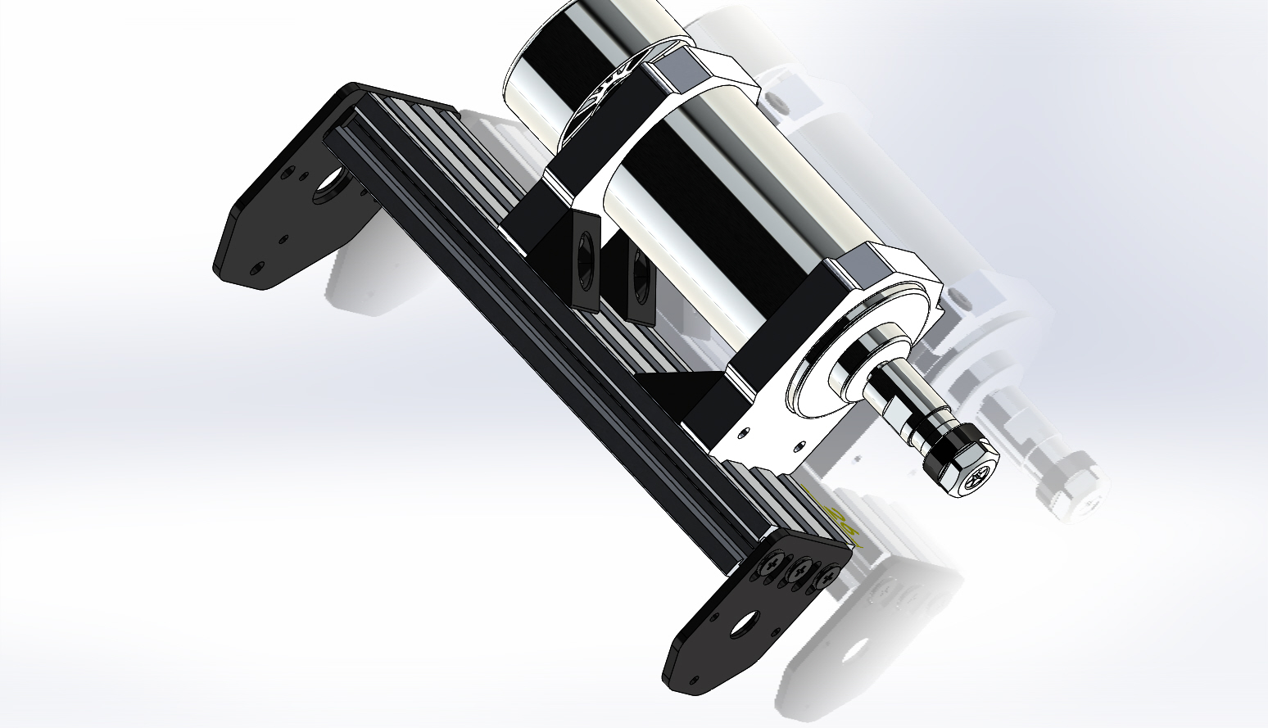

Step 2:
X_Z-Axis gantry plate assembly:
Before we begin this step let us look at how to assemble a wheel assembly. Note the package comes with the bearings and shims loose. You will need to build the wheel kits. It may make sense to build all of them at one time. See here:
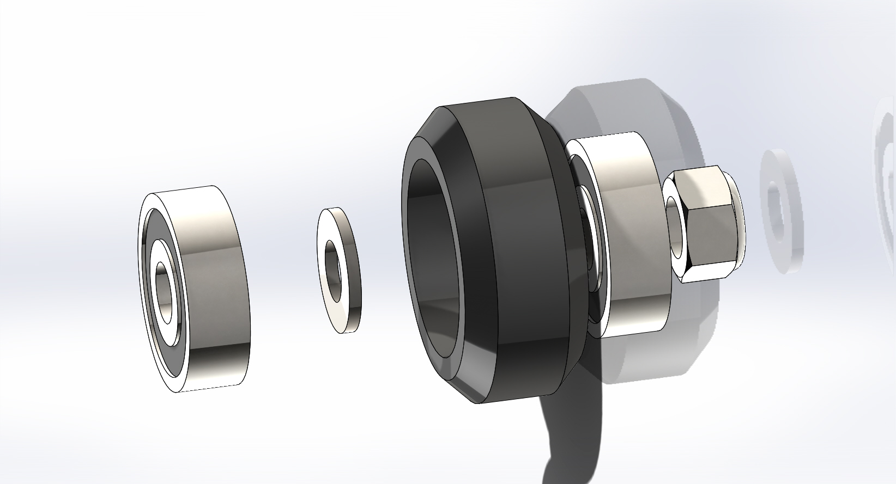
Bearing, shim, wheel, bearing. In some instances, the additional shim is required outside the wheel, at other times it is not. Do not use both shims inside the wheel.
After you build at least 6 qty wheel kits it is time to continue the X_Z axis build.

- Begin by installing M5 x 20mm bolts in the center two holes and the smaller holes in line as shown here:
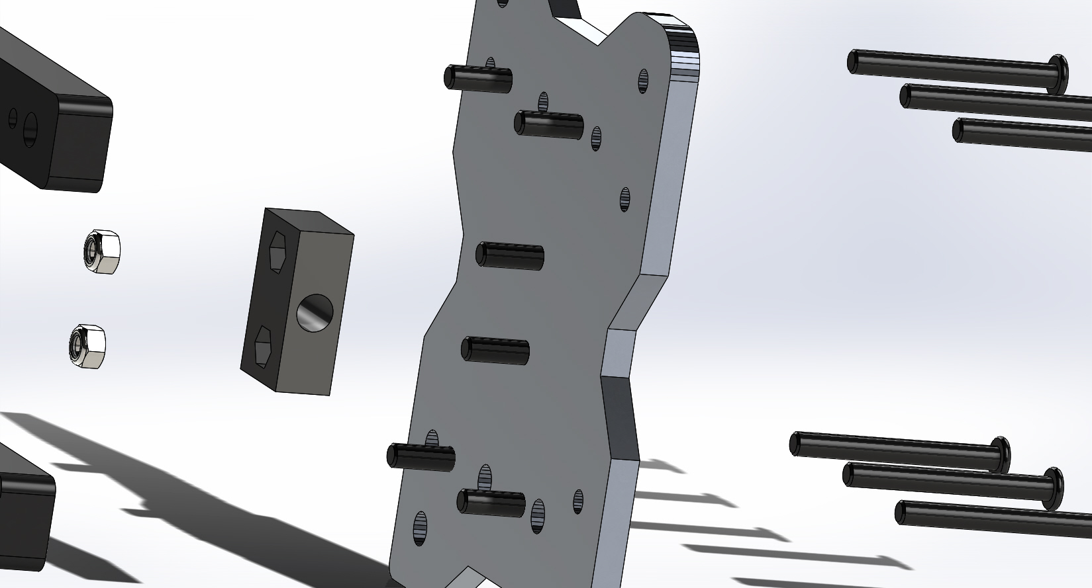

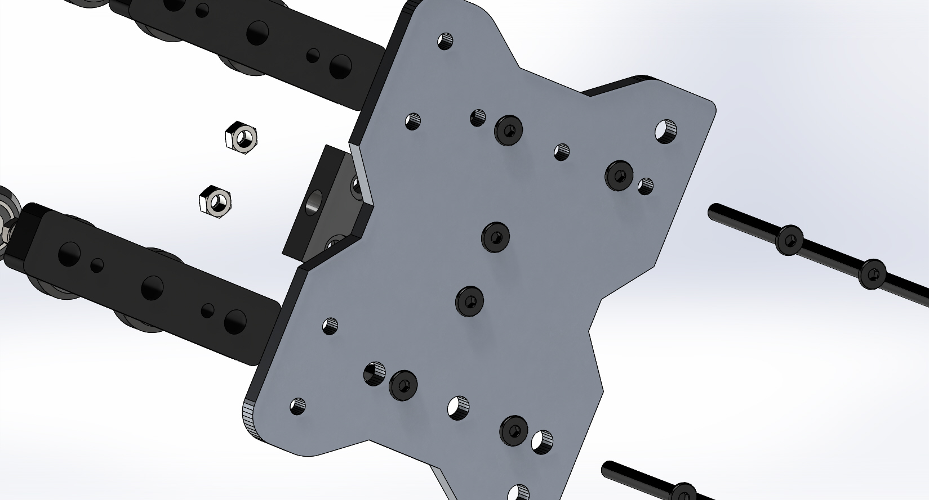
- Next install 2 qty M5 nuts into the plastic ACME nut block. Note one side has cut outs for the nuts.
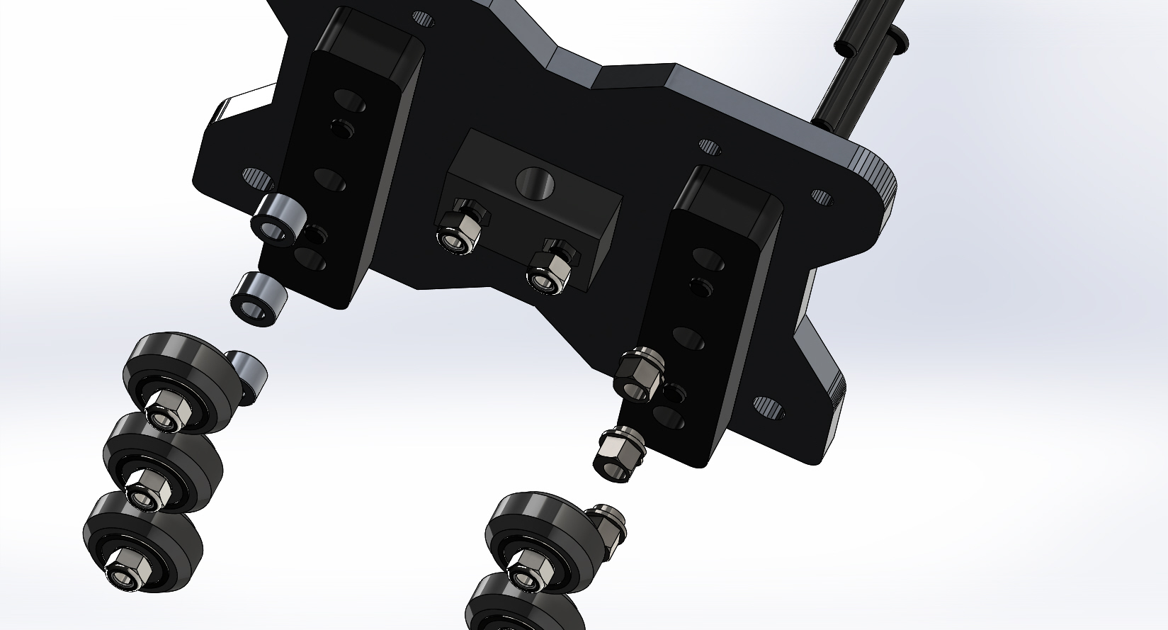
- Tighten the M5 x 20 bolts holding the black plastic ACME nut block on, snug, do not crush the plastic nut… it is possible! The bolts need to be tight, not torqued.
- Next install the spacer blocks (long black pieces) there are threaded holes that the M5x20 bolts will affix to as shown above.
- Afterwards slide the M5x45 bolts into the holes in the back of the plate, through the spacer blocks as seen here:
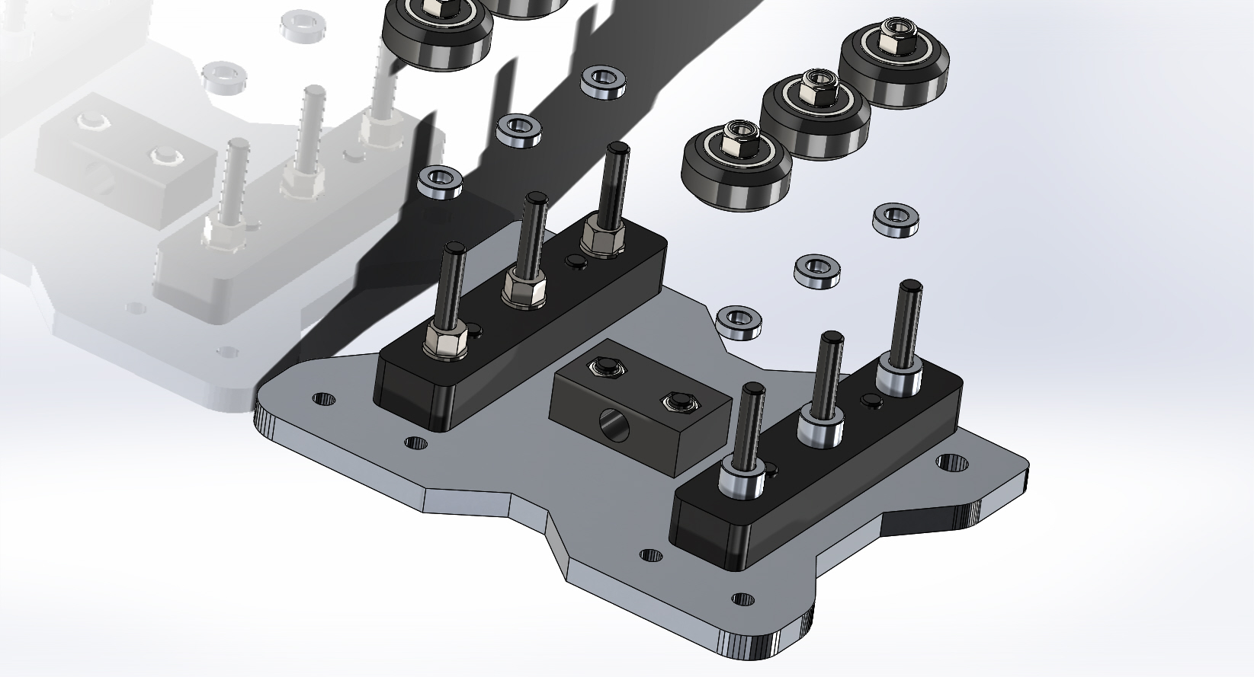

- Now we will install eccentric spacers on one spacer block and plain spacers on the other. Next install the thinner spacers (3mm) on top of the eccentric and standard spacers. The eccentrics (later) will allow for us to remove slack from the drive. Before installing the eccentric spacers, note that one set of holes on the rear of the X gantry plate is larger than the other. Install the eccentrics on the larger hole set:
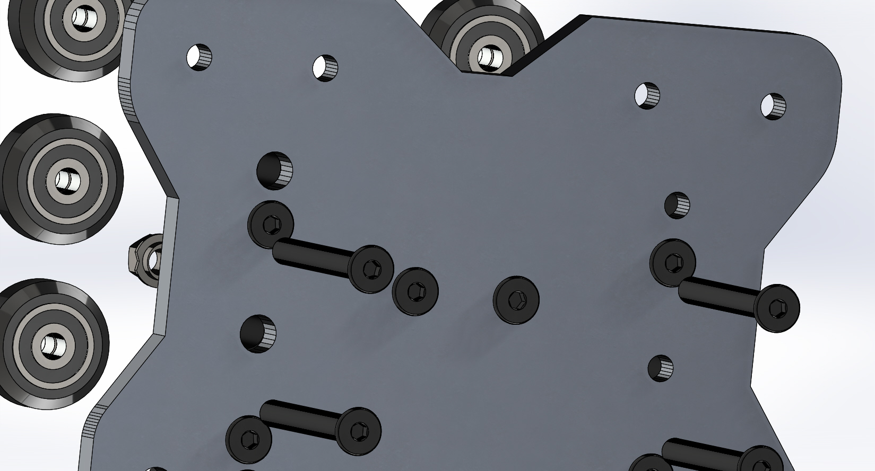
- Install the eccentrics with the cut-out (on the flange of the eccentric spacer) facing towards the outer edge of the plate.
- Install the wheels and snug up the M5 nuts holding the wheels onto the M5 x 45mm bolts.
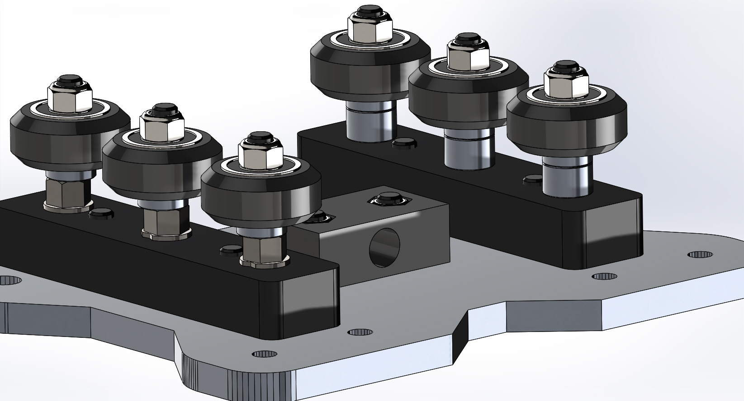

Step 3
Complete X_Z gantry assembly
In this step, we will build the X/Z gantry assembly.

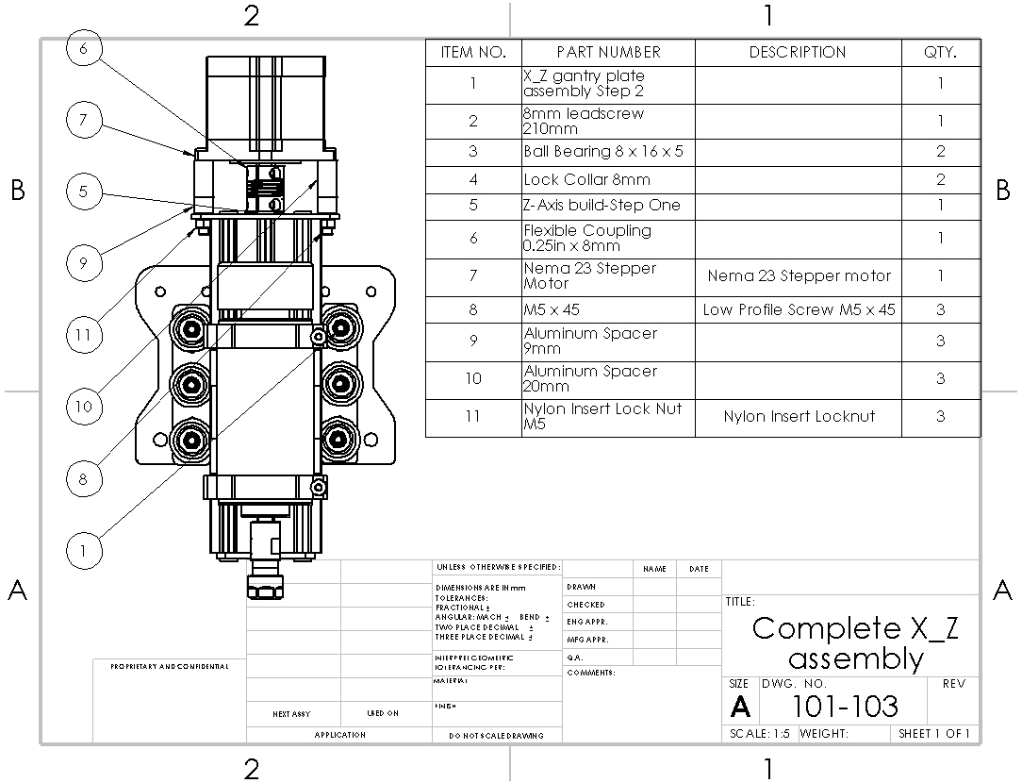

- Begin by installing the ACME rod in the ACME nut block from step 2.

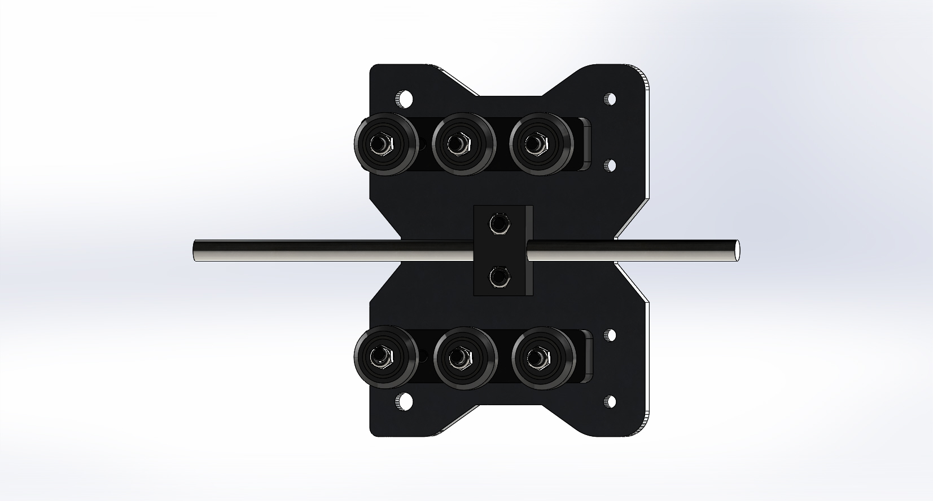
- Install a 688zz bearing and lock collar on each end. Do not tighten the set screw on the lock collar yet.
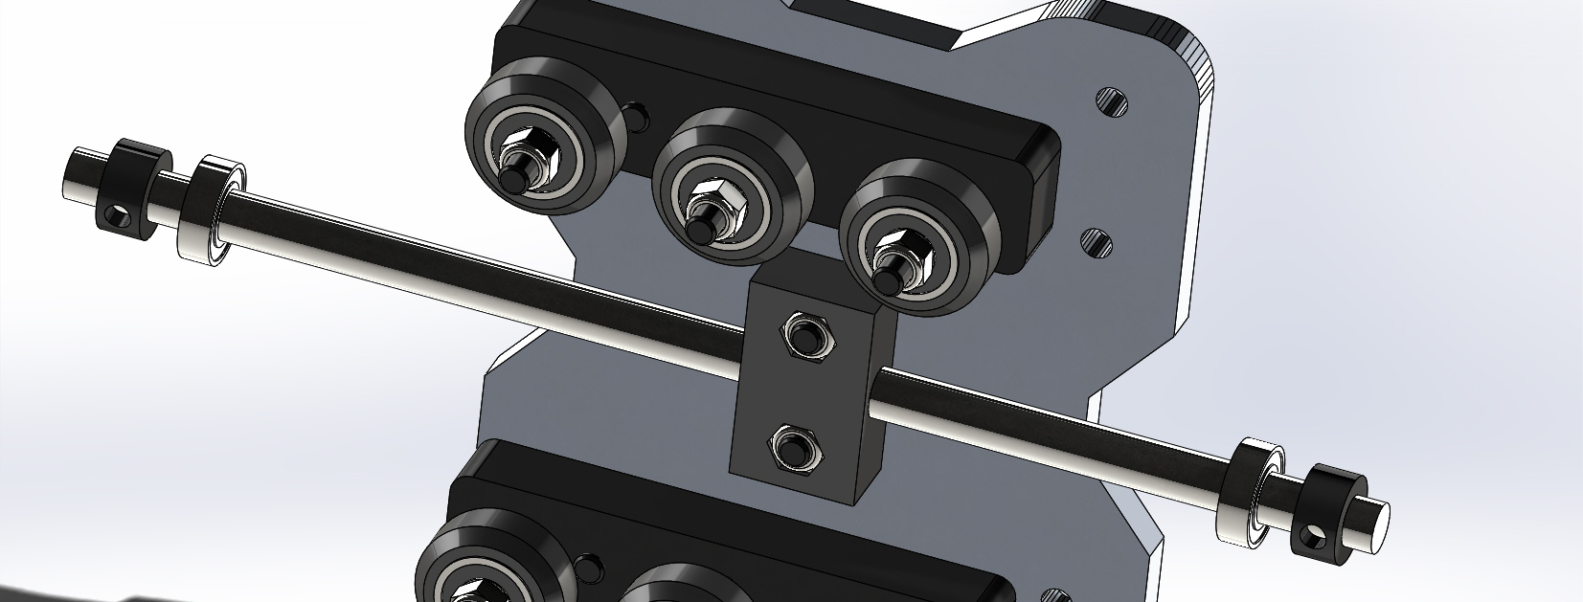
- Position the Z axis from step one (with one removed threaded rod plate) over the wheels and slide into place.
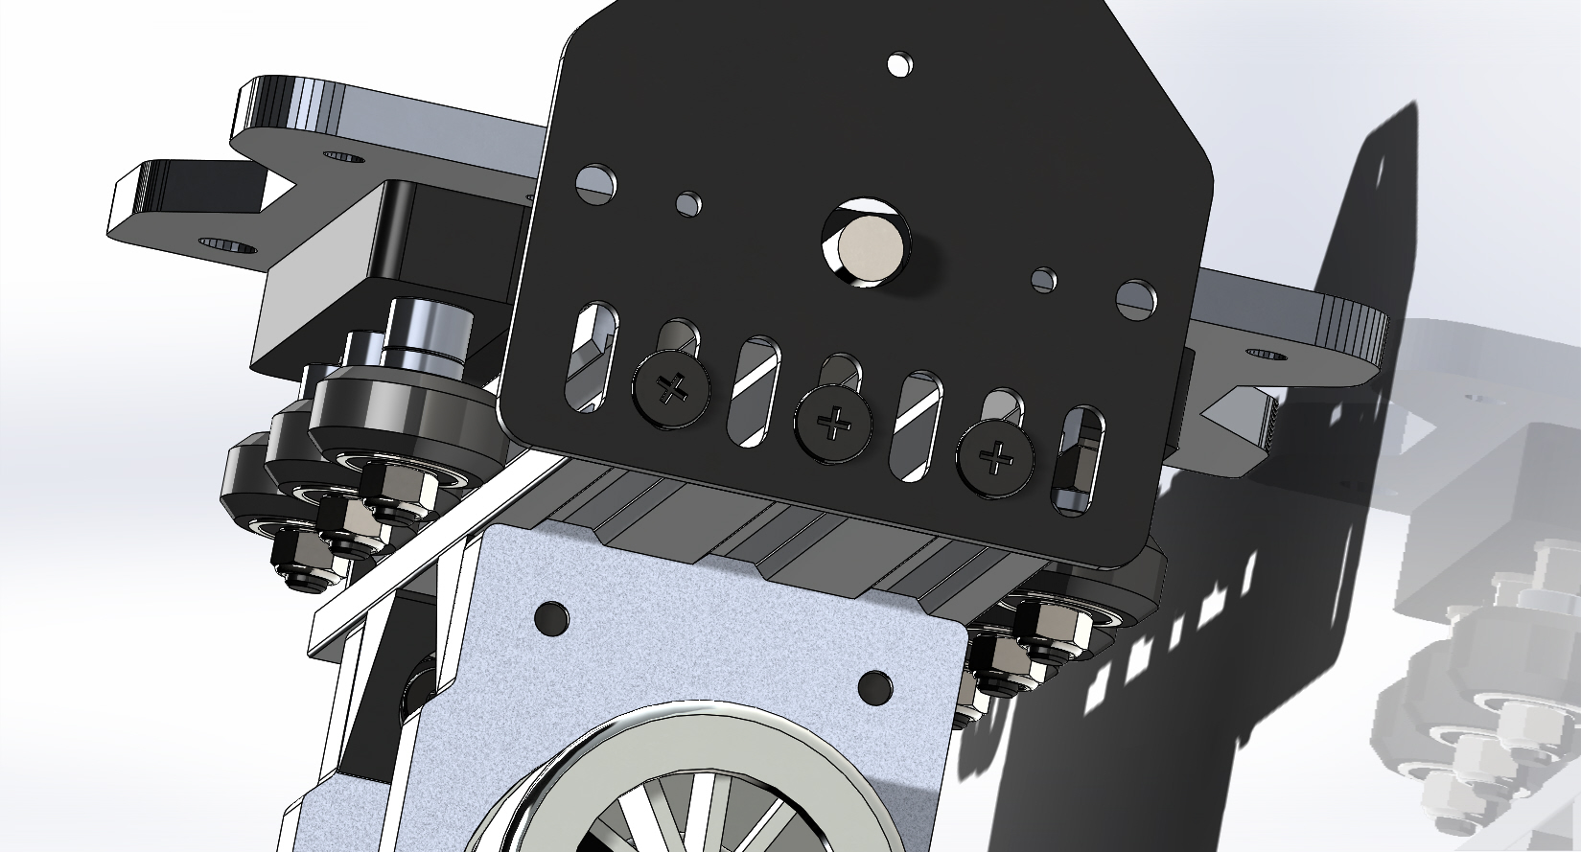
- Next, with the screws loose on the threaded rod plate, we will align the bearings with the recesses in the threaded rod plate.
- Push the bearings into the recesses of the threaded rod plates, then tighten the threaded rod plates in place.
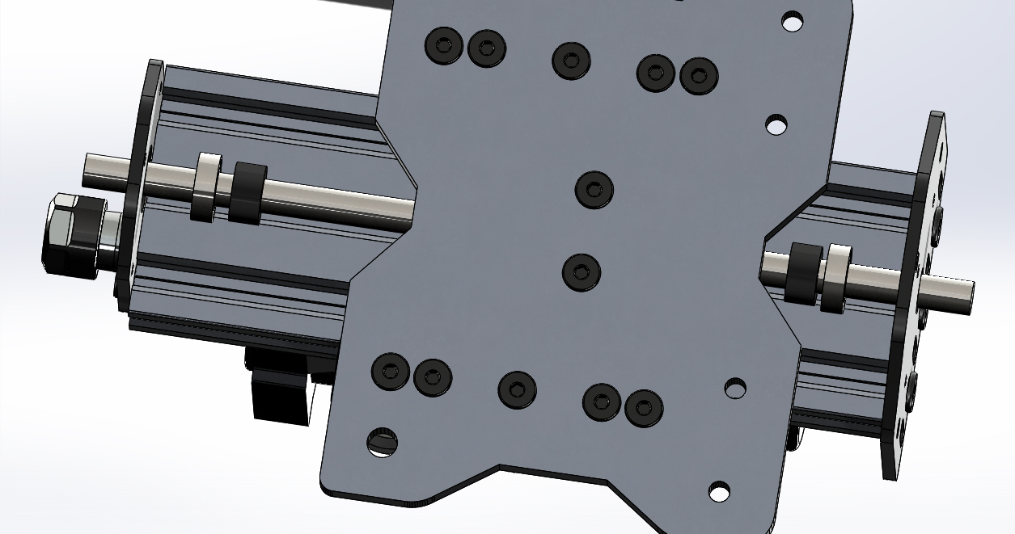
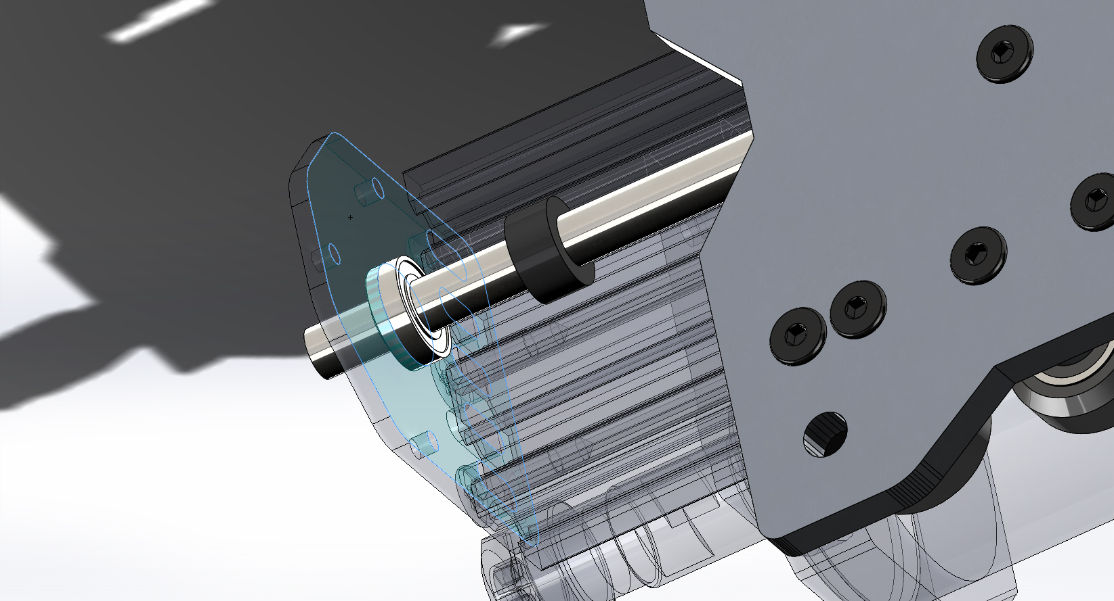
- Once the threaded rod plates are tightened down, lock the bearings in place with the lock collars. NOTE: you will need to leave about 15mm of ACME hanging out of the bottom of the lower (smaller) threaded rod plate.
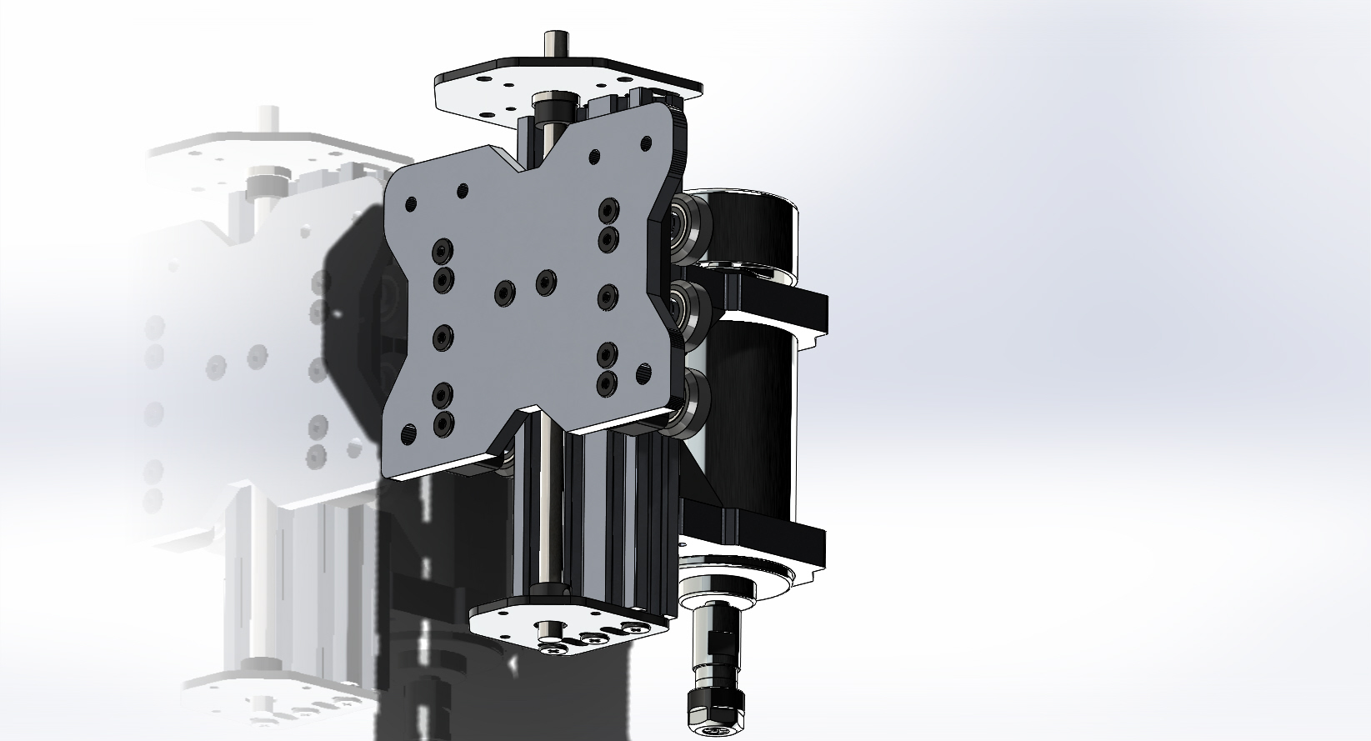
- Check to make sure there is little to no play when you turn the ACME by hand. Also check to make sure the
ACME does not bind when turning by hand. If it does either adjust the lock collars or threaded rod plates to remedy this.
- Next install the 6.35mm x 8mm coupler on the ACME rod. This goes on the top, the side with the larger threaded rod plate. Slide the coupler down on the ACME till it stops and tighten the lower set screw on the lock collar.
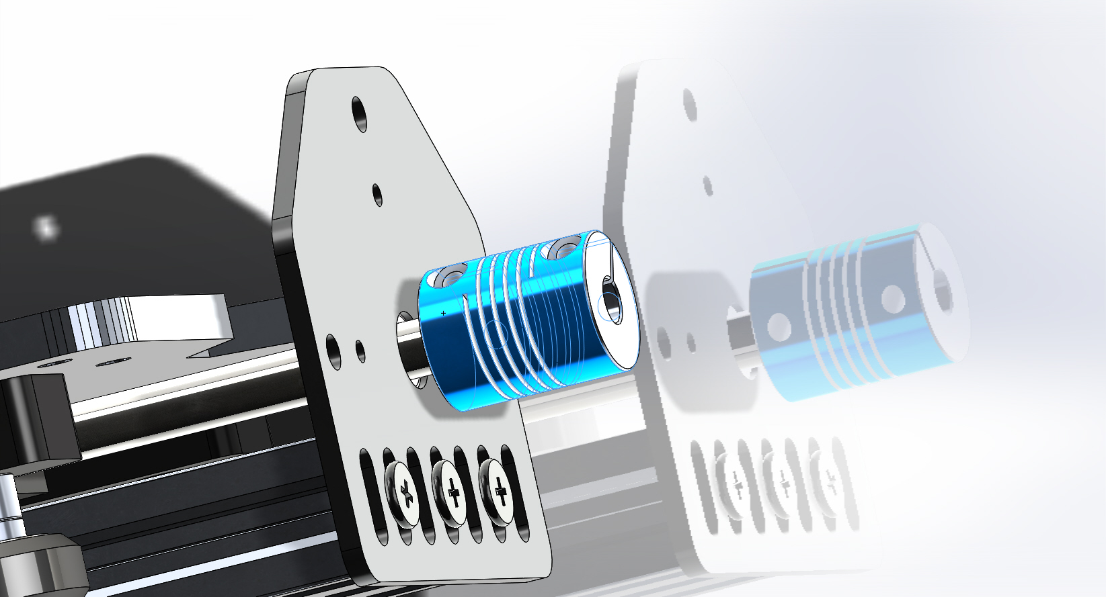
- Grab the NEMA 23 stepper motor install 3 qty M5 x 45mm bolts in any three holes, slide one each 20mm spacer and nine mm spacer over each bolt.
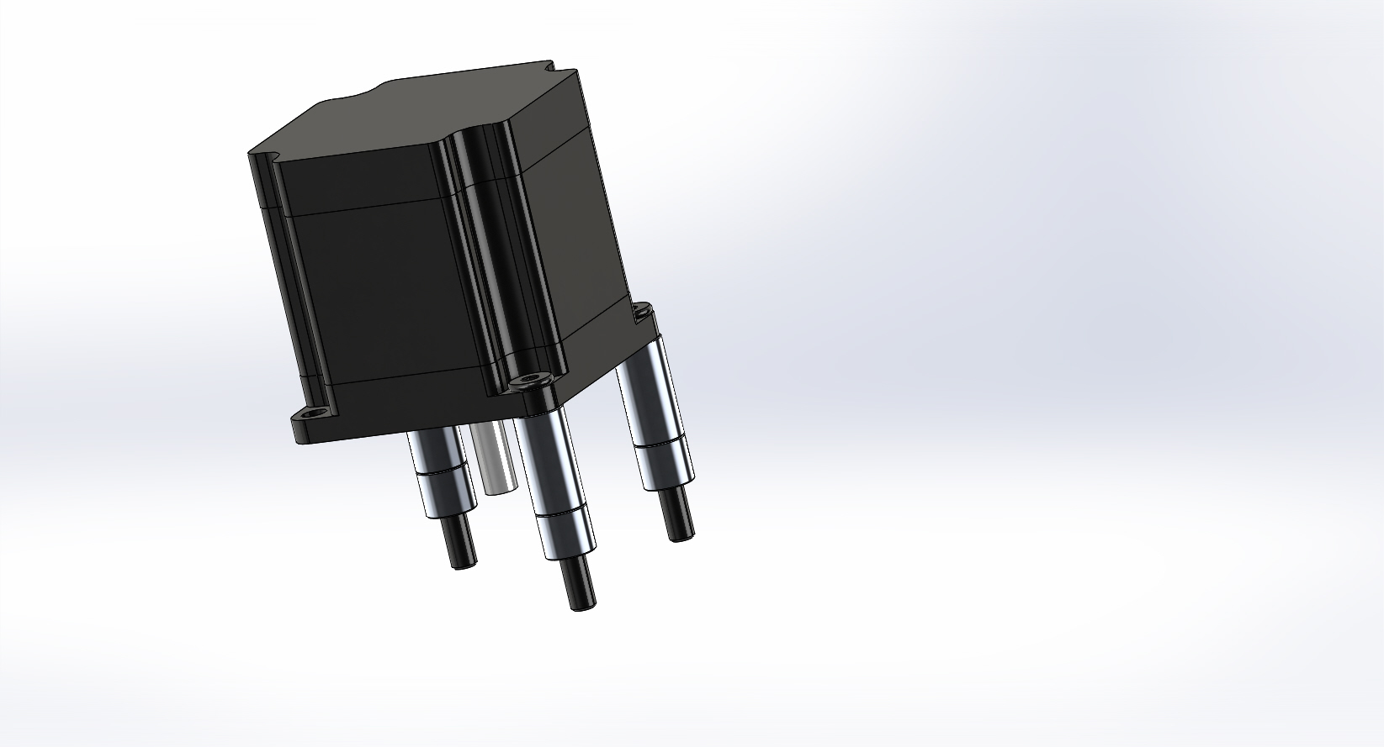
- Now slide the stepper motor shaft into the coupler and run the three bolts into the matching holes in the threaded rod plate.
- Follow with installing three qty M5 nuts and tightening the coupler onto the motor shaft.
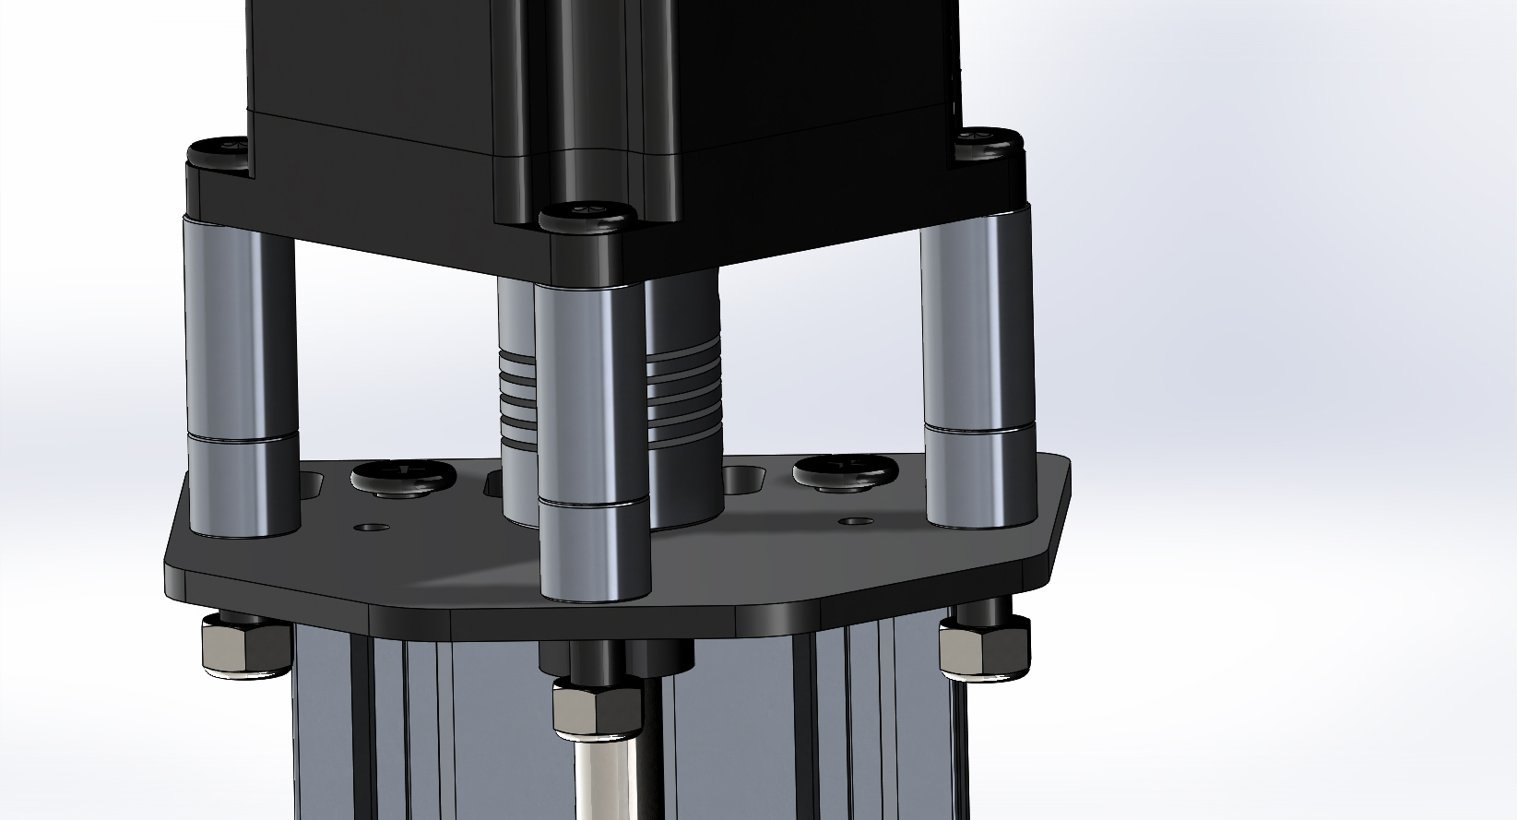
Tighten the M5 nuts to secure the motor.
- Recall the eccentric spacers installed on one of the spacer blocks above. It is now time to give these a turn and take the side to side slack out of the Z axis. When installed we did so with the cutouts facing the outside of the plate, as seen here:
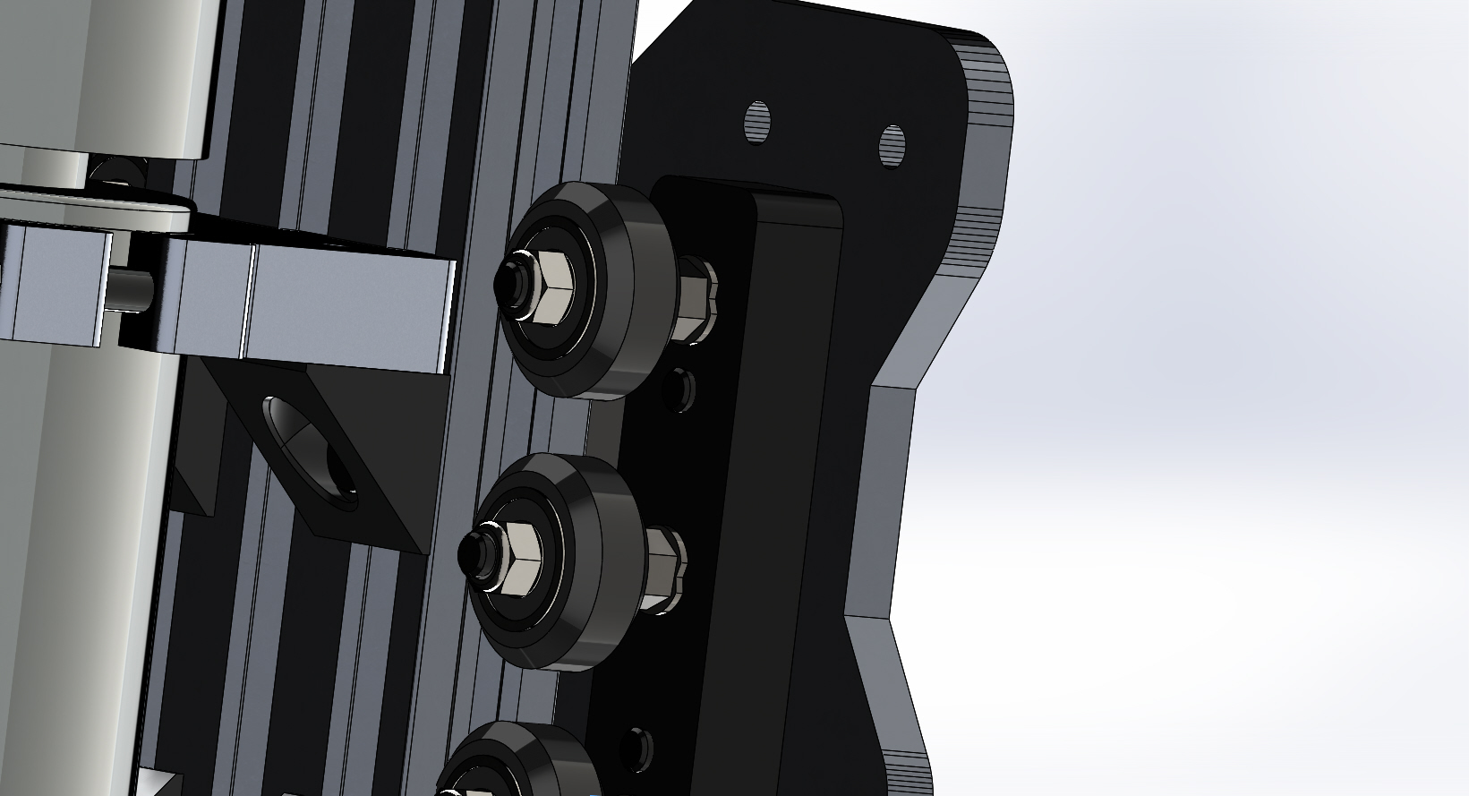
Taking the 8mm combination wrench turn each eccentric 1/8 of a revolution of a turn at a time. The wheels will get closer to the 20x60x180 extrusion. Do the top eccentric, middle, bottom. Physically feel the play in the wheel. If there is a lot of play, i.e. you can turn the wheel freely do another 1/8 of a revolution turn. Repeat till all three wheels on the left side and right side of the 20x60x180 extrusion all slightly drag. DO NOT OVER-TIGHTEN, you can damage the wheel by tightening them too much. The wheels should not lock on the metal, just rub.
The X_Z gantry is now complete.

