SMW3D OX Build Instructions
Large Format OX
Rev. 4.1
6/6/2015

Option | Step #
Wire Sheathing Kit add-on | 8
Plates Blasted upgrade | 3
Spindle upgrade | 8
Black Kit upgrade | 1
Wheel upgrade | 1
GT3 upgrade | 6
Additional X wheels upgrade | 5
Z Axis NEMA 23 upgrade | 5
TinyG add-on | 8
X gantry Cable Chain add-on | 8
E-stop add-on | 8
Touch sensor add-on | 8

These build instructions are provided as a guide to assist you in building your OX in the most efficient and accurate way possible. They can also be used to supplement the OX build instructions that are available from OpenBuilds.com on their build page. There is no guarantee or warranty expressed within this document. Use caution and work safely, SMW3D is not responsible for any harm caused by the building of this kit to persons or other items. Proceed at your own risk.
How to use this manual
- We will have checked off each step’s material list. It is highly recommended that you do the same. Each bag is labeled with the step number, and a bill of materials associated with that bag will be provided here.
PLEASE CHECK THIS COMPLETELY PRIOR TO BEGINNING YOUR BUILD.
If anything is missing or incorrect, stop here and email contact@smw3d.com and we will work with you to rectify the issue quickly.
- Please also note the extruded aluminum is bound together per axis, some pieces can be easily confused, if in question measure the length and verify it matches with the particular step.
- Once you have completed checking the BOM (Bill of Materials) begin at step one and use the text and images to complete each step.
- If you chose particular options they may be bagged separately, but will be labelled as such.
- Each step will have the tools required. We do not repeat the tools required for each step but simply add to the tool list of the last step, if additional tools are required.
- Take your time. Enjoy, building is half the fun!
STEP ONE:
Required pieces large format: | SMW3D | Customer
(2x) 20x80x1000mm aluminum extrusions
(2x) 20x40x960mm aluminum extrusions
(2x) 20x40x746mm aluminum extrusions
(4x) 5-hole 90 degree side brackets
(8x) 90 degree corner brackets
(25x) M5 x 10mm bolts
(16x) M5 x 8mm bolts
(28x) T-nuts

Tools required:
Metric Allen wrench set
Speed Square
M5 x .8 pitch tap
Mini level
Quick Tip:

You are going to have a spoiler board cut, have an additional one cut at 1000mm x 750 (large format and small format) and use it as a work platform! You will need a flat surface to build on.

Steps:
Lay out the base.
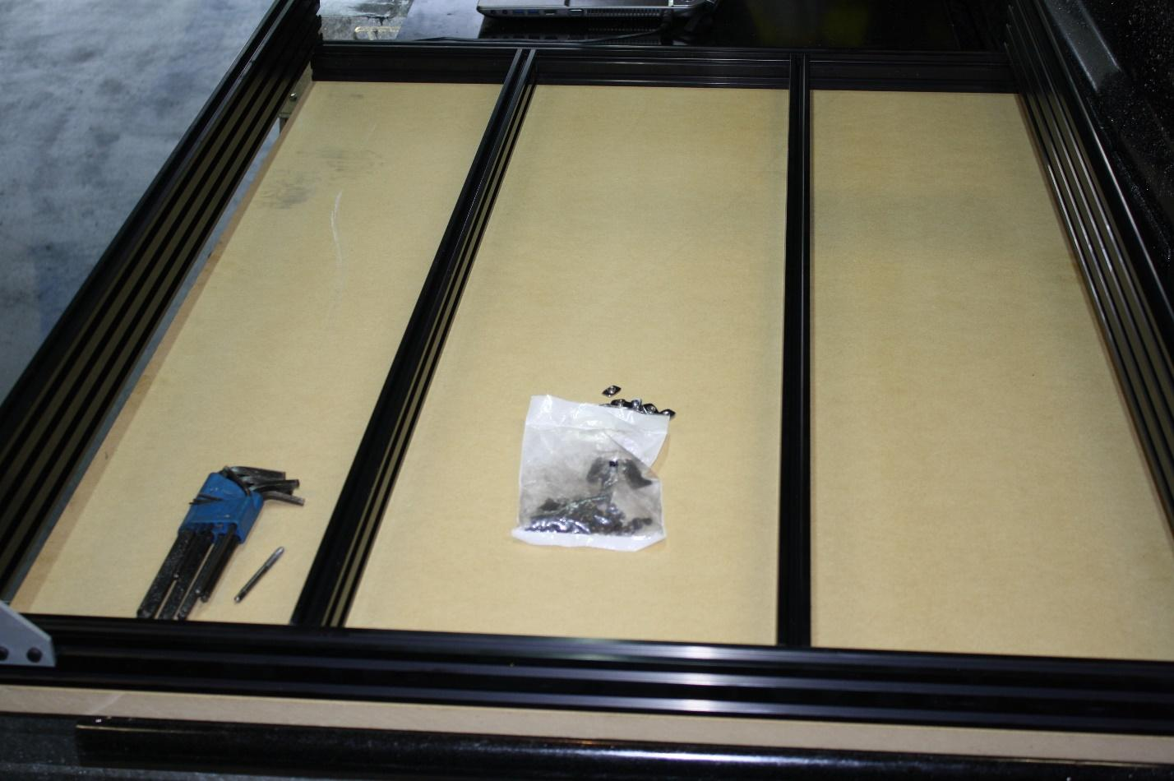
The 20 x 80 rails sit on top of the 20 x 40 rails and form a square. The support rail will be in the center of the box.
Note: the large format is shown above with two cross members; the small format only has one.
Tap M5 threads into the bottom two holes of each of the 20 x 80 aluminum extrusions on both ends. Which is the bottom? It doesn’t really matter--you choose. On the end of the extruded aluminum you will see an X pattern with a hole in the center. This hole is the one that will require M5 x .8 pitch threads. We recommend tapping the holes about 15mm deep.
Insert three T-nuts in the top slot of the 20 x 40 near the edge.
Note: if you have machined 5-hole side brackets you will need to flip the direction of the T-nuts so that the thread faces the plate, not the slot.

Install a 5-hole side bracket on each corner with the M5 x 10mm bolts, squaring the rail before tightening.
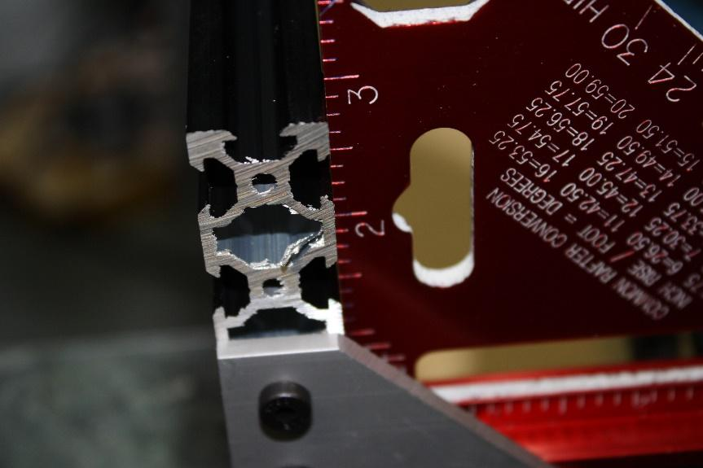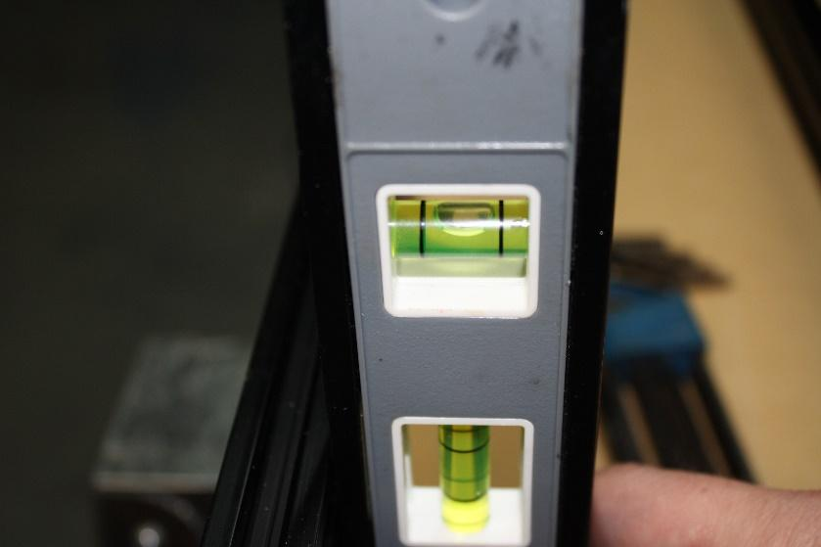
Do this for all four corners of the square frame.

On the inside top slot of the 20x40mm front and rear frame sections install T-nuts, 2 for each supporting, or cross member, 20x40mm rail.
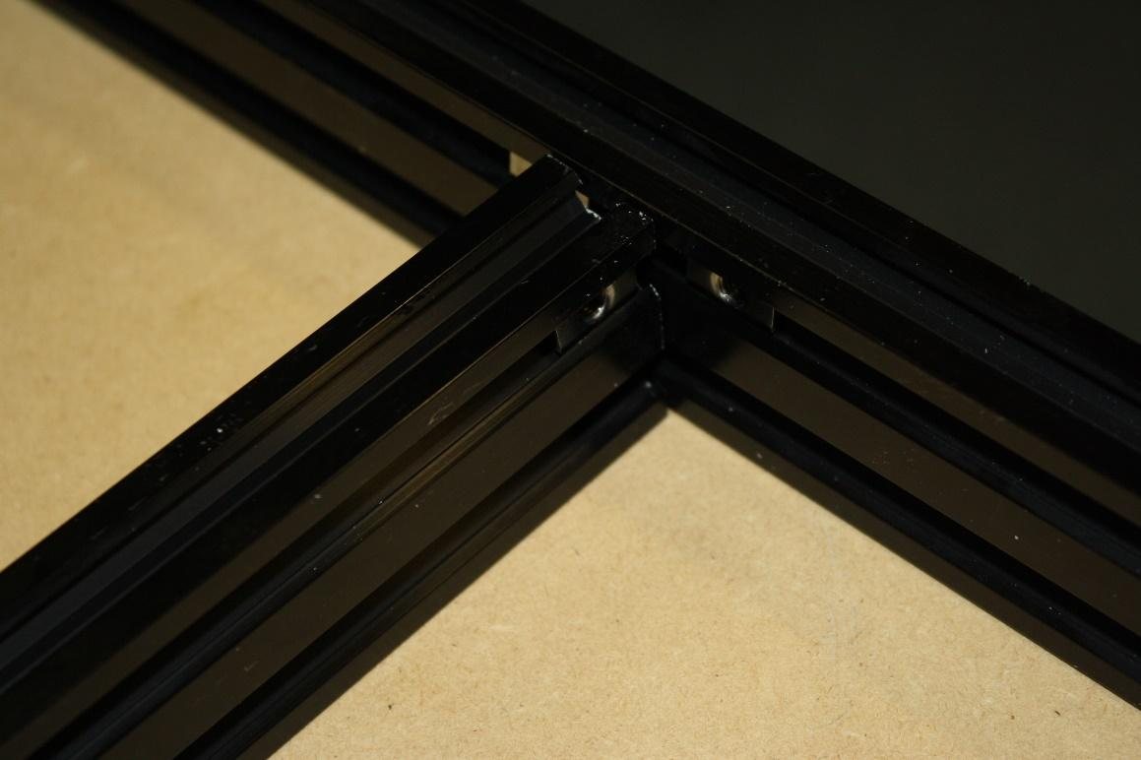
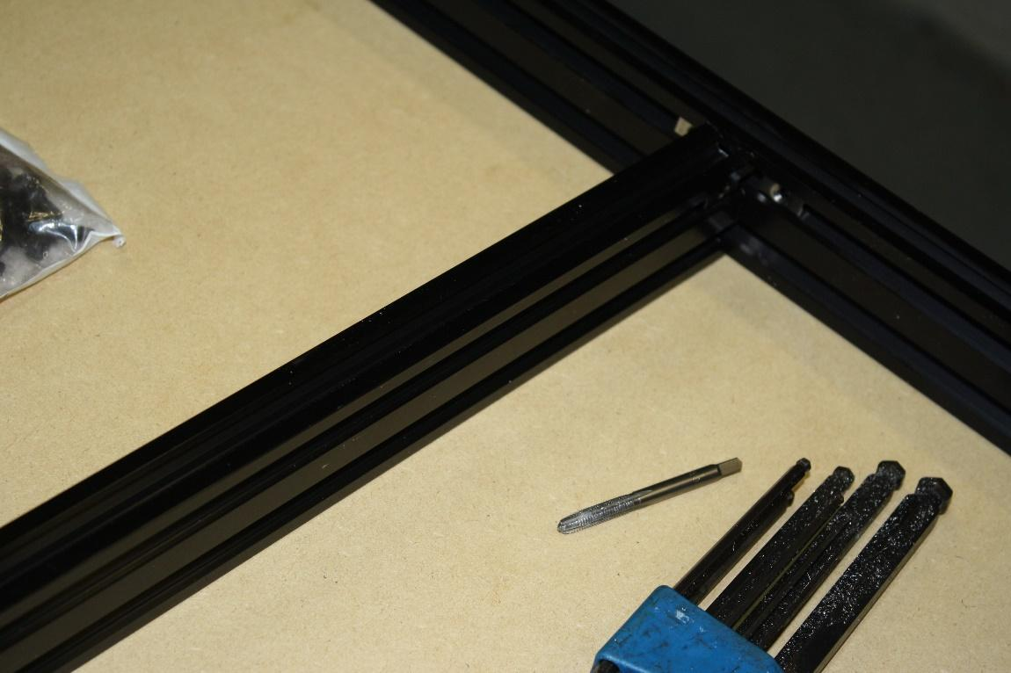
On the 20x40mm rails, install two T-nuts on each end. 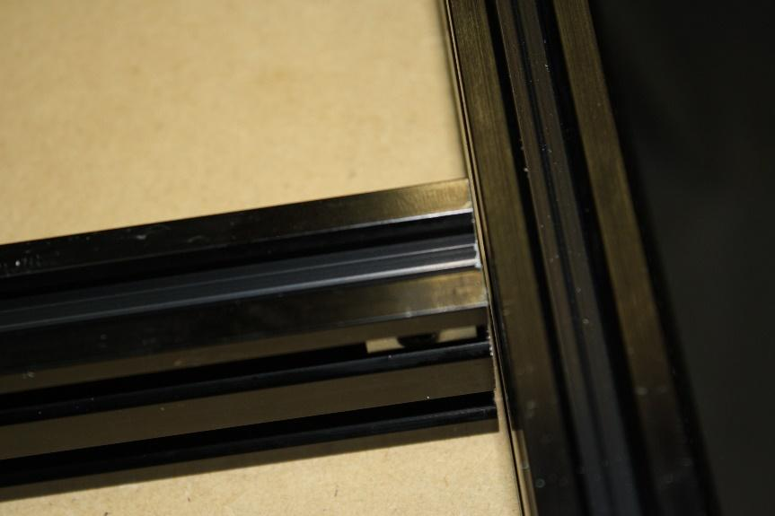
Note: it is very possible there is a slight gap between the support bars and the 20 x 40 end pieces. This should be this way.
Install one 90 degree corner bracket in each of these joints using the M5 x 8mm bolts.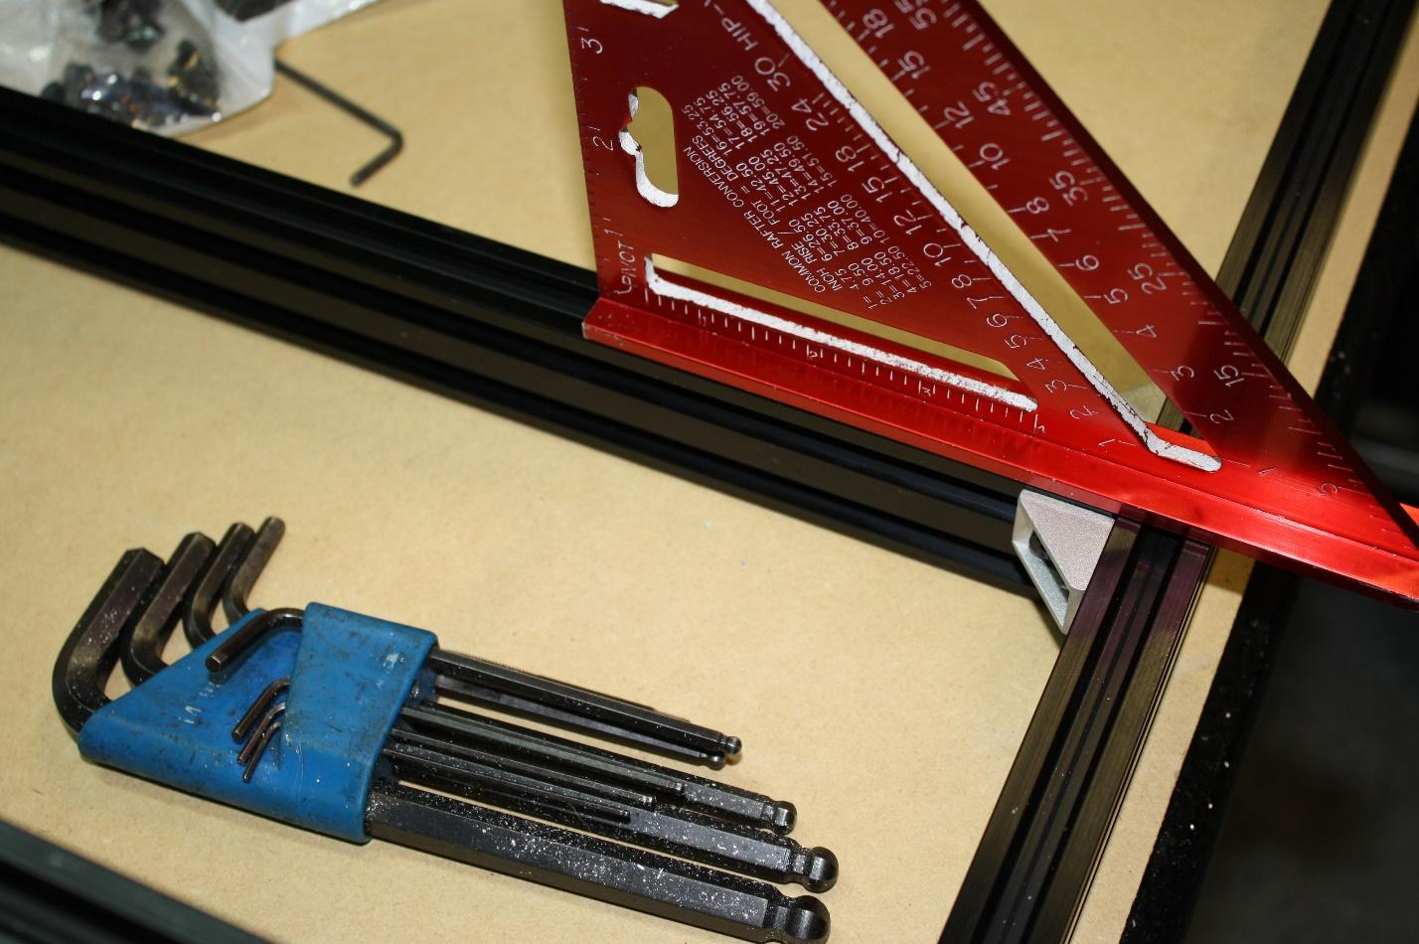.
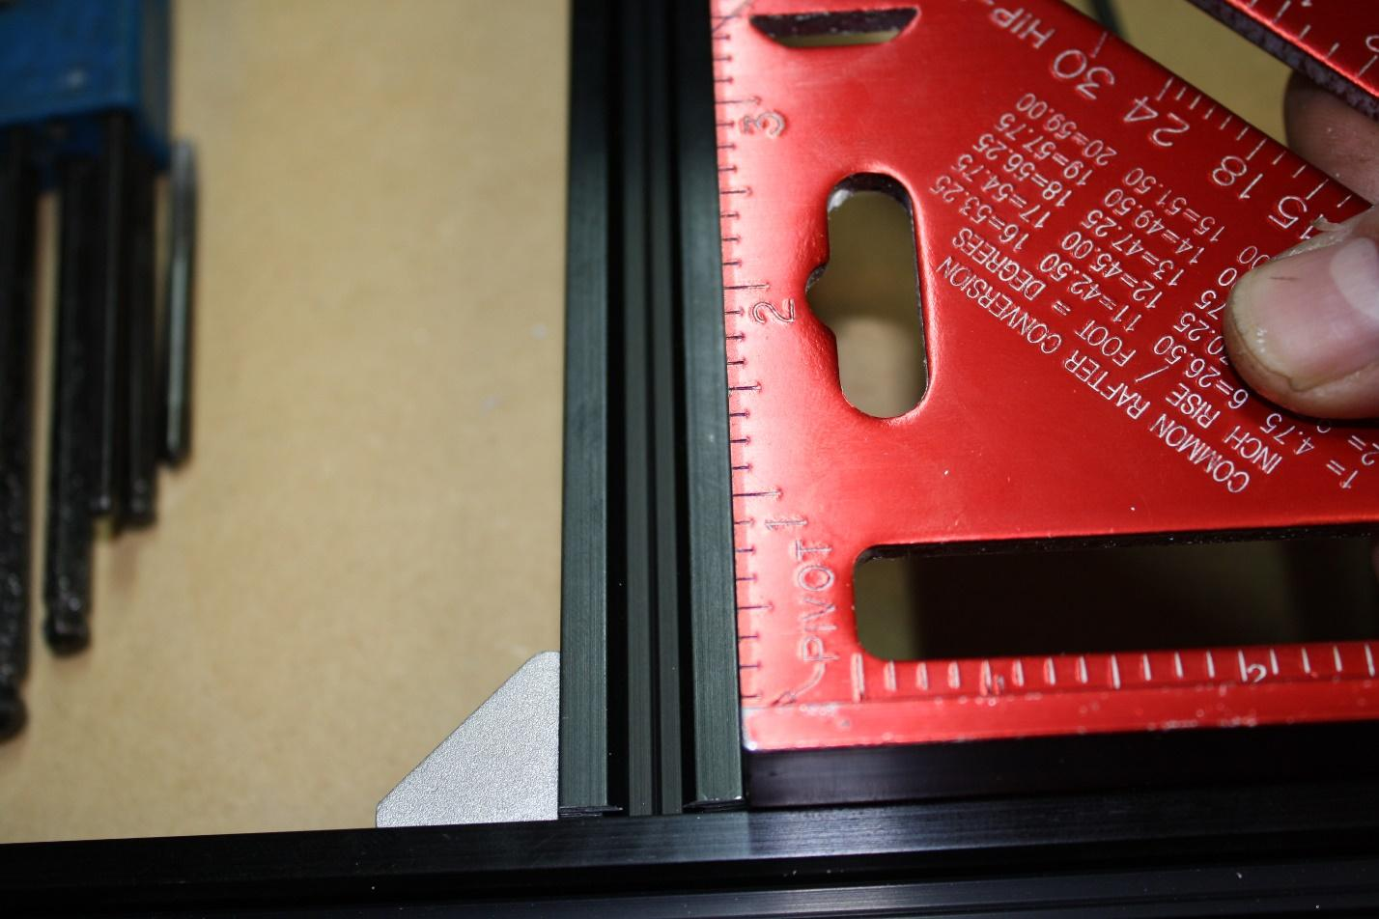
Make sure the corners are square and the top surfaces of the 20 x 40s are flat.
You can install these supports anywhere you like, equally spaced from the edges. We suggest 175mm from the inside edge of the 20 x 80mm Y gantry sticks on the large format, and centered on the small format.

STEP TWO:
Square everything. Use a level, use a tape measure, use a set of calipers, or use a micrometer. Use whatever you have available, but square the frame now. Every cut you make moving forward relies on the trueness of the frame you are looking at.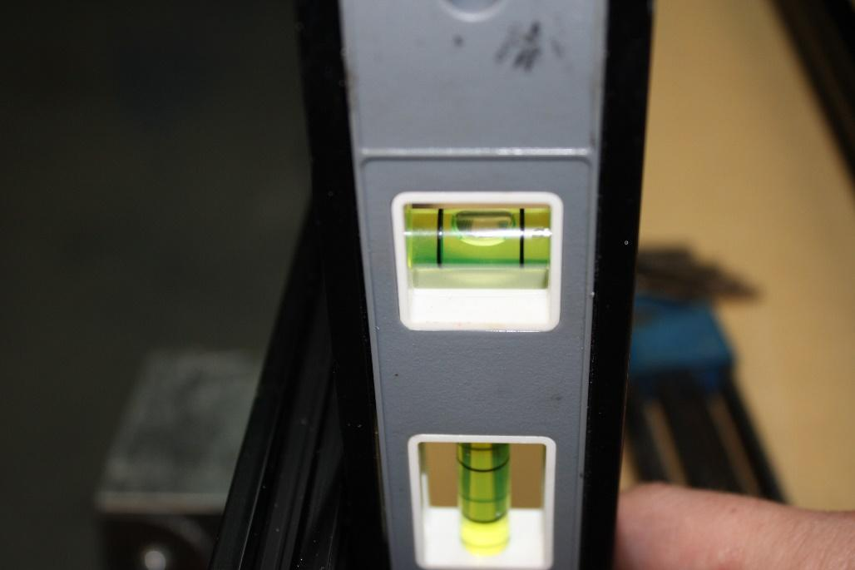

STEP THREE:
Required pieces: | SMW3D | Customer
(14x) wheel kits
(14x) M5 x 30 bolts
(2x) NEMA 23 motors
(2x) Y gantry plates (the larger ones)
(6x) eccentric spacers
(8x) M5 nuts
(8x) ¼” spacers
(8x) M5 x 20mm bolts

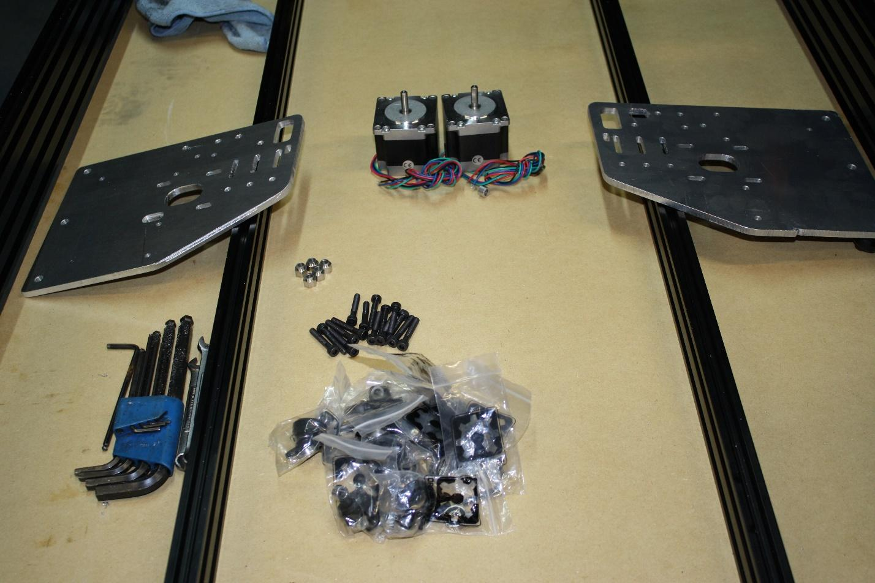
Tools required:
5/16” combination wrench
10mm combination wrench
Metric Allen wrench set
Steps:
Begin by installing three wheel kits per plate on the bottom row. This is done by building a wheel kit (if you have never built a wheel kit, please search online), installing an eccentric spacer and an M5 x 30mm bolt. Do not forget to put the spacer in between the bearings on the wheel kit. Loosely tighten the nuts on the three wheel kits per side.
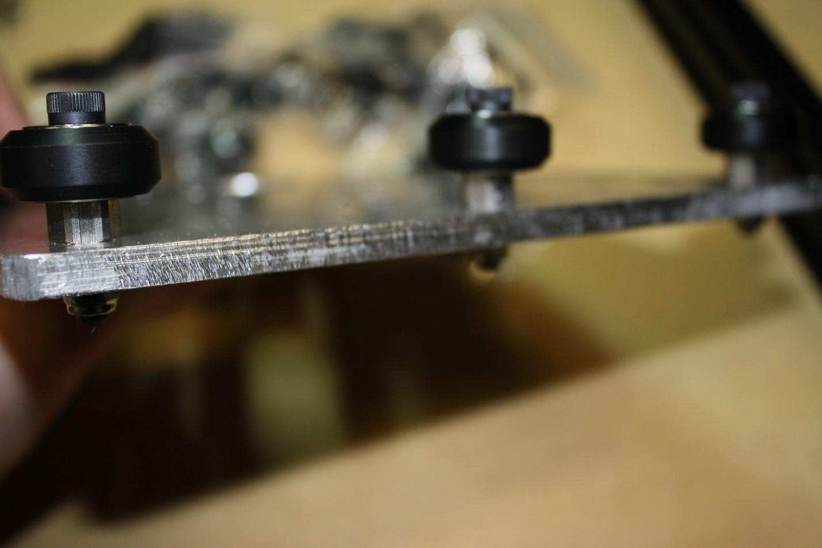
Turn the eccentric spacers till the slot on the eccentric spacer faces down towards the bottom edge of the plate.
Now let’s install the stepper motors. Depending on the controller you want the motors may be different amperage but they will have the same size mount, NEMA 23.
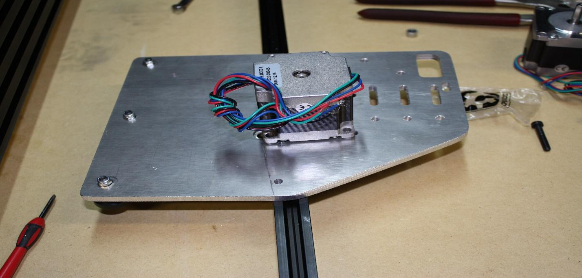
Place the motors on the outside of the plate and install a M5 x 25mm bolt into the slot on the plate with the head facing towards the OX bed (same side as the wheels).
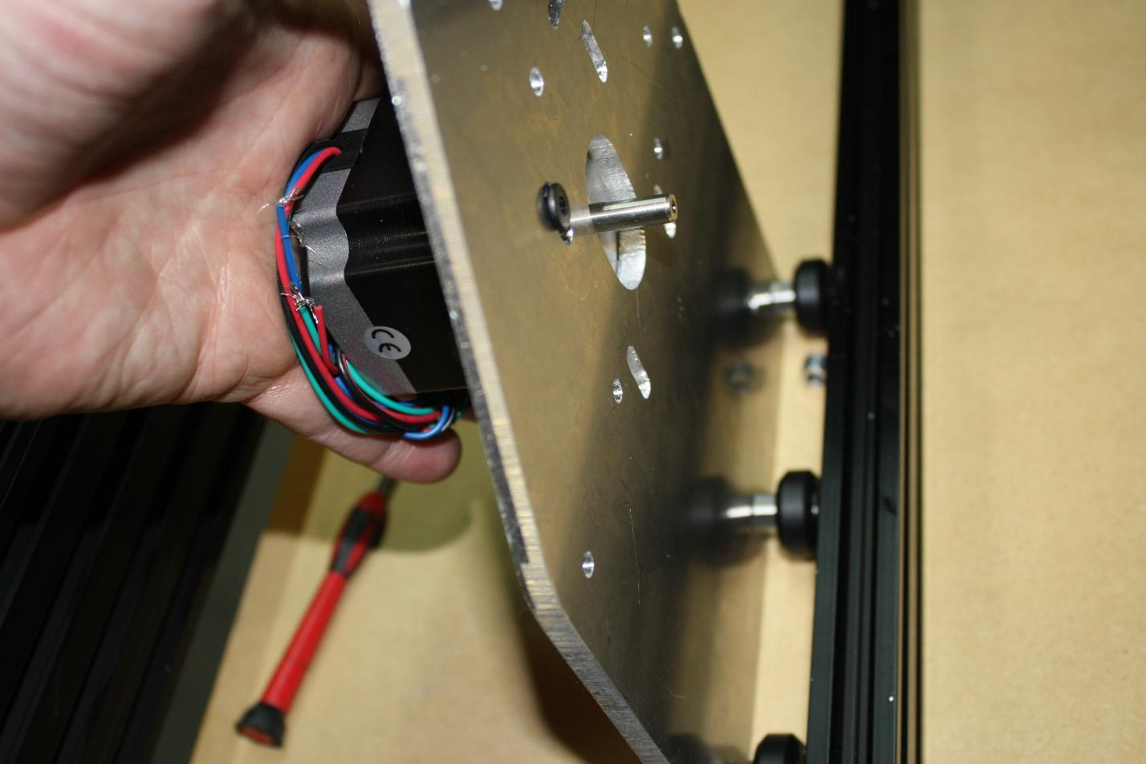
Tighten these bolts.
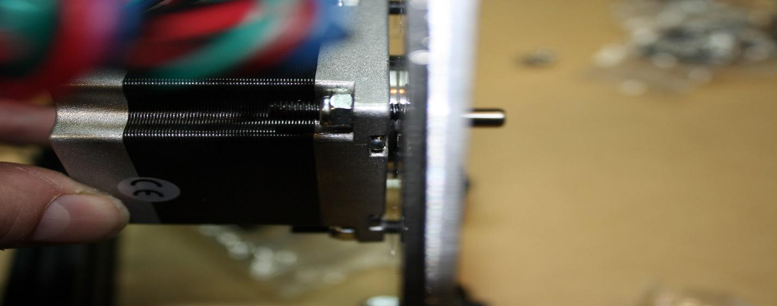

Now install the plates on the OX. Install four wheel kits on the top row of the Y gantry plates with a M5 x 30mm. Install and tighten wheel kits. Make sure the wheels still turn after install.
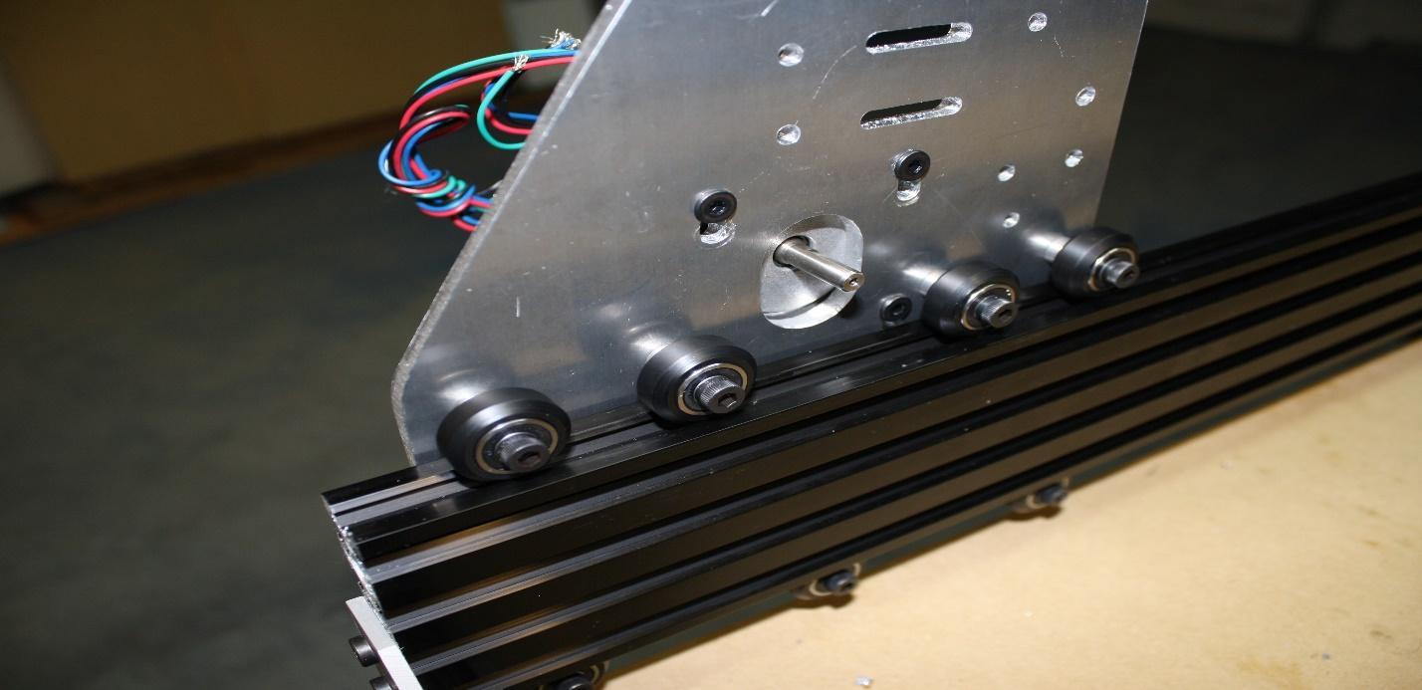
Now turn the eccentric spacers, slowly and evenly, till all four top wheels touch and have a slight resistance. It is possible you will not be able to get all four to drag the same. There are small imperfections in the wheels, bearings, bolts, metal dust from cutting the plates, etc. This will wear down naturally after a couple of runs and then you will be able to properly true the wheels.
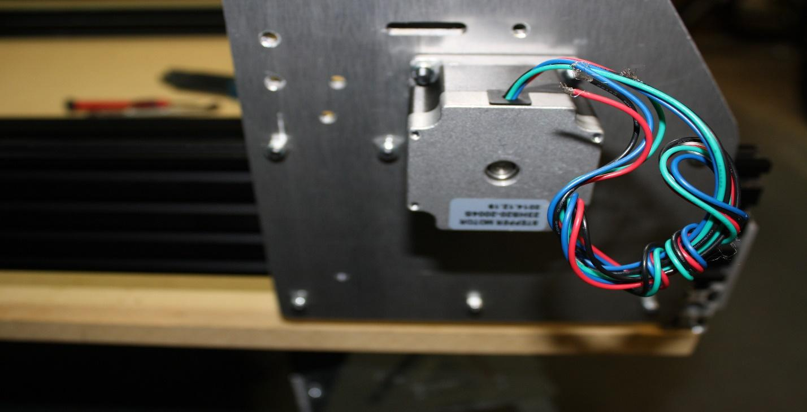
After tightening the eccentric spacers, make sure the nut and bolt are tight on each wheel.
You should be able to move the Y gantry plate down the 20 x 80. All four top wheels and all three bottom wheels have movement--none should sit idle. Excessive force should not be required to push the plate down the aluminum extrusion--you should be able to do it with ease. If it requires excessive force, then the eccentric spacers are too tight and will wear out the wheels prematurely. Loosen them until it is tight, but still moves freely with little force.
STEP FOUR:
Required pieces large format: | SMW3D | Customer
(2x) 20x60x750mm aluminum extrusions
(1x) 20x40x750mm aluminum extrusion
(18x) M5 x 15mm bolts
(2x) T-nuts
(2x) 90 degree brackets
(2x) M5 nuts
(2x) M5 x 8mm bolts

Tools needed:
Metric Allen wrench set
Metric tap set
Hand file
Steps:
Tap threads in the ends of the 20x40mm aluminum extrusion, 4 holes (2x each end).
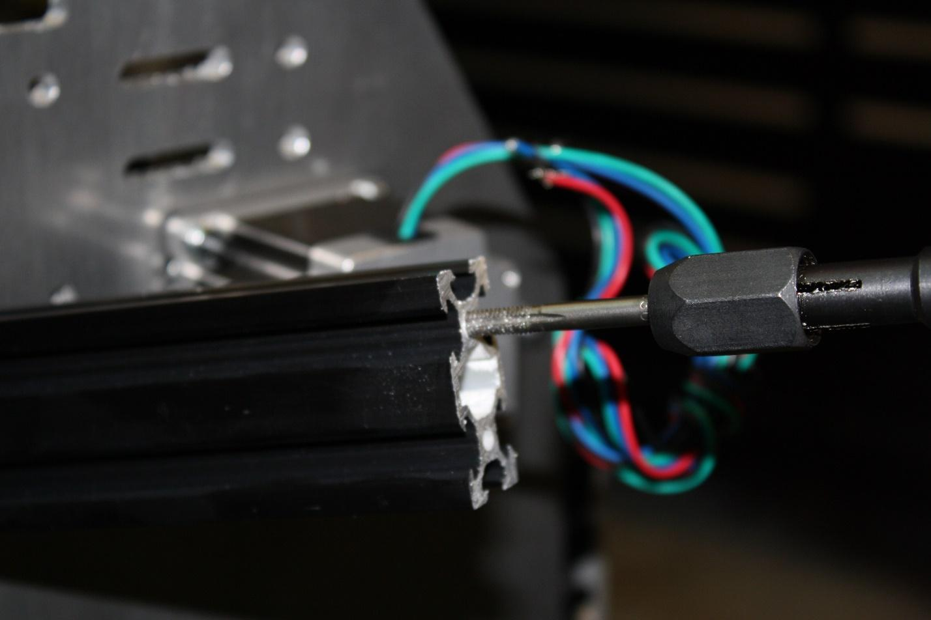
Tap the 20 x 60, all 12 holes.
Slide two T-nuts, one for each end, into the top slot of the front 20 x 60. 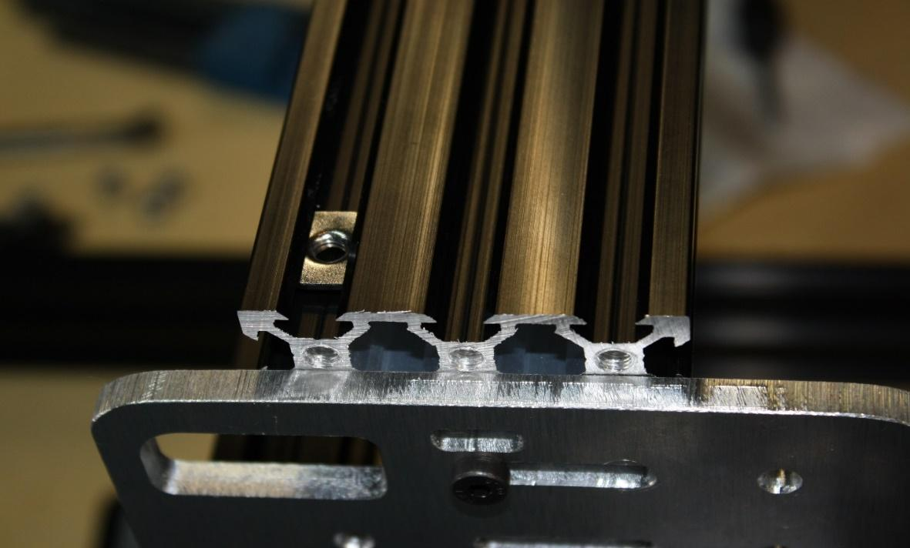
Slide the 20x60s into the gantry plates, if it is too tight you can loosen your 5-hole side brackets on the frame; this will allow the 20x80s to move in or out a little. You should not have to loosen the corners but it is one way to provide a little freedom to get the X gantry (the two 20 x 60) extrusions in place. You can also loosen the wheel kit bolts to make it a little easier too.
Bolt the 2x20x60s in with the M5 x 15mm bolts, and then do the same to the 20x40.
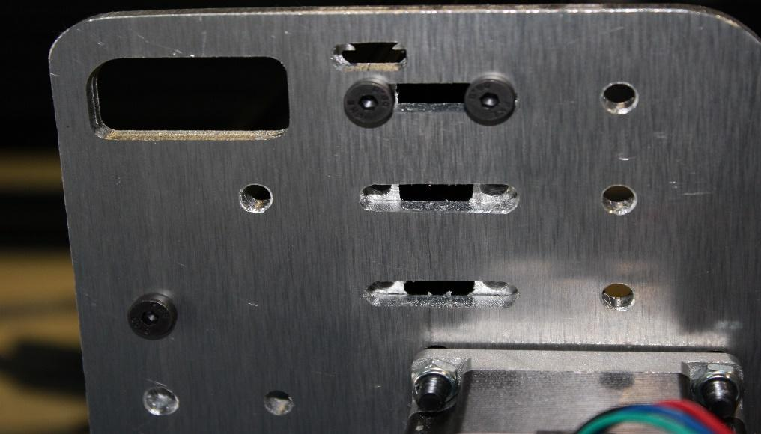
DO NOT OVER TIGHTEN these bolts. It is very easy to strip aluminum threads.
Check the trueness of your frame and make adjustments if necessary. 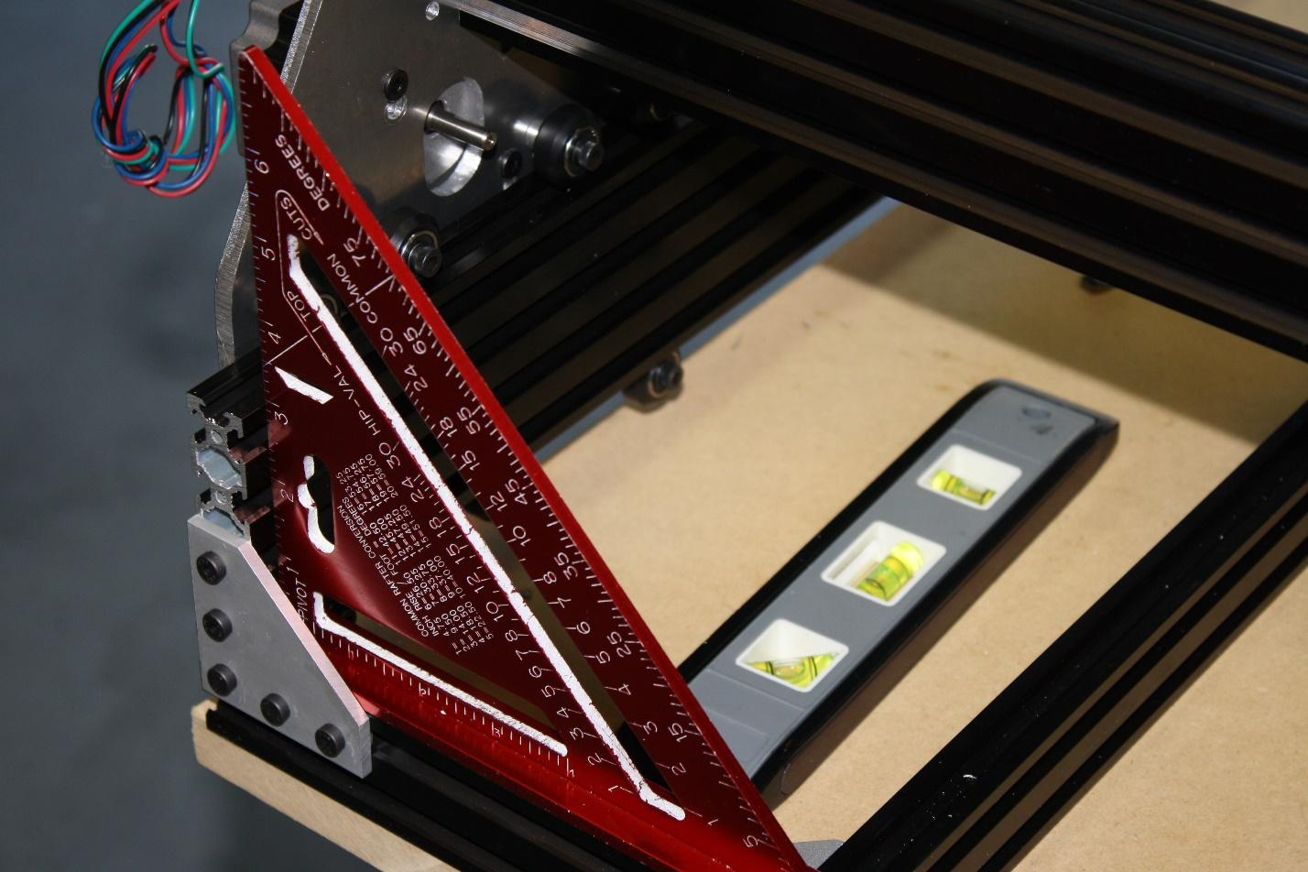
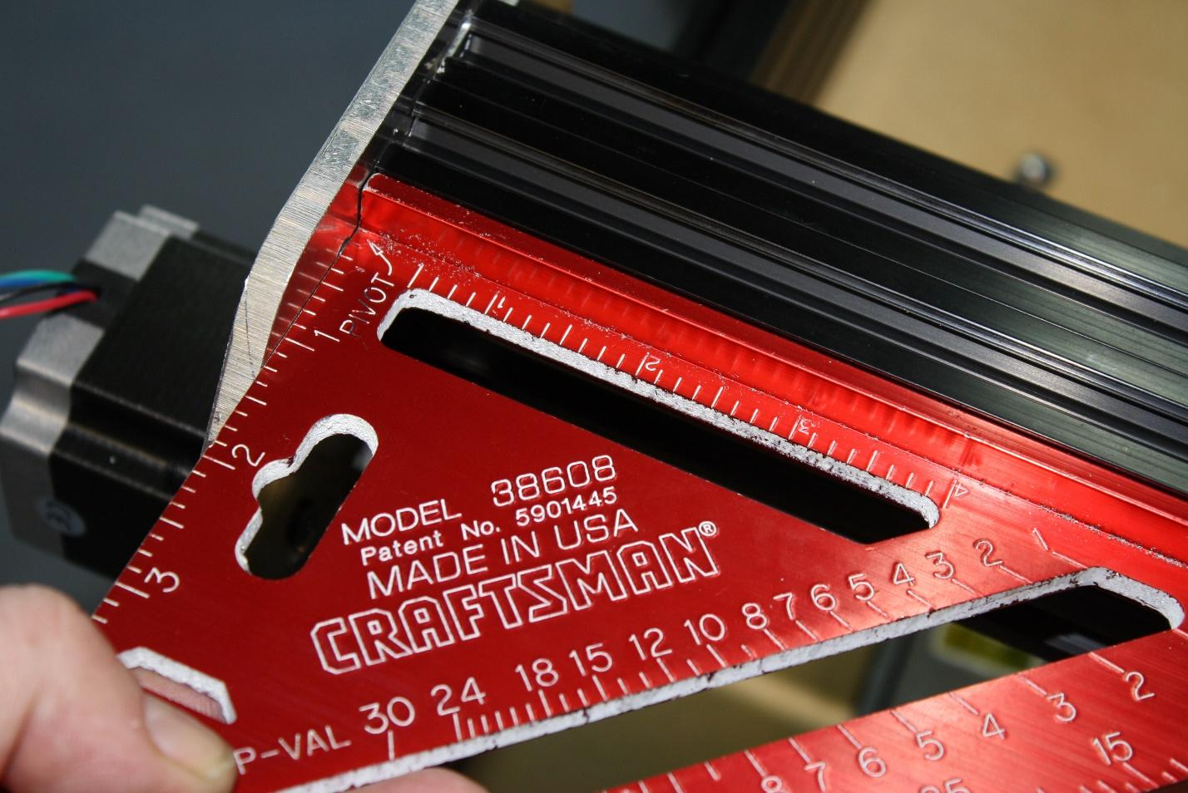
There should be no gaps between the two 20 x 60 extruded aluminum extrusions. They should sandwich together completely.
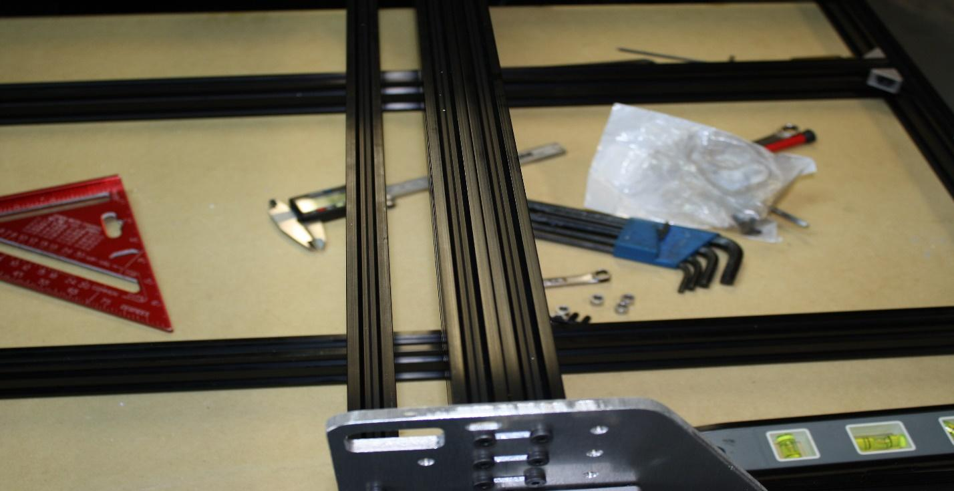
File the two tips off of one side of each 90 degree corner bracket.
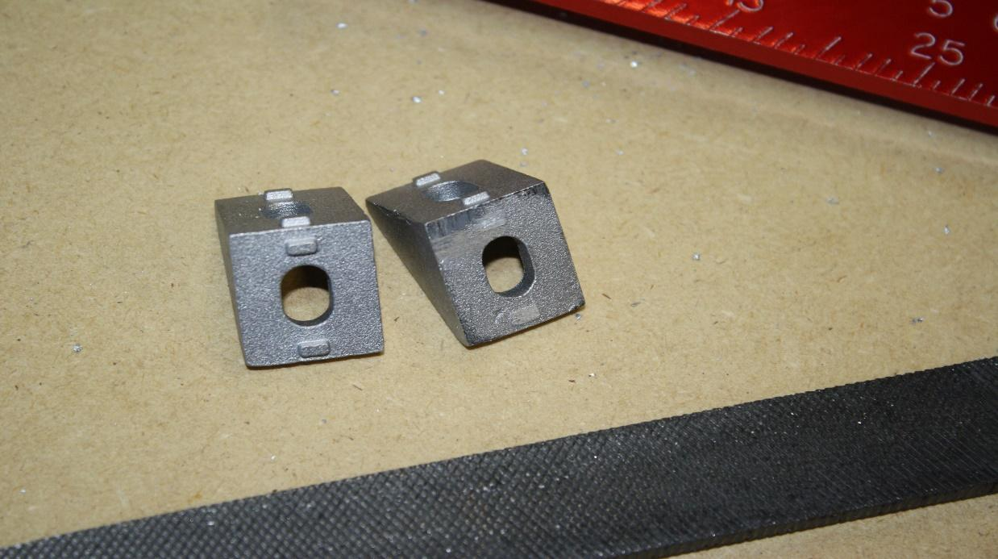
Lay the flat side of the corner bracket (where you just filed off the tabs) against the gantry plate and attach it with a M5 nut and M5 x 15mm bolt, and then do the same for the other side of the gantry.
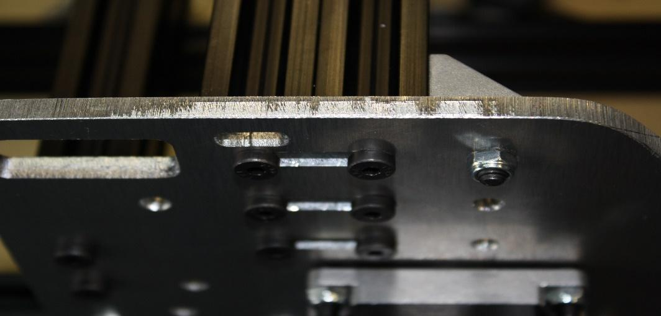
Place the M5 x 8mm bolts through the open hole on the 90 degree corner bracket and into thread, then tighten the T-nuts.
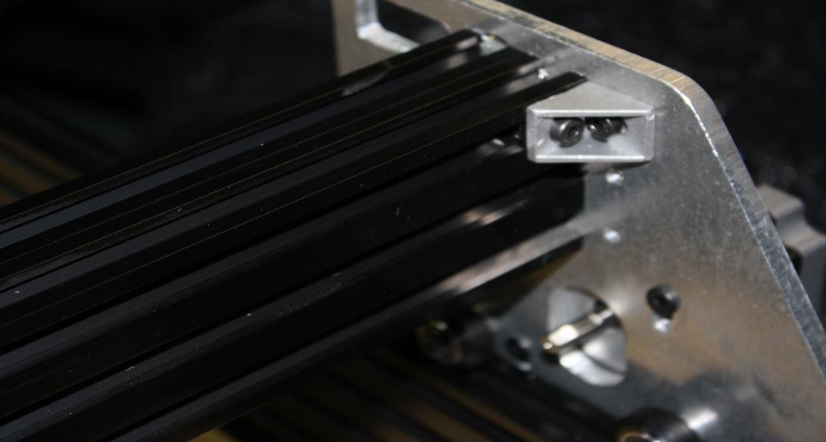

STEP FIVE:
Items required | SMW3D | Customer
(2x) X gantry plates
(14x) wheel kits
(4x) 3mm spacers,
OR (18x) 10x5x1mm shims
(4x) M5x65mm bolts
Optional wheel upgrade:
(+2x) M5 x 65mm bolts
(+2x) 3mm spacers
(+4x) wheel kits
(+6x) ¼” spacers
(16x) M5 nuts
(7x) eccentric spacers
(6x) LP M5 x 40mm bolts
(6x) LP M5 x 20mm bolts
(1x) ACME nut block
(2x) NEMA 17 threaded rod plates
(2x) 688zz bearings
(2x) lock collars
(1x) 8” ACME SCREW
(1x) 20x60x180mm aluminum extrusion
(1x) 5mm x 8mm coupling
(3x) M3 x 45 bolts
(3x) 1.5” spacers
(1x) NEMA 17 motor
(2x) spacer blocks
(6x) M5 x 15mm bolts
(1x) NEMA 23 motor
(11x) ¼” spacers
(4x) M5 x 25mm bolts
Optional NEMA 23 upgrade:
(-3x) 1.5” spacers
(-3x) M3 x 45 bolts
(-1x) NEMA 17 motor
(+1x) NEMA 23 motor
(-1x) 5mm 8mm coupler
(-1x) NEMA 17 threaded rod plate
(+1x) 6.35 x 8mm coupler
(+1x) NEMA 23 threaded rod plate
(+3x) 20mm spacers
(+3x) 9mm spacers
(+3x) M5 x 45 bolts
(+3x) M5 nuts
Begin by installing the Acme nut on the front gantry plate. Install two M5 nuts in the plastic block and install two LP M5 x 20mm bolts to secure it. Make sure the block is correctly positioned and not off angle with bottom of the plate. The blocks lower surface should be square with the lower surface of the plate.
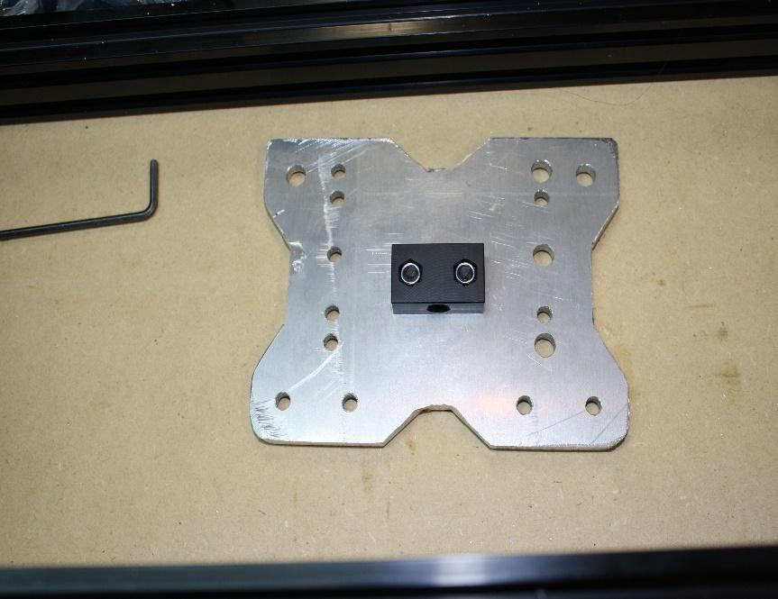
Next install the two spacer blocks using two of the LP M5 x 20 bolts for each block.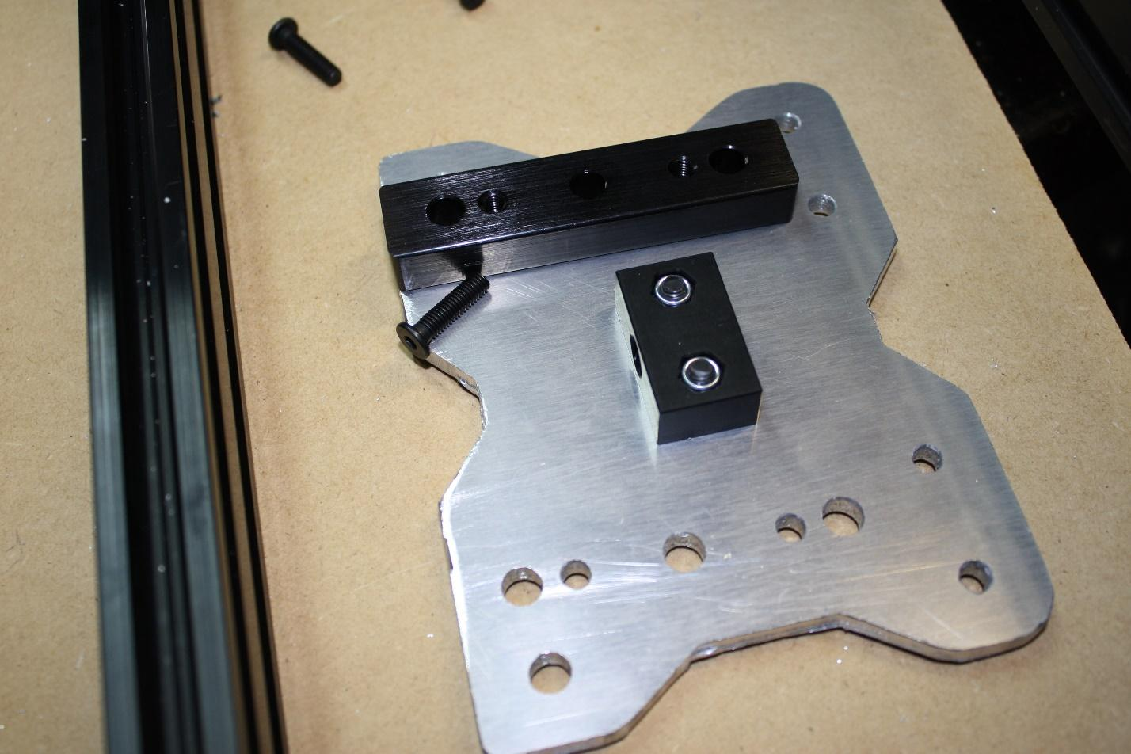

Next, install 6 wheel kits into the spacer blocks with M5 x 40mm bolts. The 3 wheels on the left side should be installed with eccentric spacers. The slot in the eccentric spacer should face outwards.
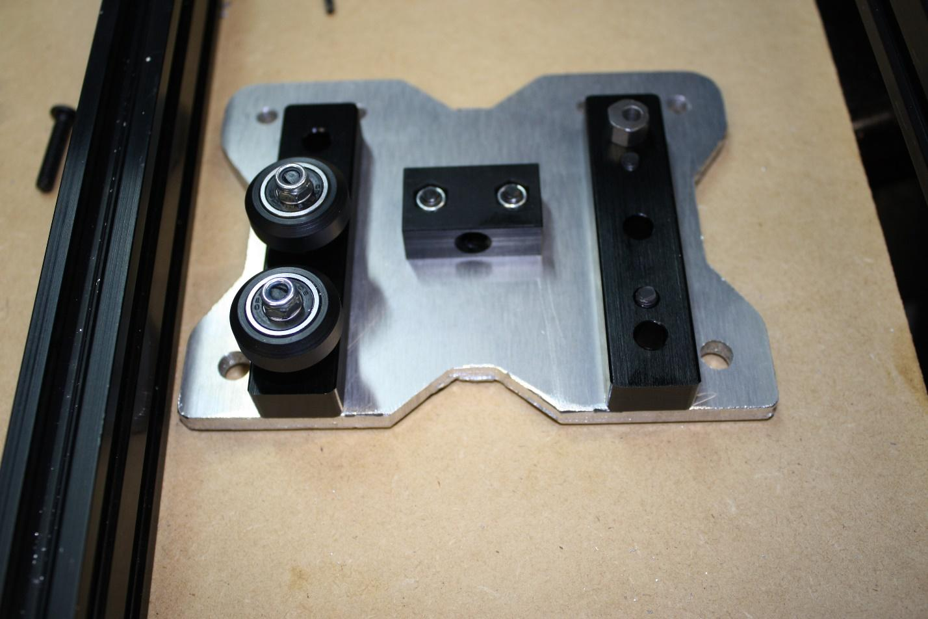
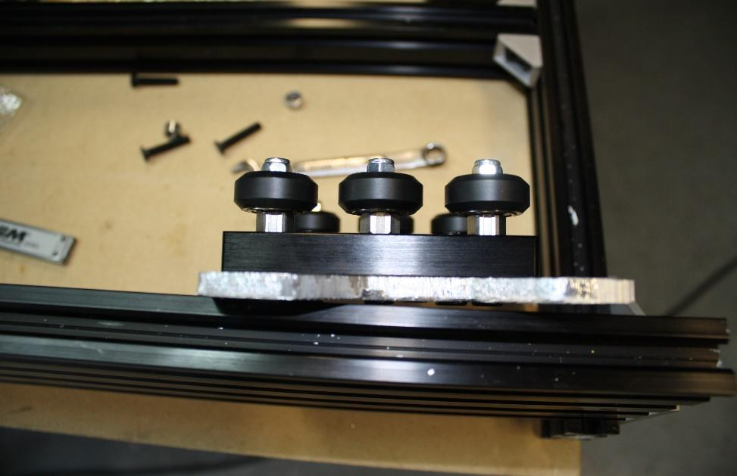
Now install a M5 x 65mm bolt into the front gantry plate. Build a wheel kit. Install the ¼” spacer, the wheel, ¼” spacer, a 3mm spacer, another wheel kit, and the ¼” spacer, followed by the back plate and a nut. Repeat this for all four top axles on the X gantry. Leave the four M5 nuts loose for now.
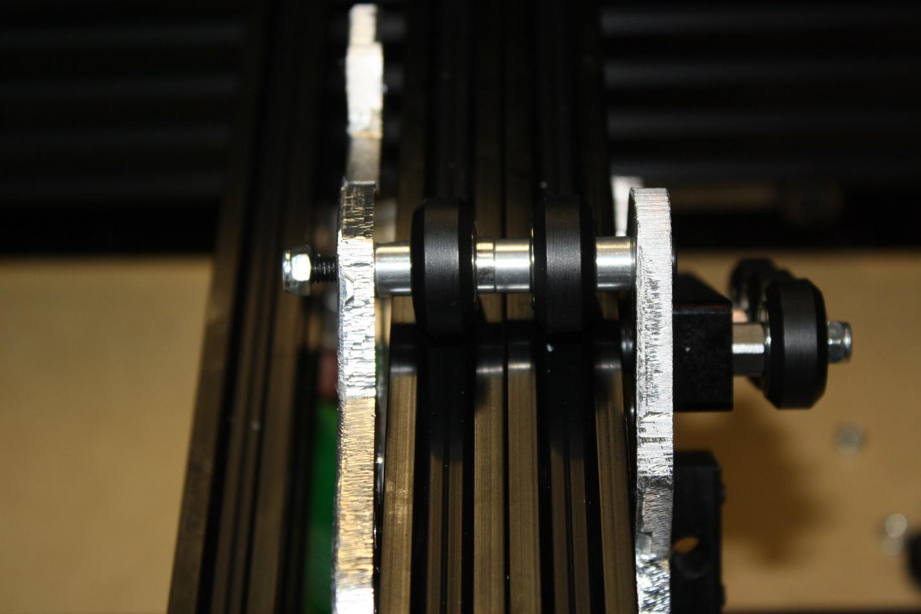
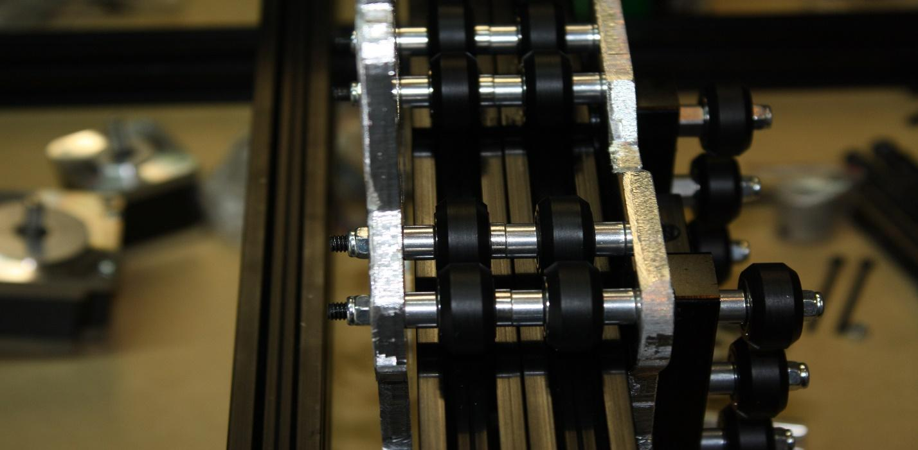
Next, install the lower two axles, but this time use an eccentric spacer in place of the outside ¼” spacers.
Note, the four axles across the top shown above is for the X gantry additional wheels upgrade; if you did not choose this option you should only place two axles on top and two on bottom.
(image shown upside down for viewing ease)
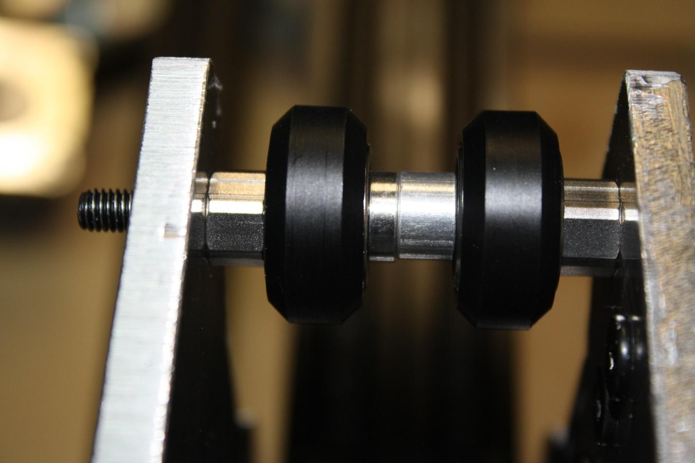
Tighten the eccentric spacers till all four wheels across the top can be turned by hand but have light drag.
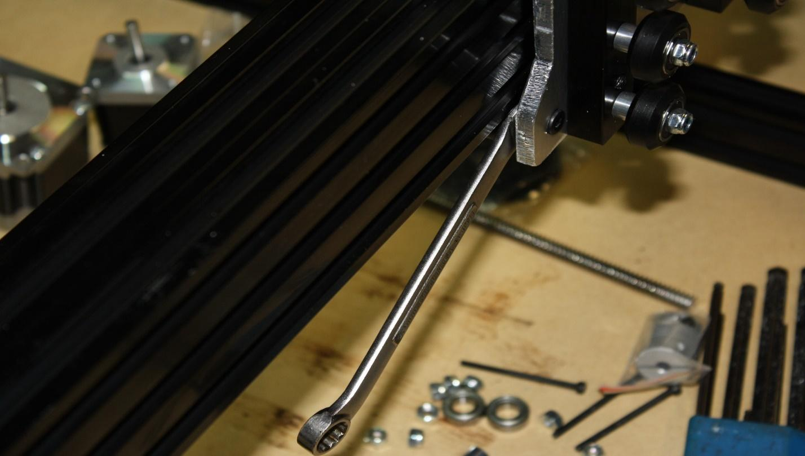
Tighten all M5 nuts.
Next install the NEMA 23 motor for the X gantry. Use four M5 x 25 bolts and four M5 nuts. Again, tighten against the motor against the gantry plate. If you use a combination wrench this will be an easy task, otherwise the nuts are slightly hard to grab.
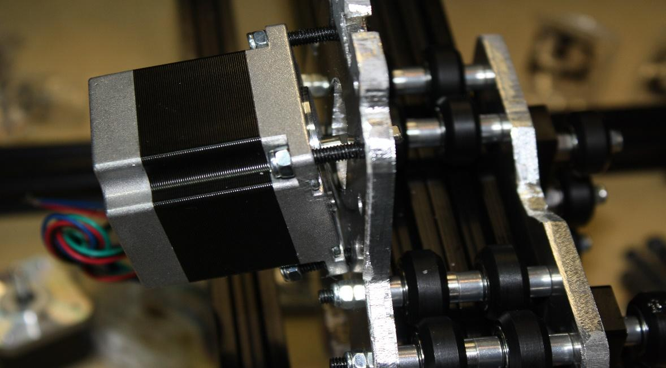
Now tap all 6 holes on the 20x60x180mm aluminum extrusion. 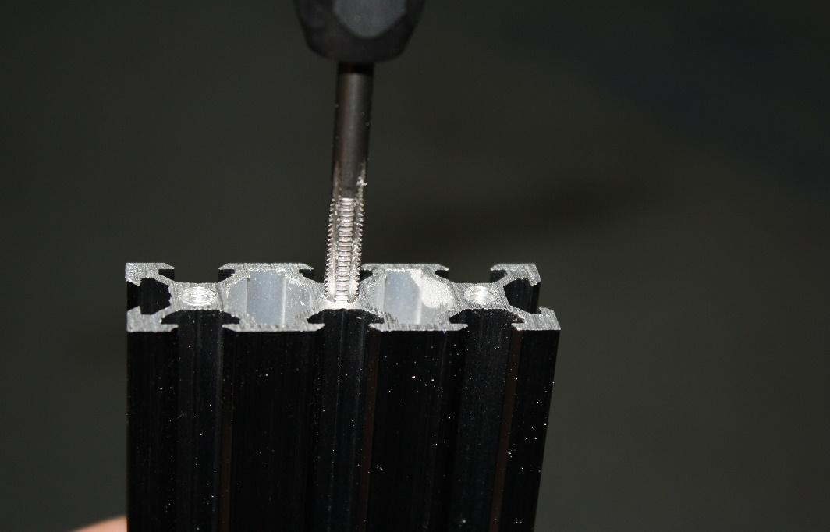

Install a threaded rod plate on one end of the 20 x 60 with three M5 x 10mm bolts. Leave this loose for now.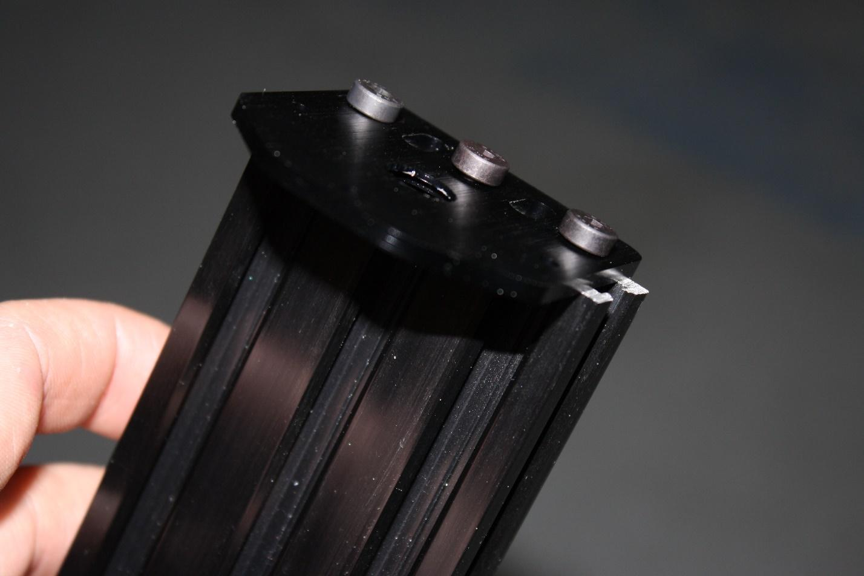
Note: there is a recess in the threaded rod plate, this should be where the bearing resides, and they should face each other.

Install the coupling on the NEMA 17.
Install the NEMA 17 on the plate with three 1.5” spacers and M3 x 45 bolts.
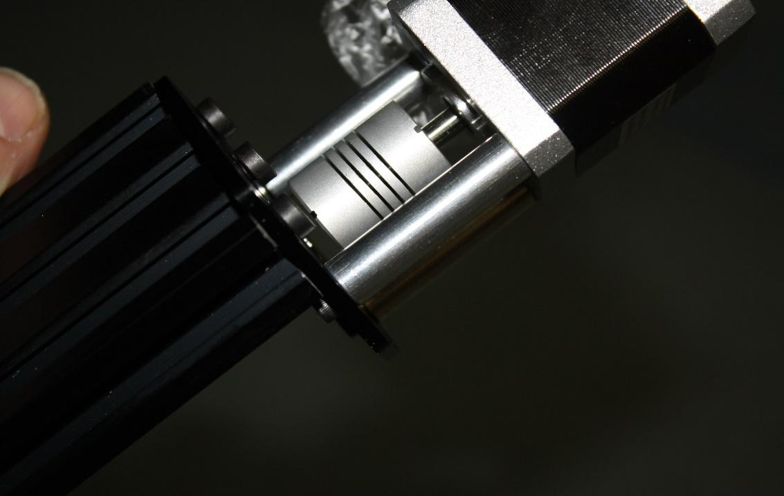
Install a lock collar on the ACME threaded rod.
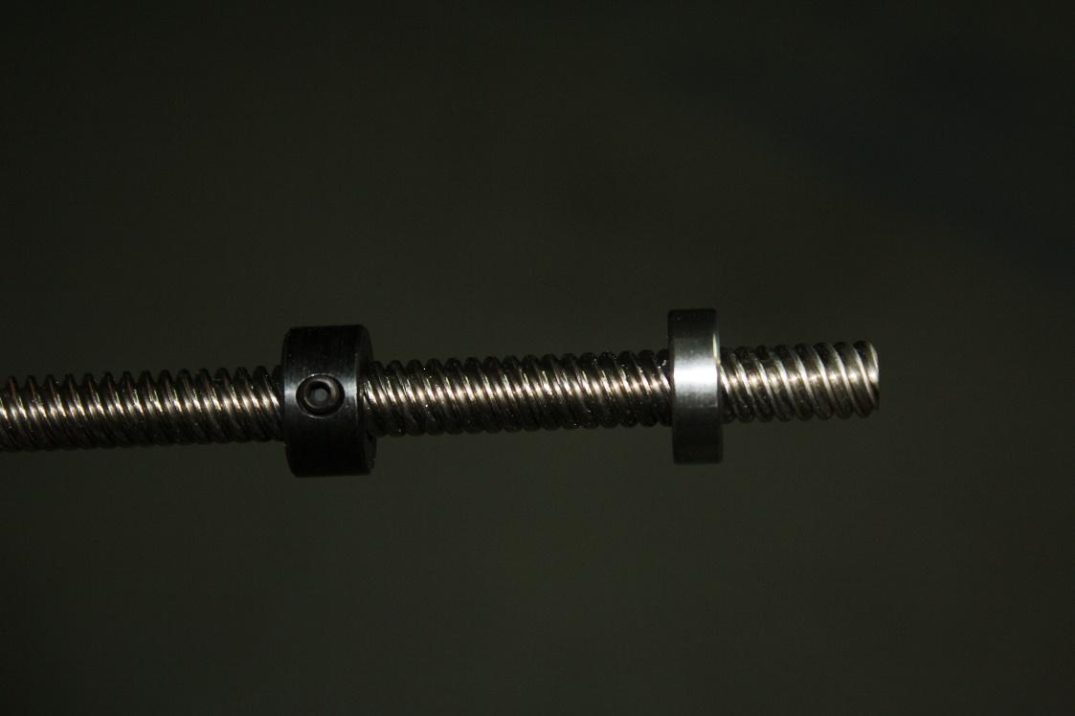
Install a bearing on the ACME threaded rod.
Note: Use light grit sandpaper on the OD (outer diameter) of the AMCE to get the bearings over the ACME thread. It is slightly larger than 8mm.

Install the ACME screw in the coupling, and then tighten the lock collar.
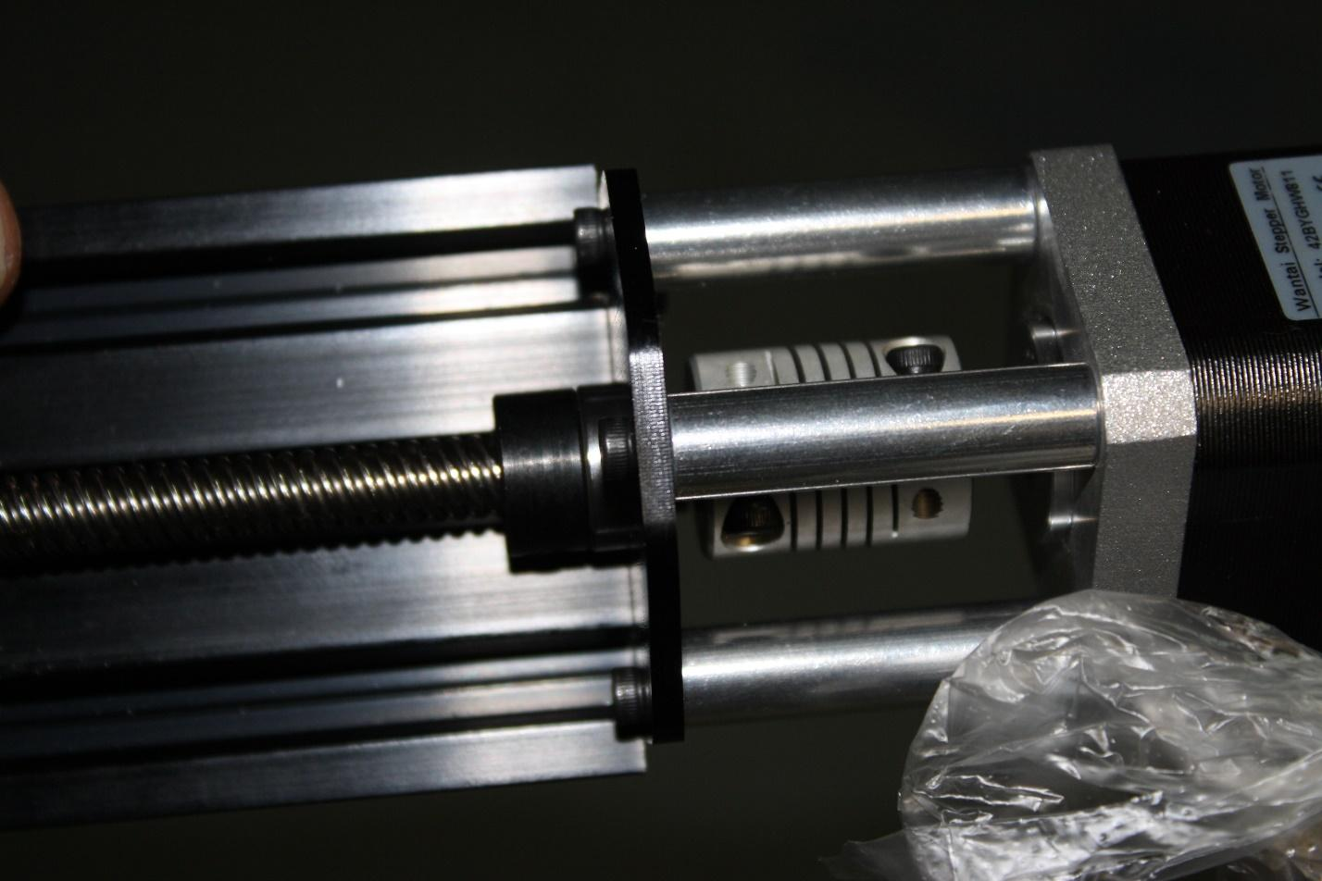
Now thread the ACME screw and assembly into the ACME nut block and thread it through using the coupling to turn it.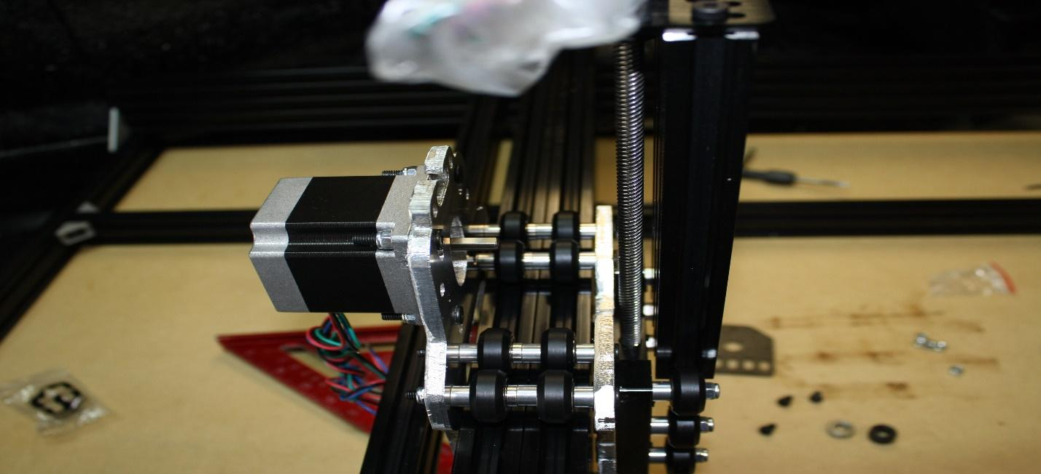

Once the lower ACME thread protrudes through the ACME block install a lock collar, bearing, and the lower plate. Push the bearing and lock collar all the way down into the lower recess in the threaded rod plate. Make sure there is no play in the Z axis up or down. Now tighten the 6 screws holding the threaded rod plate onto the 20x60x180mm aluminum extrusion.
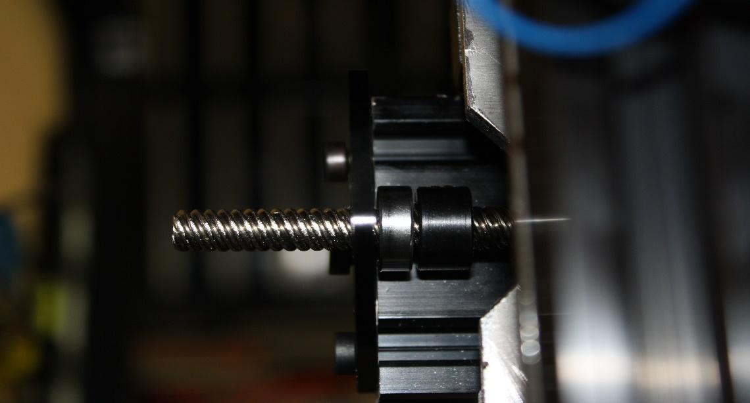
Make sure the lock collar and the bearing are pushed all the way against the threaded rod plates and then tighten the lock collar to hold everything in place.
Next, tighten the three eccentric spacers on the Z gantry. Be careful to not over tighten these. There should be no play on 20x60x180mm Z axis, but it should be able to move freely up and down by turning the ACME screw. A good rule of thumb is you should be able to turn the wheel by hand with only a small amount of resistance.
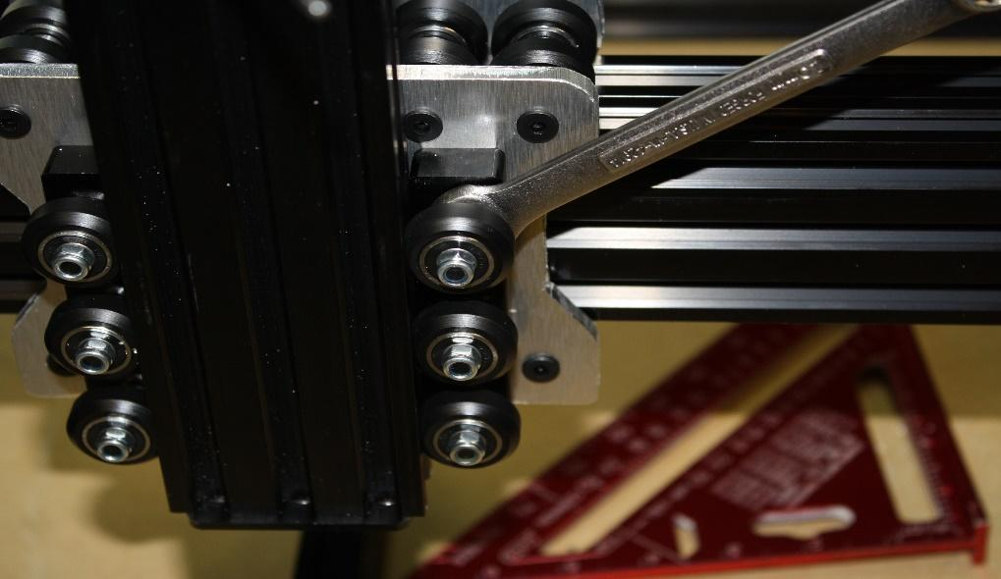
Note:
If you chose the NEMA 23 upgrade, install the NEMA 23 threaded rod plate on the top of the 20 x 60 Z-axis. Install the 6.35mm x 8mm coupler. Replace the 1.5” spacer shown above with the 20mm and the 9mm spacer, and then install the NEMA 23. Run the M5 x45 bolt through the motor both spacers and the plate. Tighten all this down with a M5 nut. Repeat three times as shown above with the M3 x 45 bolts. Check the clearance of the NEMA 23 threaded rod plate to the pulley on the X axis. These are sometimes very close; if there is interference then simply file a small bit off the front of the plate.
STEP SIX:
Items required large format: | SMW3D | Customer
(4x) T-nuts
(2x) drop-in T-nuts
(6x) M5 x 8mm bolts
(2x) 1080mm GT belt
(1x) 850mm GT belt
(3x) GT pulleys with 6.35mm bore

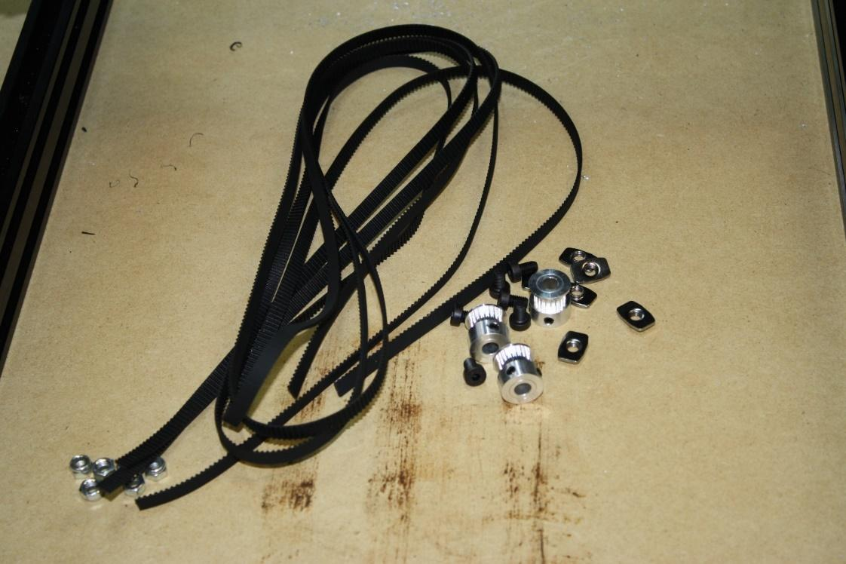

Begin by installing all three pulleys on the NEMA 23 motors, aligning them perfectly with the slot in the V-slot.
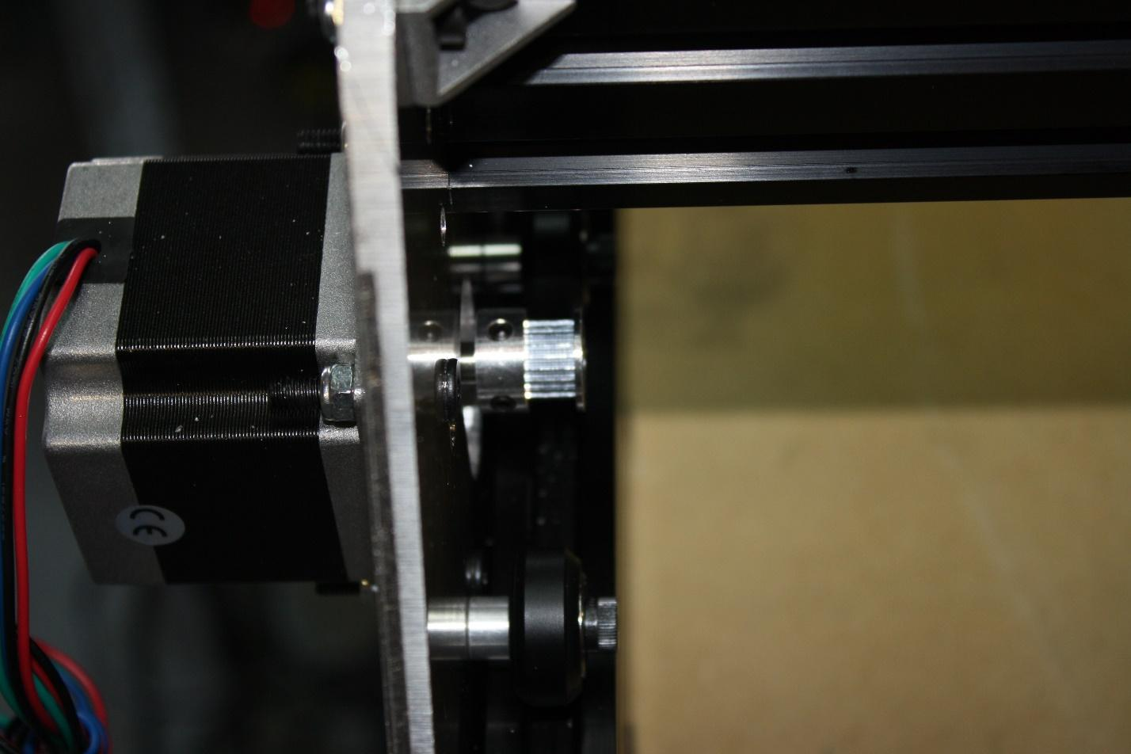
On all three pulleys, route the GT belt over the pulley and under the wheels.
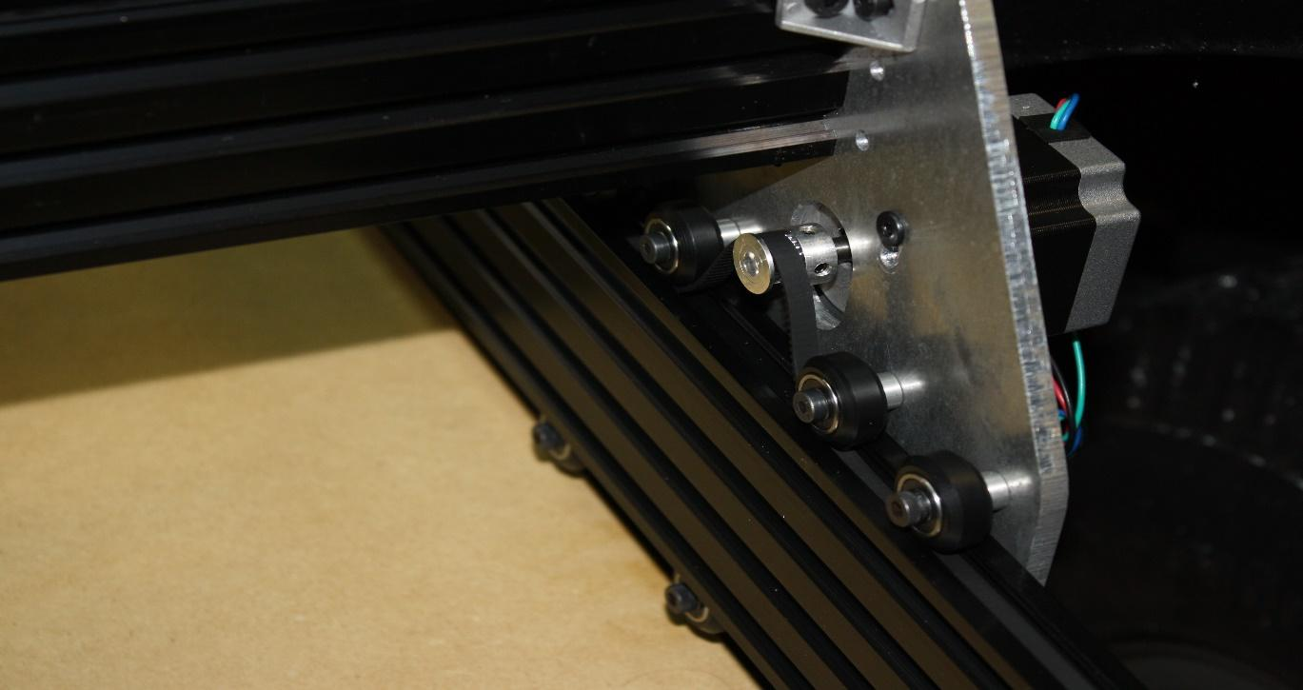

Slide a T-nut in the end of each axis, over the belt and tighten the M5 x 8mm on one end.
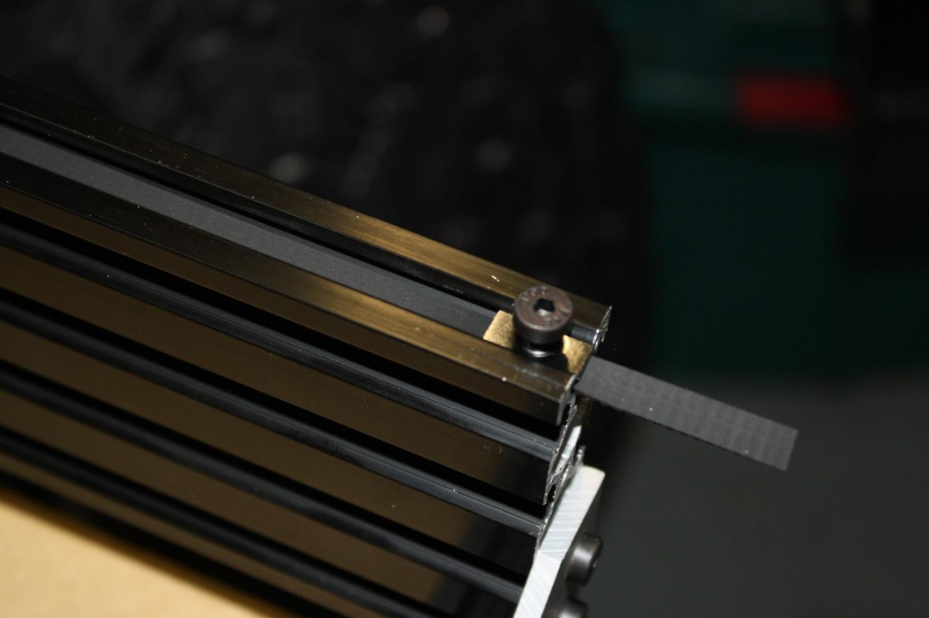
On the opposite end, pull the belt extremely tight and tighten the M5 x 8mm bolt.
Perform the same task on all three belt drives. The X axis will use the two drop in T-nuts.
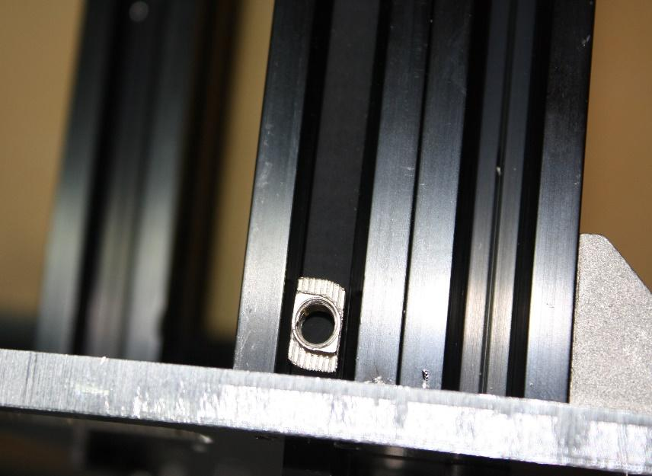
NOTE: If you are using the GT3 belt upgrade you may have to file the drop in T-nuts to make them thin enough to allow room for the belt to slide under them.
This can be a difficult step but take time to ensure the belts are tight but not so tight the axis can’t move freely. Make sure once installed the pulleys are aligned perfectly with the belts and the slots in the v-slot. 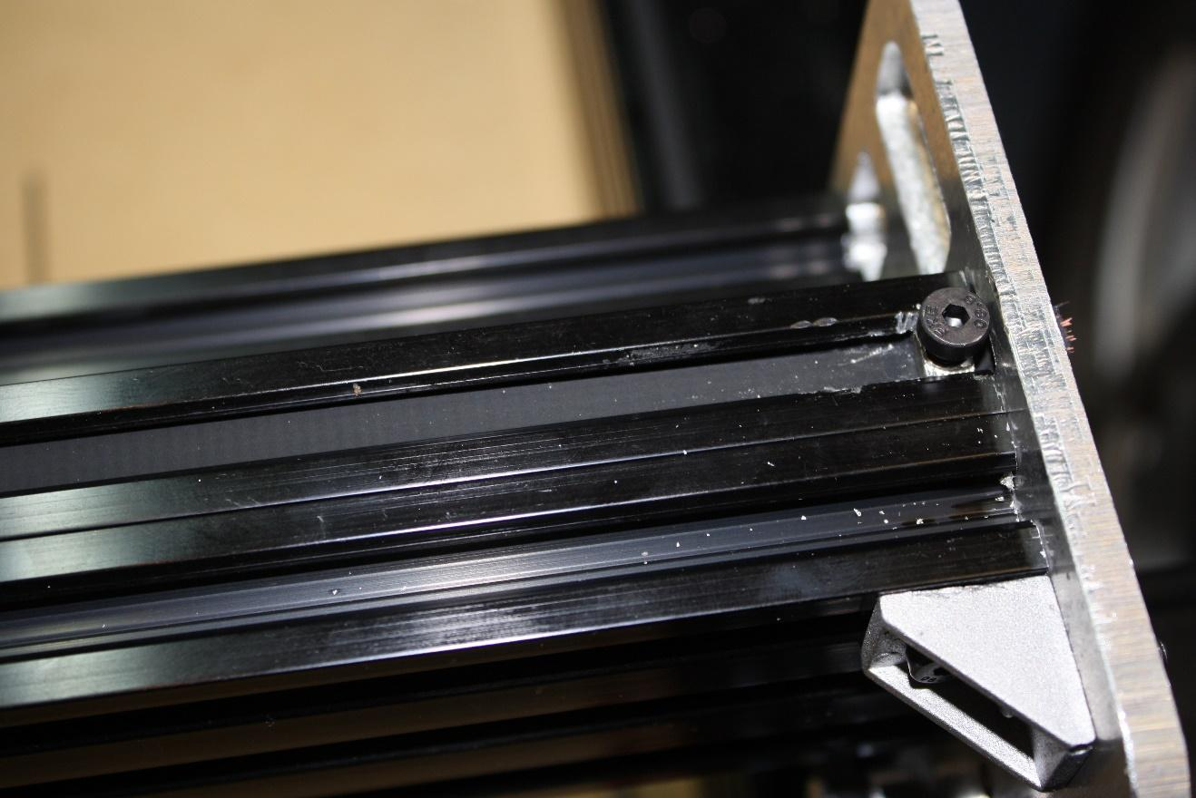
STEP SEVEN:
Install spoiler board.
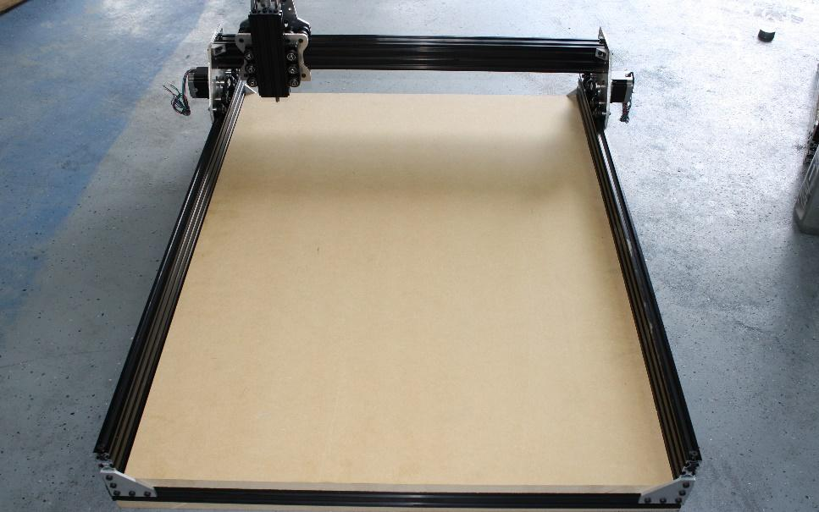
Measure the inside of the frame and have your local home improvement store cut this to length. Do not force it in; if it is too large, you will need to trim it. Forcing the spoiler board in will knock the entire system out of square!
STEP EIGHT:
Items required: | SMW3D | Customer
Spindle motor
Wire for motors
Heat shrink tubing
Power supply
Power supply cable
Optional Spindle upgrade power supply
(1x) spindle speed control module
(2x) spindle clamps
(4x) 90 degree corner brackets
(4x) T-nuts
(4x) M5 x 10mm screws
(1x) Fan for cooling control board
(1x) 2-lead wire for spindle
Optional X gantry cable chain upgrade:
(1x) Cable chain
(1x) 20mm spacer
(1x) M5 x 35mm bolt
(1x) M5 nut
(2x) M4 x 20mm bolts
Optional wire sheathing
Optional TinyG control board
Optional Z-axis touch sensor
Optional E-stop button

Tools required:
Soldering iron
Steps:
These steps will not include much detail as they will be dependent on which controller you use.
Extend the leads on all stepper motors to your controller. Use the provided heat shrink tubing and 4 lead wire to run the stepper motors to your controller.
Wire the power supply to your controller and spindle. If you chose the spindle upgrade, take the power cable for the power supply and trim about 4” off of it. Strip both ends and chain the two power supplies together.

Shown here: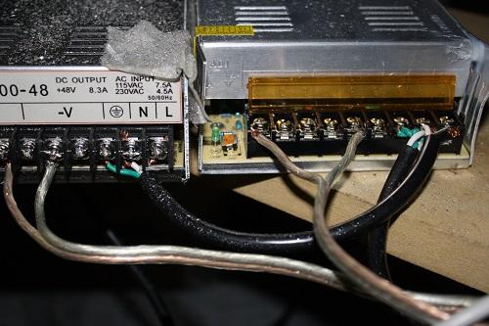
The 24V power supply goes to your controller… WATCH THE POLARITY!
The 48V power supply goes to the spindle speed control and from the speed control to the spindle.
The spindle mount is what is referred to as the “quick and dirty” method. Visit the build page on OpenBuilds.com, and under the OX build there will be a quick set of instructions on how to perform this task, as shown here:
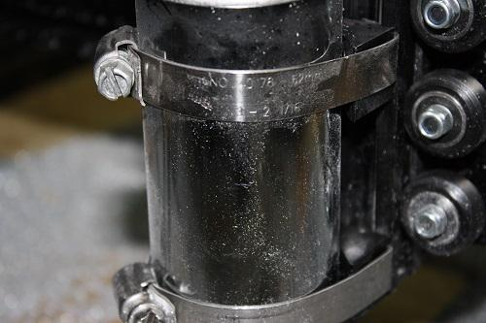

If you chose the TinyG upgrade, please follow the directions on the outside of the package to take you very informative websites on how to set everything up. Your motors are 1.8 degree steppers, the pulleys have 20 teeth, and this should be all you need to get the correct steps/mm for the X and Y axes. A good starting point is 40mm/rev for X and Y, and 8mm/rev for the Z. This should be physically verified that when you create a 12” x 12” square it actually is a 12” x 12” square.
If chosen, the E-stop button should be installed between the 24V power supply and the controller. When pressed this should stop all motion of the gantry motors. The spindle will remain turning but will stop moving therefor saving your work piece.
Simply take the ground or power wire and cut it. Run one end into one side of the kill switch and the other out of the same leg on the E-stop button. One side of the E-stop button is fully connected when pressed, while the other is fully connected until it is pressed.
NOTE: Do not connect the power supply for the spindle and the controller together, this will send 48V to the controller and destroy it.
The Z axis end stop can be seen on the SMW3D website where we give a good description of its use.
The X gantry cable chain is to be installed on top of the 20x40mm extrusion rear brace. You will need to drill and tap a hole into the top slot of the 20x40mm and install the M4 bolt through the hole on the end of the cable chain. This is done using an M4 x .7mm tap.
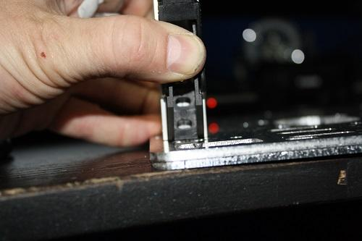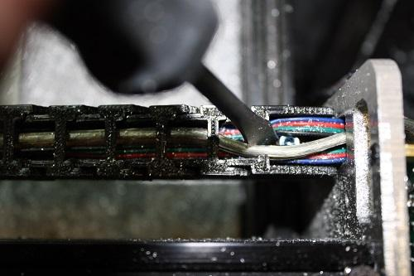
The other end of the cable chain goes to the hole above the NEMA 23 on the X gantry rear plate.

You will need to drill a hole in the side of the end of the cable chain:
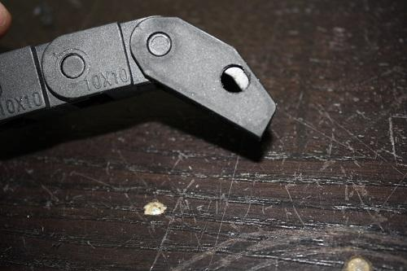
The install the spacer, bolt and nut. Then run all cables through your chain.
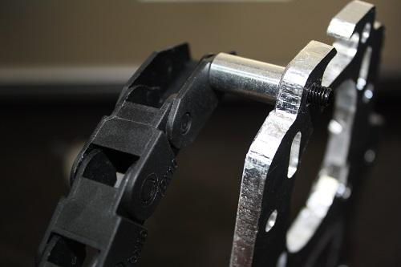
Congratulations!
Your OX is now complete and you are ready to configure your controller and start cutting!
SMW3D appreciates your business and looks forward to helping you achieve all your build goals!

There are videos on the TinyG, power supplies, and spindle speed control on SMW3D.com under the particular product.

